ORDINANCE NO. 1982

AN ORDINANCE OF THE CITY COUNCIL OF THE CITY OF FONTANA, CALIFORNIA, AMENDING SECTION 30-622 AND DIVISION 7 OF ARTICLE XI OF THE FONTANA MUNICIPAL MODIFYING DEVELOPMENT STANDARDS AND OPERATING REGULATIONS FOR THE EMERGENCY SHELTER OVERLAY AND APPLYING THE OVERLAY ON THE PROPERTY AT 11109 JASMINE STREET, PURSUANT TO A CATEGORICAL EXEMPTION IN ACCORDANCE WITH CEQA GUIDELINES SECTIONS 15060(C), 15378, AND 15061(B)(3) AND DIRECTING STAFF TO FILE A NOTICE OF EXEMPTION.

WHEREAS, pursuant to Government Code section 37100, the legislative body of a city may pass ordinances not in conflict with the Constitution and laws of the State or the United States; and

WHEREAS, Government Code sections 50022.1 to 50022.10 authorize a city to codify and recodify its ordinances; and

WHEREAS, the City of Fontana (“City”) desires to restate without substantive revision, amend and recodify certain ordinances codified in the Fontana Municipal Code (“Code”) through Municipal Code Amendment (“MCA”) No. 25-0010; and

WHEREAS, the City of Fontana General Plan (“General Plan”) includes policies and actions calling for numerous updates to the Code; and

WHEREAS, Section 30-622. – Overlay Districts, is amended to revise the description of the Emergency Shelter Overlay to reflect that it may be applied to properties with the Light Industrial (I-L) or General Industrial (I-G) general plan land use designation; and

WHEREAS, Article XI - Division 7. Overlay Districts - is amended to update the description of the Emergency Shelter Overlay; and
WHEREAS, the amendments in MCA No. 25-0010 are consistent and compatible with the General Plan and are in line with goals, policies and objectives of the City, the Housing Element policies and the Zoning and Development Code; and

WHEREAS, the amendments in MCA No. 25-0010 are in conformity with appropriate land use practices and will establish appropriate development standards for the land use designations; and

WHEREAS, the amendments in MCA No. 25-0010 attached hereto as Exhibit “A” and incorporated herein by reference, will not be detrimental to the public health, safety and general welfare, nor will it adversely affect the orderly development of property; and

WHEREAS, on December 2, 2025, the Fontana Planning Commission (“Planning Commission”) held a public meeting on MCA No. 25-0010 where it received evidence and public testimony on the Code amendments and recommended that the Fontana City Council (“City Council”) determine that the amendments are exempt pursuant to the California Environmental Quality Act (CEQA) Guidelines Sections 15060(c), 15378, and 15061(B)(3) (the common-sense exemption), and Sections No. 3.01, 3.22, and 10.59 of the 2019 Local Guidelines for Implementing CEQA. in that the activity is covered by the general rule that CEQA applies only to projects which have the potential for causing a significant effect on the environment. Where it can be with certainty that there is no possibility that the activity in question may have a significant effect on the environment, the activity is not subject to CEQA; and

WHEREAS, the Planning Commission carefully considered all evidence and testimony presented at its public hearing on December 2, 2025, and approved Resolution No. 2025-048 to recommend that the City Council approve the modifications to the Zoning and Development Code; and

WHEREAS, on February 10, 2026, the City Council held a public hearing on MCA No. 25-0010 where City Council received evidence and public testimony pertaining to the Zoning and Development Code amendments and documentation from the Planning Commission’s public hearing on December 2, 2025; and

WHEREAS, the City Council carefully considered all information pertaining to MCA No. 25-0010 that was presented at its public hearing on February 10, 2026; and

WHEREAS, all other legal prerequisites to the adoption of this Ordinance have occurred.

THE CITY COUNCIL OF THE CITY OF FONTANA DOES ORDAIN AS FOLLOWS:
Section 1. Recitals. The recitals are true, correct and incorporated herein by this reference.
Section 2. CEQA. The City Council hereby determines that the code amendments are exempt pursuant to the California Environmental Quality Act (CEQA) Guidelines Sections 15060(c), 15378, and 15061(B)(3) (the common-sense exemption) and Sections 3.01, 3.22, and 10.59 of the 2019 Local Guidelines for Implementing CEQA. Staff is directed to file a Notice of Determination pursuant to the foregoing.
Section 3. Development Code Amendment Findings. The City Council hereby makes the following findings for Municipal Code Amendment No. 25-0010 accordance with Section 30-40 “Purpose” of the Fontana Zoning and Development Code:

Finding: A Zoning and Development Code may be amended by changing the development standards (text) or zoning designation map boundaries of any zone whenever such an amendment is deemed necessary to protect or promote the public's health, safety or general welfare or when modification is viewed as appropriate in the context of generally accepted planning principles, surrounding land uses, and the General Plan.

Findings of Fact: The proposed Municipal Code Amendments will revise the Emergency Shelter Overlay to create additional opportunities for housing and support services for the unhouse population. These amendments further the General Plan goal of providing adequate housing to meet the needs of all residents in Fontana and of promoting a diversified economy.

Section 4. Development Code Amendment Approval. Based on the foregoing, the City Council hereby approves the amendments as set forth in MCA No. 25-0010, which is attached hereto as Exhibit “A” and incorporated herein by reference as fully set forth herein.

Section 5. Effective Date/Publication. This Ordinance shall take effect thirty (30) days after the date of the adoption and prior to the expiration of fifteen (15) days from the passage thereof, shall be published by the City Clerk at least once in the Fontana Herald News, a local newspaper of the general circulation, published and circulated in the City of Fontana, and henceforth and thereafter the same shall be in full force and effect.

Section 6. Custodian of Records. The documents and materials that constitute the record of proceedings on which this Ordinance is based are located at the City Clerk’s office located at 8353 Sierra Avenue, Fontana, CA 92335. The custodian or records is the City Clerk.

Section 7. Certification. The City Clerk of the City Council shall certify to the adoption of this Ordinance.

Section 8. Severability. If any provision of this Ordinance or the application of any such provision to any person or circumstance is held invalid, such invalidity shall not affect other provisions or applications of this Ordinance that can be given effect without the invalid provision or application.

APPROVED AND ADOPTED this 24th day of February, 2026.

READ AND APPROVED AS TO LEGAL FORM:

______________________________________
City Attorney
I, Germaine Key, City Clerk of the City of Fontana, and Ex-Officio Clerk of the City Council, do hereby certify that the foregoing Ordinance is the actual Ordinance adopted by the City Council and was introduced at a regular meeting on the 10th day of February 2026, and was finally passed and adopted not less than five days thereafter on the 24th day of February 2026, by the following vote to wit:

AYES:
NOES:
ABSENT:
ABSTAIN:

______________________________________
City Clerk of the City of Fontana

______________________________________
Mayor of the City of Fontana

ATTEST:

______________________________________
City Clerk

“EXHIBIT A”

AMENDMENT TO FONTANA MUNICIPAL CODE CHAPTER 30
(*Additions shown in underline, deletions shown in strikeout)

ARTICLE IX. - OVERLAY DISTRICTS DIVISION 1. - GENERALLY

Sec. 30-621. - Purpose.
The purpose of this article is to create overlay districts that establish additional use regulations and development standards for specific types of use and specific areas of the City requiring special consideration in the development process. The regulations established in this article for the overlay districts shall apply in addition to the regulations established for the underlying zone districts.

Sec. 30-622. - Overlay districts.
- Medical center overlay district. A district that may overlay any medical center complex.
- Utility corridor overlay district. A district that is intended to provide for appropriate development within or near those areas containing easements for public utilities.
- Hillside overlay district. A district that protects the public health and safety, minimizes environmental impacts, and requires development to conform to the natural topography of hillside areas.
- Auto center overlay district. A district that is intended to promote new car and truck sales adjacent to the 1-210 Freeway.
- Warehousing distribution/logistics overlay district (Sierra Avenue). A district that provides for the limited, well planned and orderly development of warehousing distribution/logistics uses on properties within the light industrial (M-1) zone as provided for in Section 30-532 et seq. Unlike other overlay districts in this division, this overlay identifies a geographic area where such uses may be allowed subject to a separate zone change request to establish the overlay on one or more parcels eligible to receive it.
- Valley business park overlay district. The intent of the valley business park overlay is to provide for a well-planned and orderly development of business park and warehousing distribution uses on parcels within the M-1 zone located on designated areas within the adopted overlay that are generally located on the south side of Valley Boulevard.
- Emergency shelter overlay district. A district that provides for seamless incorporation of emergency, supportive, and transitional housing opportunities on specific properties within the light industrial (M-1) zoning district Light Industrial (I-L) and/ or General Industrial (I-G) general plan land use designations to house individuals at risk of homelessness with such needs for no more than a six-month period, as required by Government Code § 65583(a)(4) and 65583(a)(5).

(h)(R-4) overlay district. The intent of the R-4 overlay district is to provide areas for the potential development at the multi-family residential (R-4) density of 24.1 du/ac to 39 du/ac for multi-family development in close proximity to transit routes and convenience uses in recognition of the need for affordable housing.

DIVISION 7. EMERGENCY SHELTER OVERLAY DISTRICT

Sec. 30-651. Emergency shelter overlay district (ESO) regulations.
- Applicability. The provisions of this division shall apply to light industrial (I-L) land use designations and specific plan industrial land use designations as specified in Figure
Figure 1
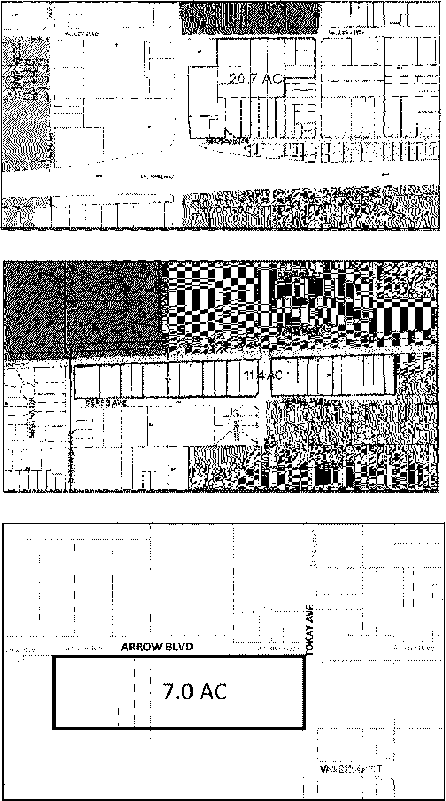

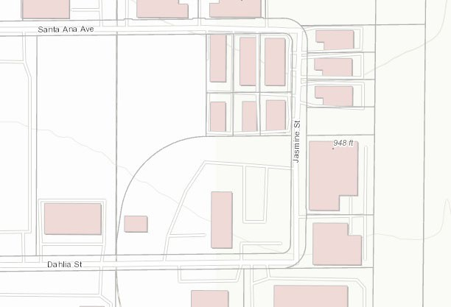

1.7 AC

- Relation to underlying zoning. The emergency shelter overlay district is a flexible designation that is intended to apply in conjunction with, or as an alternative to the provisions in the underlying zoning. When utilized in conjunction with the underlying zone, if the provisions of this division are in conflict with the provisions of the underlying zoning district, the provisions of this division shall apply.
- Intent. The intent of the emergency shelter overlay district is to provide for supportive and transitional housing uses on specific properties within the light industrial(M-1) zoning district Light Industrial (I-L) and General Industrial (I-G) general plan use designations. Additionally, the further intent of this overlay district is to allow emergency shelters without a conditional use permit or other discretionary permit in accordance with Government Code § 65583. Recognizing the need for available and affordable sites for establishment of emergency shelters and other transitional housing types outside of the traditional locations in commercial districts, the emergency shelter overlay district provides areas and districts for the development of new emergency and supportive housing to be integrated with commercial and light industrial uses and existing social services throughout the City. The purpose of the designated boundaries (area of applicability) is to maximize the potential for provision of emergency shelter and support services throughout the City of Fontana.
- Definitions.
Emergency shelters. The California Health and Safety Code (§ 50801(e)) defines "emergency shelter" as housing with minimal supportive services for homeless persons that is limited to occupancy of six months or less by a homeless person. No individual or household may be denied emergency shelter because of an inability to pay.
Single room occupancy. Typically, a single-room occupancy (SRO) unit is a multiple tenant building that houses one or two people in individual rooms (sometimes two rooms, or two rooms with a bathroom or half bathroom), or to the single room dwelling itself. SRO tenants typically share bathrooms and/or kitchens, while some SRO rooms may include kitchenettes, bathrooms, or half-baths. Most SRO units are small, with a gross floor area of less than 400 square feet. Each dwelling unit is restricted to occupancy by no more than two persons and is offered on a monthly rental basis or longer.

Supportive housing. Under the housing element law, supportive housing is defined as housing with no limit on length of stay that is occupied by a target population, and that is linked to onsite or offsite services that assist the supportive housing resident in retaining the housing, improving his or her health status, and maximizing his or her ability to live and, when possible, work in the community (California Health and Safety Code § 50675.14(b)).
Transitional housing. The California Health and Safety Code (§ 50675.2) defines "transitional housing" and "transitional housing development" as buildings configured as rental housing developments, but operated under program requirements that call for the termination of assistance and recirculation of the assisted unit to another eligible program recipient at some predetermined future point in time, which shall be no more than six months. This definition of transitional housing does not encompass all transitional housing facilities, particularly those that operate as group quarters or community care facilities that charge fees rather than rents.

Sec. 30-652. Administrative site plan review required.
Any development proposal within the emergency shelter overlay district shall be subject to an administrative site plan review process pursuant to Article II, Division 10 et seq. of this Code.

Sec. 30-653. Emergency shelters.
The following standards shall be required for development or establishment of emergency shelters in the ESO district:
The following development standards shall apply.
  - [Density of residents.] The maximum resident density shall be one resident per 150 square feet, up to a maximum of 60 residents in a single shelter. Facilities operated independently of the City of Fontana by private organizations or other government, or quasigovernment organizations, shall be limited to a maximum of 50 residents.

  - [Number of staff.] The facility shall be staffed with one staff person per 15 occupied beds and shall be awake during the hours of operation.

  - Waiting/intake area. The shelter may have a waiting and intake area no larger than 100 square feet combined;

(3)(4) On-site manager. The shelter must have at least one on-site manager at all times during hours of operation.

(4)(5) Distance requirements. The distance between emergency shelters shall be a minimum of 300 feet. No emergency shelter shall be located within 300 feet of any public park and/or school.

(5)(6) Security. The emergency shelter shall provide a security plan that ensures the safety of the residents, visitors and employees. The plan shall be reviewed by the Chief of Police or his designee and shall include, but is not limited to, the following:

    - Color, security surveillance system with recording capability; unless otherwise approved in writing by the Chief of the Fontana Police Department, the security system shall include surveillance cameras capable of recording interior and exterior common areas, in color, 24 hours per day. All recordings shall be retained for a minimum of 30 days.
    - On-site security guard(s), the number of security guards shall be based on the following ratio of one guard for every ten patrons.
    - Adequate external lighting shall be provided for security purposes. The lighting shall be stationary, directed away from adjacent properties.

(7) Length of stay. Emergency shelter shall only be provided for a time period of six months for any individual resident.

(6)(8) Laundry facility. The shelter shall provide on-site laundry facilities or services adequate for the number of residents.

(7)(9) Outdoor activities. Any emergency shelter adjacent to a residential use shall limit outdoor activities to the following hours: 8:00 a.m. to 9:00 p.m. Monday through Sunday.

- Pay phone. There shall not be any outdoor public telephones on the site nor along the public right-of-way.

(8)(11) Signage. No signs are permitted on the property relating to its use as a shelter for the homeless unless approved in writing by the Planning Director;

(9)(12) Bathroom facilities. Each emergency shelter shall provide facilities for personal care (i.e., bathroom and shower facilities).

(10)(13) Toilets. No outdoor toilets are allowed on the site unless during construction or a special event;

(11)(14) Shelter provider. The agency or organization operating the emergency shelter shall comply with the following requirements:
  - Staff and services shall be provided to assist residents of the shelter in obtaining permanent housing and income;
  - A written management plan including, as applicable, provision for staff training, neighborhood outreach, security, screening of residents to ensure compatibility with services provided at the facility, and for training, counseling, and treatment outreach programs for residents;

(12)(15) Facility layout. Living, dining, and kitchen areas shall be physically separated from sleeping areas.
(13)(16) Sleeping area. Each emergency shelter shall provide at least 35 30 square feet of sleeping area per bed.

(14)(17) Litter and graffiti. The owner/operator shall:
- Maintain the exterior of the premises, including signs and accessory structures, free of litter and graffiti at all times;
- Provide for daily removal of trash from the premises and abutting sidewalks or alleys within 20 feet of the premises; and
- Remove graffiti within 48 hours of written notice from the City.

(15)(18) Controlled access. The facility and/or the premises shall be accessed by one entrance.

(16)(19) Property maintenance. The agency shall ensure that the facility is clean and litter-free at all times. The grounds shall be landscaped with materials which are compatible with the surrounding neighborhood and maintained in a trim and weed-free state. The structure shall be painted and maintained such that it is compatible with structures existing in the surrounding neighborhood.

(17) Facility shall not provide “walk in” services for new or prospective residents. Operators shall strictly enforce a “no walk-in/no walk-out” policy for facility guests and residents. Details regarding the management and enforcement of this policy shall be provided in the facility’s operations and management plan, subject to the review and approval of the Planning Director.

Sec. 30-654. Transitional housing facilities.
The following development standards shall apply.
- Establishment. A management plan form shall be obtained, completed in detail, and returned to the City of Fontana's Community Development Department Housing Manager for review and approval. The transitional housing program management plan is a detailed analysis of how an agency intends to operate and maintain a transitional housing facility in accordance with existing city ordinances and the criteria contained in this section.

- Qualifications. The applicant shall be a qualified agency with knowledge, understanding, and demonstrable experience in the operation and management of a transitional housing facility.

- Client screening. The agency should establish a screening process, similar to standard renting procedures, which includes letter(s) of reference, verification of employment, and determination of tenant ability to pay rent. The tenants should agree to participate in the daily maintenance of the transitional housing facility, and in an orientation/training process provided by the facility aimed at promoting their transition toward stability.
- Maximum client stay. Clients should be limited to a maximum stay of six months.

- Rent structure. The facility shall provide transitional housing below the median rent level within the City of Fontana.

- Property maintenance. The agency shall ensure that the facility is clean and litter-free at all times. The grounds shall be landscaped with materials which are compatible with the surrounding neighborhood and maintained in a trim and weed-free state. The structure shall be painted and maintained such that it is compatible with structures existing in the surrounding neighborhood.

- Agency services. The agency shall identify in the management plan the services which are available to clients off-site, and shall demonstrate the client's ability to transport one's self to the site where services are provided.

Sec. 30-655. General development standards and design guidelines.

- General. The development standards and design guidelines in this division shall be minimum requirements for emergency shelters, supportive and transitional housing type uses. Those standards and guidelines not fully addressed in this section shall be as otherwise stated in the appropriate section(s) of the Fontana Municipal Code, including, but not limited to, Section 30-664 et seq., and Section 30-679 et seq. of this Code.

Table 30-655.A.
Lot Dimensions, Building Height and Maximum Intensity

Feature | Standard
Minimum lot size | The minimum lot size shall be 20,000 square feet
Lot dimensions | Minimum width of 150 feet
Lot dimensions | Minimum depth of 150 feet
Maximum building height | The maximum building height shall be 100 feet
Maximum lot coverage | The maximum lot coverage shall be 60%
Floor-area ratio (FAR) | The maximum base FAR shall be 0.50

- Building setbacks. All required yard areas (setbacks) shall be clear of all structures and other required site features such as parking areas, loading areas, fire lanes, etc., and shall be landscaped and maintained in a neat, healthy, aesthetically pleasing condition in accordance with the landscaping provisions of this division. Setback may be increased to provide an appropriate separation between uses in order to protect the public health, safety, and welfare if alternative means of providing separation are not practical.

Table 30-655.B
Yard Area-Building Setbacks
Yard | Standard
Minimum front yard setbacks | 25 feet
Minimum rear yard setbacks | 25 feet
Minimum interior side yard setbacks | 15 feet
Minimum corner/street side yard setback | 15 feet

- Parking and loading requirements. Off-street parking shall be located at the rear or side of the building, but may be considered elsewhere at the discretion of the Director of Community Development. Visitor parking may be located at the front of the building adjacent to the main entry. Service and loading areas may be located at the sides and rear of the building, except where such building sides are adjacent to a public right-of-way.
- Parking. The following are regulations for off-street parking and loading. They identify required number of parking and loading spaces for all new development projects and those proposing substantial modifications to existing buildings. For all parking and loading-related information or regulations not specifically addressed in this section, refer to Section 30-679 et seq. of this Code.

Table 30-655.C
Minimum Number of Parking Spaces Required

Use | Facility Parking | Staff Parking | Guest Parking | Bike Rack | Loading Spaces
Emergency Shelter | 1 space per five beds | 1 space  per employee | 1 space per ten beds | 5  spaces | 1 Truck space
Supportive Housing | 1 space per room, family or resident | 1 space per employee | 1 space per three room, family or resident | 5  spaces | 1 Van space
Transitional Housing | 1 space per room, family or resident | 1 space per employee | 1 space per three room, family or resident | 5  spaces | 1 Van space

  - Parking and access.
    - Parking lots shall not be the dominant visual element on the site.
    - Surface parking areas shall integrate trees and landscape improvements to reduce the heat island effect and to promote better visual aesthetics.
    - Parking lot design shall include water quality storm water facilities consistent with City standards. See Figure 1.
Figure 1
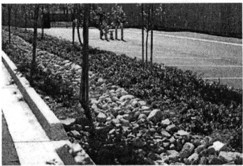
- Fences, walls, and screening. The following are standards and guidelines for fences, walls, and screening.

Table 30-655.D
Standards for Fences, Walls and Screening

Location | Materials | Maximum Height
Within front setback area | Solid wall | 42 inches
Within front setback area | Wrought iron or tubular steel | 6 ft.
Within street side setback area | Solid wall | 8 ft.
Within interior side setback area | Solid wall | 8 ft.
Within rear setback area | Solid wall | 8 ft.
Screening of incidental outdoor storage from view of the public right-of-way | Solid wall | 8 ft.
Notes:
- All fences and walls shall be finished with decorative material (e.g., stucco, split-face, and or slump stone) when visible from the public right-of-way.
- All fences and walls shall not interfere with or obstruct the line-of-sight for motorists.
- Screening walls must meet the design standards of Section (n)(3)(a).

  - Fences and walls.
    - Walls and fencing materials shall consist of wrought iron, tubular steel, stone, stucco, or brick, and shall be compatible with the overall design character/style of the development. The use of chain-link fence and similar materials is prohibited.
    - Walls and fences shall be integrated with landscaping along the base of the wall or fence.

    - Wall heights and surfaces shall be articulated with varying facade depths or pilasters to promote architectural interest, and shall include a cap along the top of the wall.
    - Landscaping shall be used in combination with walls and fences to visually soften blank surfaces and to deter graffiti. Additionally, all walls shall have an anti-graffiti coating to further deter graffiti, to the satisfaction of the City. See Figure 2.
Figure 2
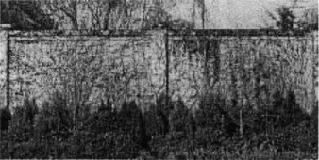
- Landscaping. Those standards and guidelines not fully addressed in this section shall be as otherwise stated in the appropriate section(s) of the Fontana Municipal Code, including, but not limited to, Section 30-664 et seq., of this Code.
  - Landscaping shall be used alone or in conjunction with other features (e.g. open space buffer, topography) to reduce potential visual and light and glare conflicts.
  - Landscape setbacks along public rights-of-way shall incorporate landscape buffers with undulating and variable height earth-mounding (berms), and/or low walls, preferably in a three-tier planting design.
  - Landscaping shall be in scale with adjacent structures, streets, and public spaces, and be sized appropriately when fully grown.
  - Landscaped areas should incorporate a three-tiered planting system:
    - Ground cover and flowering plants;
    - Shrubs and vines; and,
    - Trees.
- Site design.
  - Courtyards and plazas.
    - Buildings should be arranged to create opportunities for open space amenities (e.g., plazas, courtyards, outdoor eating areas, etc.).
  - Building orientation.
    - The organization of buildings, parking areas, and landscaping shall recognize the existing characteristics of the site and shall relate to the surrounding development in scale and character.
    - Buildings should be oriented in a manner that takes advantage of passive solar design.

    - Buildings shall be oriented to provide a buffer between sensitive uses (i.e. residential, schools, and parks).
  - Site elements.
    - Screening.
      - Loading areas shall be completely screened from public right-of-way(s) by building placement and/or decorative walls. Landscaping may be used in addition to such building placement and/or walls, but shall not be the sole means of screening. A sight-line analysis shall be taken from public right-of-way(s) to indicate screening of all items.
      - Trash storage enclosures and outdoor mechanical equipment shall be completely screened from public view.
      - Roof-mounted and ground-mounted mechanical equipment utilities, storage, and storage areas shall be screened from public right-of-way by a visual barrier (e.g., wall, fence, landscape material, parapet walls etc.) or other approved screening devices. Special consideration shall be given to the screening of roof-mounted equipment on building rooftops that are visible from the public right-of-way. See Figure 3.
Figure 3
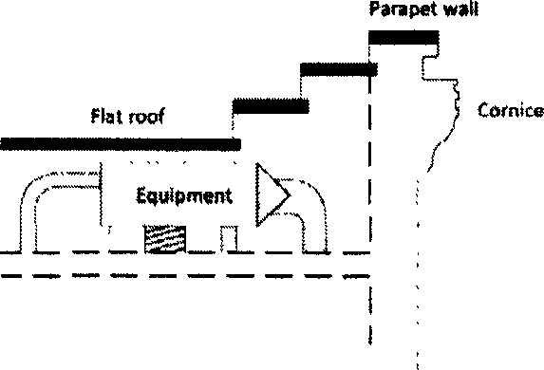
  - Lighting.
    - Outdoor lighting plans shall take into consideration the location and potential growth pattern of nearby trees (existing and planned) so that appropriate lighting levels are maintained over time.
    - Energy efficiency shall be considered through use of proper light location and placement, as well as use of energy-efficient bulbs and/or fixtures.
    - Lighting fixtures shall include hoods or other design techniques to reduce glare and light pollution, especially along major streets, and to prevent light spillover onto adjacent properties.
    - Lighting shall be provided in project entryways, walkways, and parking lots to promote safety.
    - Lighting may be mounted on poles or bollards, affixed to building walls, or placed within paved or landscaped areas. Appropriate materials and

construction methods shall be used to ensure proper function of project lighting fixtures.
    - Decorative light fixtures shall be consistent with the architectural design of the building.
  - Architecture.
    - Mass and scale.
      - The mass and scale of the buildings shall respect the visual and physical relationship to the adjacent buildings and surrounding sensitive uses. Taller building elements shall be placed towards the center of the site, with lower elements adjacent to surrounding properties.
      - Buildings shall be stepped back when adjacent to or in close proximity to sensitive uses (e.g. residential, schools, etc.).
      - Vertical and horizontal offsets shall be provided to reduce the visual bulk of the building.
    - Building facades.
      - Building facades shall incorporate architectural elements such as windows, pillars, and wall plane breaks to minimize blank walls, to create visual interest, and to reduce the opportunity for graffiti.
      - All building elevations, whether front, side, or rear shall be architecturally detailed.
      - Architectural accents (e.g., cornices, tiles, trim around windows, grooves in building faces, accent band details, bulkheads, etc.) shall be used to create variation along building facades.
      - Roofs shall be designed as an integral component of building form, mass, and facade. Building form shall be enhanced by sloped or offset roof planes, eave heights, and rooflines.

