ORDINANCE NO. _____

AN ORDINANCE OF THE CITY COUNCIL OF THE CITY OF FONTANA, CALIFORNIA, APPROVING FONTANA MUNICIPAL Code Amendment No. 24-003 to amend MULTIPLE SECTIONS OF CHAPTER 30, ZONING AND DEVELOPMENT CODE, INCLUDING AMENDMENTS TO SECTION 30-491 TO FOR DRIVE-THRU RESTAURANTS; SECTIONS 30-361 THROUGH 30-363 AND 30-366 THROUGH 30-370 FOR SETBACKS FOR CIVIC BUILDINGS; SECTION 30-371.2 FOR BUILDING HEIGHTS IN CONNECTION WITH ROOFTOP AMENITIES IN THE SIERRA CORE DISTRICT OF THE FORM BASED CODE; SECTION 30-372 FOR MAXIMUM BUILDING LENGTH FOR DUPLEX AND MULTIPLEX BUILDING TYPES IN THE FORM BASED CODE; SECTION 30-374 FOR LANGUAGE RELATED TO GROUND FLOOR ENTRIES FOR ROWHOUSES IN THE FORM BASED CODE; SECTION 30-381 TO MODIFY THE LANGUAGE RELATED TO PORCH FRONTAGE TYPES; AND SECTION 30-404.1 TO REMOVE MINIMUM BARBEQUE FACILITIES REQUIREMENTS FROM THE DOWNTOWN CORE, PURSUANT TO A CATEGORICAL EXEMPTION IN ACCORDANCE WITH CEQA GUIDELINES SECTIONS 15060(C), 15061(B)(3), AND SECTION 15378.

WHEREAS, pursuant to Government Code section 37100, the legislative body of a city may pass ordinances not in conflict with the Constitution and laws of the State or the United States; and

WHEREAS, Government Code sections 50022.1 to 50022.10 authorizes a city to codify and recodify its ordinances; and

WHEREAS, the City of Fontana (“City”) desires to restate without substantive revision, amend and recodify certain ordinances codified in the Fontana Municipal Code (“Code”); and

WHEREAS, the General Plan includes policies and actions calling for numerous updates to the Code; and

WHEREAS, Section 30-491. – Special Use Regulations*. Is amended to modify the requirements for queuing, screening, seating, and design for drive-thru restaurants; and

WHEREAS, Section 30-361. – Civic district. is amended to allow the Fontana Planning Commission (“Planning Commission”) to modify building setbacks for civic buildings; and

WHEREAS, Section 30-362. – Station area district. is amended to allow the Planning Commission to modify building setbacks for civic buildings; and

WHEREAS, Section 30-363. – Downtown gateway district. is amended to allow the Planning Commission to modify building setbacks for civic buildings; and

WHEREAS, Section 30-366. – Transitional district. is amended to allow the Planning Commission to modify building setbacks for civic buildings; and

WHEREAS, Section 30-367. – Sierra gateway district. is amended to allow the Planning Commission to modify building setbacks for civic buildings; and

WHEREAS, Section 30-368. – Route 66 gateway district. is amended to allow the Planning Commission to modify building setbacks for civic buildings; and

WHEREAS, Section 30-369. – Valley gateway district. is amended to allow the Planning Commission to modify building setbacks for civic buildings; and

WHEREAS, Section 30-370. – Village gateway district. is amended to allow the Planning Commission to modify building setbacks for civic buildings; and

WHEREAS, Section 30-371.2. – Sierra core. is amended to allow certain height increases in association with rooftop amenities; and

WHEREAS, Section 30-372. – Duplex, multiplex. is amended to increase the maximum building length for duplex and multiplex building types in the Form Based Code; and

WHEREAS, Section 30-374. – Rowhouse. is amended to allow above grade ground floors for Rowhouse building types; and

WHEREAS, Section 30-381. – Porch. is amended to clarify the definition of covered porch; and

WHEREAS, Section 30-404.1. – Downtown Core. is amended to remove the minimum number of barbecue facilities to be provided for a multi-family project; and

WHEREAS, State law requires zoning regulations to be consistent with the General Plan and therefore updating the Municipal Code would contribute to consistency with the General Plan; and

WHEREAS, a notice of the public hearing was published in the local newspaper on Saturday, June 28, 2024, and simultaneously displayed at City Hall; and

WHEREAS, on June 18, 2024, the Planning Commission held a public meeting on amendments to sections 30-491, 30-361 through 30-363, 30-366 through 30-370, 30-371.2, 30-372, 30-374, 30-381, and 30-404.1, (together “MCA No. 24-003”) where they received evidence and public testimony on the amendments and staff recommendations to find that the amendments promote the goals of the City’s General Plan and recommend that the Fontana City Council (“City Council”) adopt such amendments and determine that the amendments qualify for a categorical exemption pursuant to the California Environmental Quality Act (CEQA) Guidelines Sections 15060(c), 15061(B)(3) (the common-sense exemption), and Sections No. 3.01, 3.22, and 10.59 of the 2019 Local Guidelines for Implementing CEQA. This Ordinance is nonetheless exempt from the requirements of CEQA in that the activity is covered by the general rule that CEQA applies only to projects which have the potential for causing a significant effect on the environment. Where it can be with certainty that there is no possibility that the activity in question may have a significant effect on the environment, the activity is not subject to CEQA; and

WHEREAS, the Planning Commission carefully considered all evidence and testimony presented at its public hearing on June 18, 2024, found that the amendments promote the goals of the City’s General Plan and recommended that the City Council approve the modifications to the Zoning and Development Code; and

WHEREAS, the amendments in MCA No. 24-003 are consistent and compatible with the General Plan and are in line with goals, policies and objectives of the City; the Housing Element policies and the Zoning and Development Code; and

WHEREAS, the amendments in MCA No. 24-003 will be in conformity with appropriate land use practices and will establish appropriate development standards for the land use designations; and

WHEREAS, the amendments in MCA No. 24-003 are attached here to as Exhibit “A” and incorporated herein by reference, will not be detrimental to the public health, safety and general welfare, nor will it adversely affect the orderly development of property; and

WHEREAS, the amendments in MCA No. 24-003 will better express the City’s policies and will generally promote good land use planning and regulation; and

WHEREAS, On June 28, 2024, the Fontana Planning Department published notice of the public hearing in the local newspaper; and

WHEREAS, on July 9, 2024, the City Council held a public meeting on MCA No. 24-003 where City Council received evidence and public testimony pertaining to the Zoning and Development Code amendments; and

WHEREAS, the City Council carefully considered all information pertaining to MCA No. 24-003 that was presented at its public hearing on July 9, 2024; and

WHEREAS, all other legal prerequisites to the adoption of this Ordinance have occurred.
NOW, THEREFORE, THE CITY COUNCIL OF THE CITY OF FONTANA, CALIFORNIA, DOES ORDAIN AS FOLLOWS:

SECTION 1. Recitals. The recitals are true, correct and incorporated herein by this reference.

SECTION 2. CEQA. The City Council hereby determines that this project qualifies for a categorical exemption pursuant to CEQA Guidelines Sections 15060(c), 15061(B)(3) (the common-sense exemption), and 15378 and Sections No. 3.01, 3.22, and 10.59 of the 2019 Local Guidelines for Implementing CEQA, that this Ordinance is nonetheless exempt from the requirements of CEQA in that the activity is covered by the general rule that CEQA applies only to projects which have the potential for causing a significant effect on the environment. Where it can be seen with certainty that there is no possibility that the activity in question may have a significant effect on the environment, the activity is not subject to CEQA. Therefore, a Notice of Exemption is to be filed.

SECTION 3. Development Code Amendment Findings. The City Council hereby makes the following findings for Municipal Code Amendment No. 24-003 accordance with Section 30-40 “Purpose” of the Fontana Zoning and Development Code:

Finding: A Zoning and Development Code may be amended by changing the development standards (text) or zoning designation map boundaries of any zone whenever such an amendment is deemed necessary to protect or promote the public's health, safety or general welfare or when modification is viewed as appropriate in the context of generally accepted planning principles, surrounding land uses, and the General Plan.

Findings of Fact: The City initiated the Code amendment to amend Chapter 30 to modify multiple sections to provide clarity, eliminate inconsistencies, streamline City processes, and improve the implementation of the Code which is beneficial to the community to promote public welfare and furthers good planning principals and the General Plan. Additionally, the amendments will provide flexibility to various development standards which will allow for various housing developments and promote the public’s health and safety or general welfare.

SECTION 4. Development Code Amendment Approval. Based on the foregoing, the City Council hereby approves the amendments as set forth in MCA No. 24-003, which is attached hereto as Exhibit “A” and incorporated herein by reference as fully set forth herein.

SECTION 5. Effective Date/Publication. This Ordinance shall take effect thirty (30) days after the date of the adoption and prior to the expiration of fifteen (15) days from the passage thereof, shall be published by the City Clerk at least once in the Fontana Herald News, a local newspaper of the general circulation, published and circulated in the City of Fontana, and henceforth and thereafter the same shall be in full force and effect.

SECTION 6. Custodian of Records. The documents and materials that constitute the record of proceedings on which this Ordinance is based are located at the City Clerk’s office located at 8353 Sierra Avenue, Fontana, CA 92335. The custodian or records is the City Clerk.

Section 7. Certification. The City Clerk of the City Council shall certify to the adoption of this Ordinance.

SECTION 8. Severability. If any provision of this Ordinance or the application of any such provision to any person or circumstance is held invalid, such invalidity shall not affect other provisions or applications of this Ordinance that can be given effect without the invalid provision or application.

APPROVED AND ADOPTED this 9th day of July 2024.

READ AND APPROVED AS TO LEGAL FORM:

_________________________________________
City Attorney

I, Germaine Key, City Clerk of the City of Fontana, and Ex-Officio Clerk of the City Council, do hereby certify that the foregoing Ordinance is the actual Ordinance adopted by the City Council and was introduced at a regular meeting on the 9th day of July 2024, and was finally passed and adopted not less than five days thereafter on the 23rd day of July 2024, by the following vote to wit:

AYES:
NOES:
ABSENT:

_________________________________________
City Clerk of the City of Fontana

_________________________________________
Mayor of the City of Fontana

ATTEST:

_________________________________________
City Clerk

“Exhibit A”

AmendmENT to FONTANA MUNICIPAL CODE CHAPTER 30
(*Additions shown in underline, deletions shown in strikeout)

ARTICLE VI. – COMMERCIAL AND MIXED-USE ZONING DISTRICTS
DIVISION 3. – USE REGULATIONS
Sec. 30-491. Special use regulations *.
This section establishes special regulations for certain permitted uses marked with an asterisk (*) in Table No. 30-489. The specified use is permitted provided that the use conforms to the following regulations:
(1) Construction trailers. Trailers used for construction offices or watchman's quarters are permitted at a construction site with the approval of a temporary use permit as required in Article II provided:
a. Trailers are located on the same or adjacent premises as the construction site.
b. Trailers are used only during the period of construction. All trailers shall be removed prior to final project inspection.
c. Not more than one person per shift resides in the trailer if used for watchman's quarters.
d. Shall comply with provision set forth for temporary uses as defined in Article II.
(2) Restaurant, drive-thru.
a. A minimum stacking distance of 132 feet shall be provided from the forward most drive-up window to the entrance of the stacking space. The stacking space shall be located completely clear of any adjacent public right-of-way and all circulation aisles provided on the site. Drive-thru aisle shall have a minimum 12-foot-wide driveway.
b. The menu board shall be enhanced, landscaped and located to provide a minimum distance of 40 feet from the menu board to the entrance to the stacking space.
c. The drive-thru lane and parking areas visible from a public street shall be screened from view by decorative screening devices that will be integrated into the overall landscape design. Such screening devices may include planters, berming, landscaping, or other screening acceptable to the Director of Community Development.
d. A drive-thru lane is not permitted adjacent to a parcel zoned for a residential use.
e. Exterior doors on any children's play area shall be for emergency exit only.
f. Outdoor dining/seating is permitted provided the parking standards of Table 30-314.A are met.
g. All new drive-thru restaurants shall have a solid decorative porte chochere above the drive-thru window. Existing drive-thru restaurants requesting modifications shall construct a porte chochere when sufficient space allows.
- A drive-through restaurant applicant shall provide a queuing study and plan for the business’s high volume periods, such as its grand opening. The applicant shall not queue any less than 15 vehicles.

- The required queue area on site shall be measured from the forwardmost drive-up window to the entrance of the stacking space. The stacking space shall be located completely clear of any adjacent public right-of-way and all circulation aisles provided on site.

- The queue area shall accommodate the morning or afternoon peak hour queue length for the facility. The peak queue length shall hold 25% of all vehicles arriving during the morning or afternoon peak hour, whichever time provides the highest stream of traffic. The peak queue length shall be calculated using a queuing study, provided by the applicant's engineer, based on the anticipated peak hour traffic counts from three similar sized restaurants, with similar operational profiles, from the same franchise, located near the project site, with similar land use, operation and building size. Twenty (20) feet shall be allocated for each queued vehicle.

- The drive-thru lane and associated parking area(s) visible from a public street shall be screened from view by a landscape berm. If berming is physically impossible, a decorative wall with caps and pilasters shall be provided or a decorative wall with caps, pilasters, and trellis work shall be provided. Additionally, a three-foot landscape hedge at the time of planting shall be provided in front of the wall for either scenario.

- A drive-thru lane located adjacent to a parcel zoned for residential use is not permitted.

- A line of sight from the public right of way shall be provided for a project that includes a drive-thru lane to demonstrate the screening devices used to screen the drive-thru lane and associated parking area(s).

- The menu board shall be enhanced, landscaped, and located at a minimum distance of 40 feet from the menu board to the entrance to the stacking space.

- Exterior doors on any children's play area shall be for emergency exit only.

- Indoor or outdoor dining/seating is required. The proposed number of indoor or outdoor seats must be approved by the Director of Planning. Outdoor seating areas shall be designed to be consistent with the architectural style of the drive-thru restaurant, shall be located near the main pedestrian entrance and shall include tables with seating, a trash receptacle, a low fencing enclosure, and a protective structure over the entire area.

- The outdoor dining area may include a plaza, arcade, colonnades, or courtyard design.

- All new drive-thru restaurants shall have a solid decorative porte cochere above the drive-thru window(s). Existing drive-thru restaurants may construct a porte cochere when sufficient space allows. The porte-cochere may encroach into the required setback and right-of-way up to a maximum of two feet.

- Building entrances shall be oriented toward the street with drive-thru lanes, pick-up window, and off-street parking facilities oriented towards the rear or side yard areas to the extent feasible. Pick-up windows shall be located near the outdoor dining area to encourage walkability.

- Architectural treatment shall include a variety of roof lines and wall projections on all elevations of the building. The architecture of the drive-through restaurant shall be compatible with the surrounding uses in form, materials, colors, scale, design, etc.

[Remaining text of Section 30-491(2) will remain, unmodified]

Sec. 30-361. Civic district.
The civic district consists primarily of civic and institutional uses and active and passive recreation areas.
Setback |  | Building setback from PL
 |  | Front |  | Side/Rear
 |  | Min. (ft.) | Max. (ft) | Min. (ft.)
i. | Front Street | 5 | 25* | —
ii. | Side Street | 0 | 15* | —
iii. | Side (Interior) | — | — | 10
iv. | Rear yard | — | — | 10

* Required setbacks for civic buildings may be modified with Planning Commission approval.

Allowed  Building Types | Min |  | Max.
Allowed  Building Types | Stories/ft. | Lot W/D | Stories/ft. | Lot W/D
Flex | 1/18 | 25/75 | 4/55 | —
Liner | 1/18 | 75/75 | 4/55 | —
Frontage Coverage |  |  | 50% minimum
Story Height
Ground Floor |  | Upper Stories
Min. Height | 12 ft. | Minimum Height |  | 10 ft.

W = Building lot width along primary frontage; D = Building lot depth perpendicular to primary frontage.
Required Parking
Non-Residential Uses | 65% of cumulative parking requirements per FMC
Parking Placement: On-site above-ground parking and access shall be located in compliance with the following requirements:
Setback
Front street | Min. 20 ft.
Side street | Min. 5 ft.
Side interior | 0 ft.
Rear property/rear alley | 0 ft./min. ft.

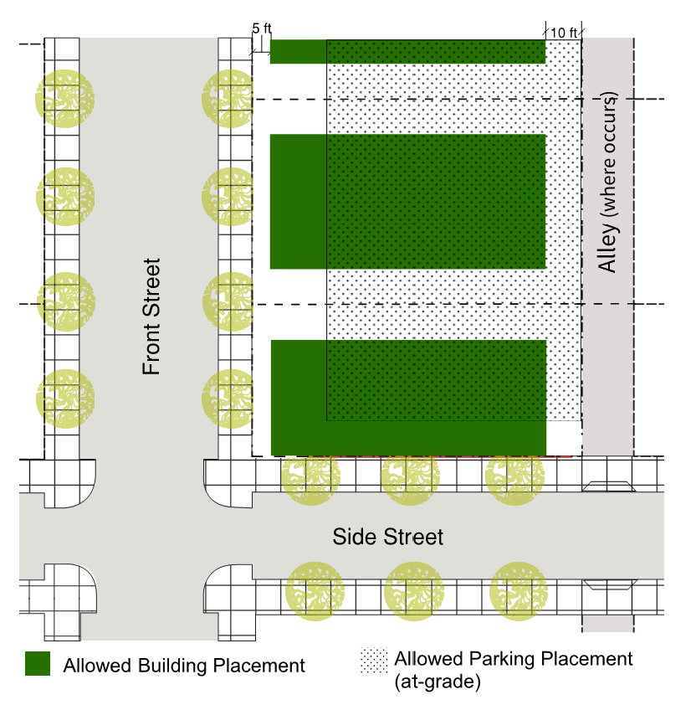
Frontage Types
• Forecourt
• Arcade
• Gallery
Encroachments: Buildings, architectural features, and signs may encroach into the required setbacks and right-of-way subject to the following requirements:
Description | Encroachment
Description | Horizontal |  |  |  | Vertical
Description | Front | St. Side | Rear | Side | min. 8 ft. clear
Arcade, gallery, awning | min. 2 ft. clear of curb |  | min. 5 ft. from PL | N/A | min. 8 ft. clear
Balcony | 4 ft. max. |  | min. 5 ft. from PL | min. 5 ft. from PL | min. 8 ft. clear
Bay window | 4 ft. max. on upper floors only |  | min. 5 ft. from PL | min. 5 ft. from PL | min. 8 ft. clear
Eave | min. 2 ft. clear of curb |  | min. 3 ft. from PL | min. 3 ft. from PL | min. 8 ft. clear

Sec. 30-362. Station area district.
The station area district includes the Metrolink station and Omnitrans bus terminal as the primary anchors. This area provides a transition between the retail district, the south Sierra gateway district and Chaffey College.
Residential or  Mixed-Use Density |  |  | Minimum |  | Maximum
 |  |  | 15 units/acre |  | 39 units/acre
Commercial  Floor Area Ratio  (without a residential component) |  |  | — |  | 2.0
Setback |  |  | Building setback from PL
 |  |  | Front |  | Side/Rear
 |  |  | Min. (ft.) | Max. (ft) | Min. (ft.)
i. | Front Street |  | 0 | 10 * | —
ii. | Side Street |  | 0 | 10 * | —
iii. | Side (Interior) |  | — | — | 0
iv. | Rear yard |  | — | — | 5
 |  | rail-  adjacent | — | — | 10

* Required setbacks for civic buildings may be modified with Planning Commission approval.

Allowed  Building Types | Min |  | Max.
Allowed  Building Types | Stories/ft. | Lot W/D | Stories/ft. | Lot W/D
Court | 1/18 | 100/100 | 4/55 | 150/150
Flex | 2/30 | 25/100 | 4/55 | 400/150
Hybrid | 2/30 | 150/160 | 4/55 | 400/150
Liner | 2/30 | 100/100 | 4/55 | 200/150
Live/Work | 2/24 | 75/80 | 3/40 | 150/150
Frontage Coverage |  |  | 50% minimum
Story Height
Ground Floor |  | Upper Stories
Min. Height | 12 ft. | Minimum Height |  | 10 ft.

W = Building lot width along primary frontage; D = Building lot depth perpendicular to primary frontage.
Required Parking
Residential Uses | Studio or 1 bedroom | 1 space per unit
Residential Uses | 2+ bedroom | 1.5 spaces per unit
Non-Residential Uses | No Parking Required
Parking Placement: On-site above-ground parking and access shall be located in compliance with the following requirements:
Setback
Front Street | Min. 20 ft.
Side Street | Min. 5 ft.
Side interior | 0 ft.
Rear property/rear alley | 0 ft./min. ft.

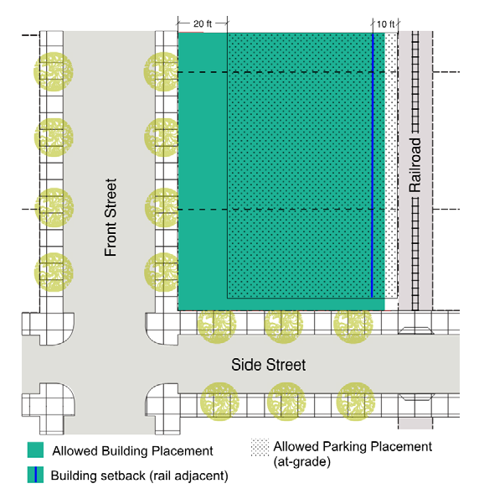
Frontage Types
• Forecourt
• Shopfront
• Arcade
• Gallery
• Stoop
Encroachments: Buildings, architectural features, and signs may encroach into the required setbacks and right-of-way subject to the following requirements:
Description | Encroachment
Description | Horizontal |  |  |  | Vertical
Description | Front | St. Side | Rear | Side | min. 8 ft. clear
Arcade, gallery, awning | min. 2 ft. clear of curb |  | min. 5 ft. from PL | N/A | min. 8 ft. clear
Balcony | 4 ft. max. |  | min. 5 ft. from PL | min. 5 ft. from PL | min. 8 ft. clear
Bay window | 4 ft. max. on upper floors only |  | min. 5 ft. from PL | min. 5 ft. from PL | min. 8 ft. clear
Eave | min. 2 ft. clear of curb |  | min. 3 ft. from PL | min. 3 ft. from PL | min. 8 ft. clear

Sec. 30-363. Downtown gateway district.
The downtown gateway district is primarily intended for commercial retail and personal service uses. New development should incorporate pedestrian elements to help serve as a transition to surrounding land uses.
Residential or  Mixed-Use Density |  | Minimum |  | Maximum
 |  | 15 units/acre |  | 39 units/acre
Commercial  Floor Area Ratio  (without a residential component) |  | — |  | 2.0
Setback |  | Building setback from PL
 |  | Front |  | Side/Rear
 |  | Min. (ft.) | Max. (ft) | Min. (ft.)
i. | Front Street | 5 | 35 * | —
ii. | Side Street | 5 | 20 * | —
iii. | Side (Interior) | — | — | 0
iv. | Rear yard | — | — | 15

* Required setbacks for civic buildings may be modified with Planning Commission approval.

Allowed  Building Types | Min |  | Max.
Allowed  Building Types | Stories/ft. | Lot W/D | Stories/ft. | Lot W/D
Flex | 2/30 | 25/100 | 5/70 | 400/150
Hybrid | 3/40 | 150/160 | 5/70 | 400/150
Liner | 1/24 | 100/100 | 5/70 | 200/150
Live/Work | 1/24 | 75/80 | 3/40 | 150/150
Court | 2/24 | 100/100 | 5/70 | 150/150
Frontage Coverage |  |  | 50% minimum
Story Height
Ground Floor |  | Upper Stories
Min. Height | 12 ft. | Minimum Height |  | 10 ft.

W = Building lot width along primary frontage; D = Building lot depth perpendicular to primary frontage.
Required Parking
Residential Uses | Studio or 1 bedroom | 1 space per unit
Residential Uses | 2+ bedroom | 1.5 spaces per unit
Non-Residential Uses | No parking required
Parking Placement: On-site above-ground parking and access shall be located in compliance with the following requirements:
Setback
Front Street | Min. 20 ft.
Side Street | Min. 5 ft.
Side interior | 5 ft.
Rear property/rear alley | 0 ft./min. ft.

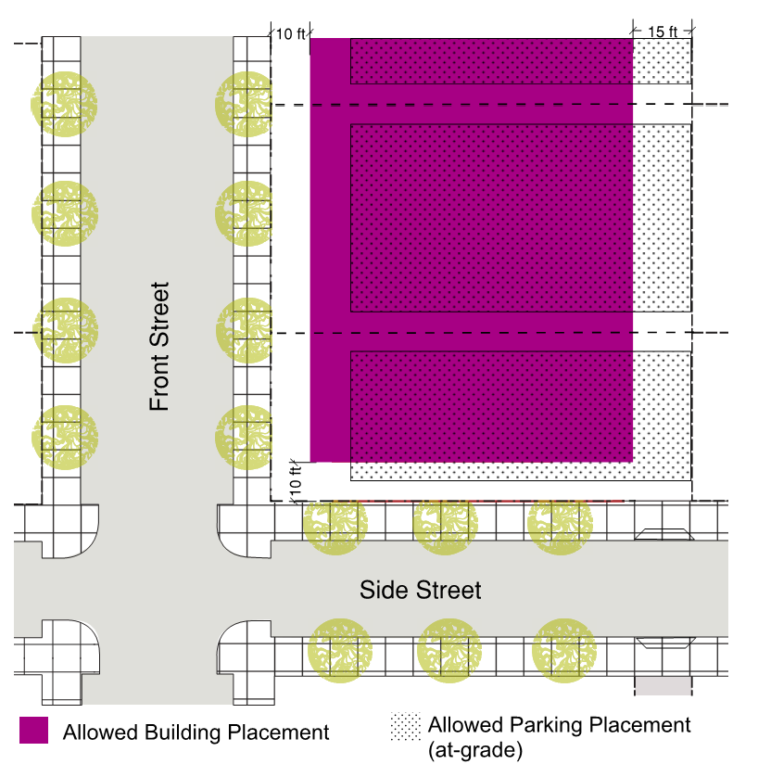
Frontage Types
• Forecourt
• Lightcourt
• Shopfront
• Arcade
• Gallery
• Stoop
Encroachments: Buildings, architectural features, and signs may encroach into the required setbacks and right-of-way subject to the following requirements:
Description | Encroachment
Description | Horizontal |  |  |  | Vertical
Description | Front | St. Side | Rear | Side | min. 8 ft. clear
Arcade, gallery, awning | min. 2 ft. clear of curb |  | min. 5 ft. from PL | N/A | min. 8 ft. clear
Balcony | 4 ft. max. |  | min. 5 ft. from PL | min. 5 ft. from PL | min. 8 ft. clear
Bay window | 4 ft. max. on upper floors only |  | min. 5 ft. from PL | min. 5 ft. from PL | min. 8 ft. clear
Eave | min. 2 ft. clear of curb |  | min. 3 ft. from PL | min. 3 ft. from PL | min. 8 ft. clear

Sec. 30-366. Transitional district.
The transitional district is adjacent to more intense commercial uses providing a transition to more sensitive uses, such as residential. This district includes a mixture of commercial office, retail, personal services, and residential.
Multi-Family or Mixed-Use Density |  | Minimum |  | Maximum
 |  | 12 units/acre |  | 39 units/acre
Detached Single-Family Density |  | 3 units/acre |  | 12 units/acre
Commercial Floor Area Ratio |  | — |  | 2.0
Setback |  | Building setback from PL
 |  | Front |  | Side/Rear
 |  | Min. (ft.) | Max. (ft) | Min. (ft.)
i. | Front Street | 10 | 30 * | —
ii. | Side Street | 10 | 15 * | —
iii. | Side (Interior) | — | — | 5
iv. | Rear yard | — | — | 20

* Required setbacks for civic buildings may be modified with Planning Commission approval.

Allowed  Building Types | Min |  | Max.
Allowed  Building Types | Stories/ft. | Lot W/D | Stories/ft. | Lot W/D
Court | 2/30 | 100/100 | 3/40 | 150/150
Live/Work | 1/18 | 75/80 | 3/40 | 150/150
Rowhouse | 1/18 | 125/125 | 3/40 | 125/150
Rosewalk & Bungalow Court | 1/18 | 75/100 | 3/40 | 150/150
Duplex, Multiplex | 1/18 | 50/100 | 3/40 | 75/100
Single Family | 1/18 | 50/100 | 3/40 | —
Frontage Coverage |  |  | 50% minimum
Story Height
Ground Floor |  | Upper Stories
Min. Height | 12 ft. | Minimum Height |  | 10 ft.

W = Building lot width along primary frontage; D = Building lot depth perpendicular to primary frontage.
Required Parking
Residential Uses | Studio or 1 bedroom | 1 space per unit
Residential Uses | 2+ bedrooms | 1.5 spaces per unit
Non-Residential Uses | 65% of cumulative parking requirements per FMC (no parking required in downtown)
Parking Placement: On-site above-ground parking and access shall be located in compliance with the following requirements:
Setback
Front Street | Min. 30 ft.
Side Street | Min. 10 ft.
Side interior | 5 ft.
Rear property/rear alley | Min. 5 ft.

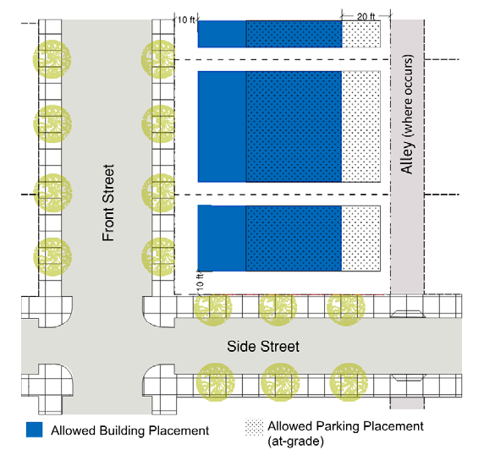
Frontage Types
• Forecourt
• Stoop
• Porch
• Shopfront
• Dooryard
Encroachments: Buildings, architectural features, and signs may encroach into the required setbacks and right-of-way subject to the following requirements:
Description | Encroachment
Description | Horizontal |  |  |  | Vertical
Description | Front | St. Side | Rear | Side | min. 8 ft. clear
Arcade, gallery, awning | min. 2 ft. clear of curb |  | min. 5 ft. from PL | N/A | min. 8 ft. clear
Balcony | 4 ft. max. |  | min. 5 ft. from PL | min. 5 ft. from PL | min. 8 ft. clear
Bay window | 4 ft. max. on upper floors only |  | min. 5 ft. from PL | min. 5 ft. from PL | min. 8 ft. clear
Eave | min. 2 ft. clear of curb |  | min. 3 ft. from PL | min. 3 ft. from PL | min. 8 ft. clear

Sec. 30-367. Sierra gateway district.
The Sierra gateway district is intended to encourage pedestrian-oriented development and land uses. Uses are to include a mix of medium- to high-density residential, retail and services, office, entertainment, education, and open space.
Residential or Mixed-Use Density |  | Minimum |  | Maximum
 |  | 18 units/acre |  | 39 units/acre
Commercial Floor Area Ratio (without residential component) |  | — |  | 2
Setback |  | Building setback from PL
 |  | Front |  | Side/Rear
 |  | Min. (ft.) | Max. (ft) | Min. (ft.)
i. | Front Street | 0 | 10 * | —
ii. | Side Street | 0 | 10 * | —
iii. | Side (Interior) | — | — | 0
iv. | Rear yard | — | — | 5

* Required setbacks for civic buildings may be modified with Planning Commission approval.

Allowed  Building Types | Min |  | Max.
Allowed  Building Types | Stories/ft. | Lot W/D | Stories/ft. | Lot W/D
Flex | 1/30 | 25/100 | 4/60 | 400/150
Hybrid | 3/40 | 150/160 | 5/70 | 400/150
Liner | 1/24 | 100/100 | 5/70 | 200/150
Live/Work | 1/24 | 75/80 | 3/40 | 150/150
Rowhouse | 2/24 | 75/80 | 3/40 | 150/150
Frontage Coverage |  |  | 50% minimum
 |  |  | When the development project is 5 acres or more in size and does not include any residential uses, frontage coverage can be reduced to 25% at the discretion of the Planning Commission if it can be determined that the reduced frontage benefits public safety.
Story Height
Ground Floor |  | Upper Stories
Min. Height | 12 ft. | Minimum Height |  | 10 ft.

W = Building lot width along primary frontage; D = Building lot depth perpendicular to primary frontage.
Required Parking
Residential Uses | Studio or 1 bedroom | 1 space per unit
Residential Uses | 2+ bedrooms | 1.5 spaces per unit
Non-Residential Uses | 65% of cumulative parking requirements per FMC
Parking Placement: On-site above-ground parking and access shall be located in compliance with the following requirements:
Setback
Front Street | Min. 20 ft.
Side Street | Min. 5 ft.
Side interior | 0 ft.
Rear property/rear alley | 0 ft./min. ft.

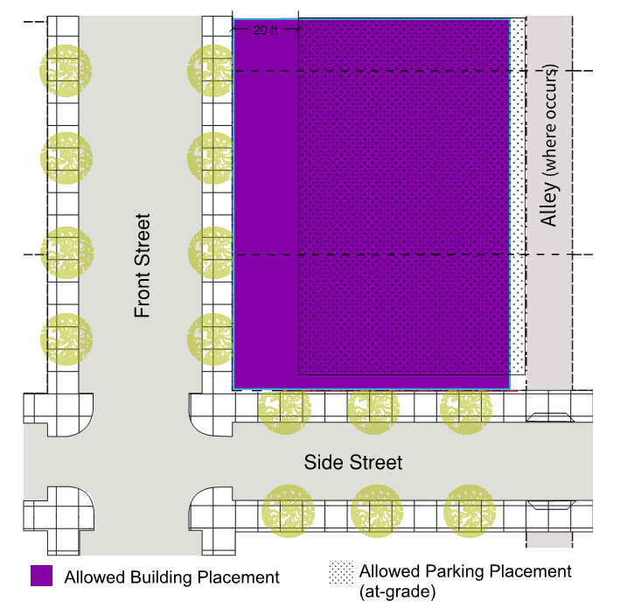
Frontage Types
• Forecourt
• Storefront
• Arcade
• Gallery
• Stoop
Encroachments: Buildings, architectural features, and signs may encroach into the required setbacks and right-of-way subject to the following requirements:
Description | Encroachment
Description | Horizontal |  |  |  | Vertical
Description | Front | St. Side | Rear | Side | min. 8 ft. clear
Arcade, gallery, awning | min. 2 ft. clear of curb |  | min. 5 ft. from PL | N/A | min. 8 ft. clear
Balcony | 4 ft. max. |  | min. 5 ft. from PL | min. 5 ft. from PL | min. 8 ft. clear
Bay window | 4 ft. max. on upper floors only |  | min. 5 ft. from PL | min. 5 ft. from PL | min. 8 ft. clear
Eave | min. 2 ft. clear of curb |  | min. 3 ft. from PL | min. 3 ft. from PL | min. 8 ft. clear

Sec. 30-368. Route 66 gateway district.
The Route 66 gateway district is primarily intended for commercial retail and personal service uses with incorporated automobile uses that have traditionally been located along the corridor.
Residential or Mixed-Use Density |  | Minimum |  | Maximum
 |  | 18 units/acre |  | 39 units/acre
Commercial Floor Area Ratio (without a residential component) |  | — |  | 2.0
Setback |  | Building setback from PL
 |  | Front |  | Side/Rear
 |  | Min. (ft.) | Max. (ft) | Min. (ft.)
i. | Front Street | 0 | 10 * | —
ii. | Side Street | 0 | 10 * | —
iii. | Side (Interior) | — | — | 0
iv. | Rear yard | — | — | 5

* Required setbacks for civic buildings may be modified with Planning Commission approval.

Allowed  Building Types | Min |  | Max.
Allowed  Building Types | Stories/ft. | Lot W/D | Stories/ft. | Lot W/D
Flex | 1/30 | 25/100 | 4/60 | 400/150
Hybrid | 3/40 | 150/160 | 5/70 | 400/150
Liner | 1/24 | 100/100 | 5/70 | 200/150
Live/Work | 1/24 | 75/80 | 3/40 | 150/150
Rowhouse | 2/24 | 75/80 | 3/40 | 150/150
Frontage Coverage |  |  | 50% minimum
Story Height
Ground Floor |  | Upper Stories
Min. Height | 12 ft. | Minimum Height |  | 10 ft.

W = Building lot width along primary frontage; D = Building lot depth perpendicular to primary frontage.
Hotels may be allowed to a maximum of seven stories and 90 feet in height.
Required Parking
Residential Uses | Studio or 1 bedroom | 1 space per unit
Residential Uses | 2+ bedrooms | 1.5 spaces per unit
Non-Residential Uses | 65% of cumulative parking requirements per FMC
Parking Placement: On-site above-ground parking and access shall be located in compliance with the following requirements:
Setback
Front Street | Min. 20 ft.
Side Street | Min. 5 ft.
Side interior | 0 ft.
Rear property/rear alley | 0 ft./min. ft.

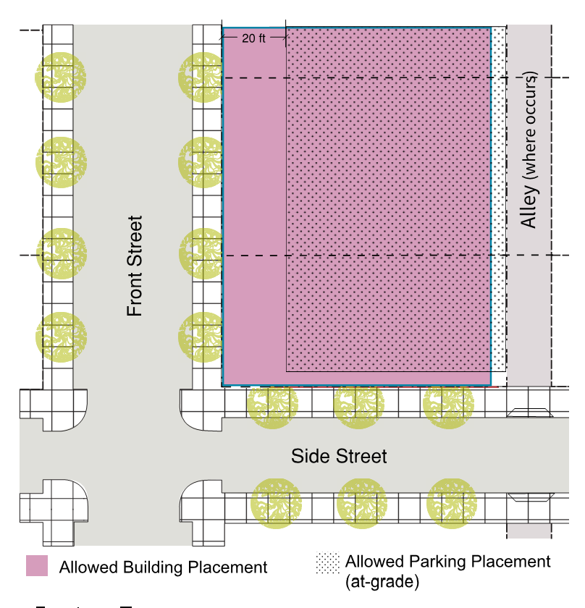
Frontage Types
• Forecourt
• Lightcourt
• Storefront
• Arcade
• Gallery
• Stoop
Encroachments: Buildings, architectural features, and signs may encroach into the required setbacks and right-of-way subject to the following requirements:
Description | Encroachment
Description | Horizontal |  |  |  | Vertical
Description | Front | St. Side | Rear | Side | min. 8 ft. clear
Arcade, gallery, awning | min. 2 ft. clear of curb |  | min. 5 ft. from PL | N/A | min. 8 ft. clear
Balcony | 4 ft. max. |  | min. 5 ft. from PL | min. 5 ft. from PL | min. 8 ft. clear
Bay window | 4 ft. max. on upper floors only |  | min. 5 ft. from PL | min. 5 ft. from PL | min. 8 ft. clear
Eave | min. 2 ft. clear of curb |  | min. 3 ft. from PL | min. 3 ft. from PL | min. 8 ft. clear

Sec. 30-369. Valley gateway district.
The Valley gateway district is intended to encourage pedestrian and transit-oriented development. Land uses should include a mixture of housing types, retail and services, general and medical office, entertainment and education.
Residential or Mixed-Use Density |  | Minimum |  | Maximum
 |  | 20 units/acre |  | 39 units/acre
Commercial Floor Area Ratio (without residential component) |  | — |  | 2.0
Setback |  | Building setback from PL
 |  | Front |  | Side/Rear
 |  | Min. (ft.) | Max. (ft) | Min. (ft.)
i. | Front Street | 0 | 10 * | —
ii. | Side Street | 0 | 10 * | —
iii. | Side (Interior) | — | — | 0
iv. | Rear yard | — | — | 5

* Required setbacks for civic buildings may be modified with Planning Commission approval.

Allowed  Building Types | Min |  | Max.
Allowed  Building Types | Stories/ft. | Lot W/D | Stories/ft. | Lot W/D
Flex | 2/30 | 25/100 | 5/70 | 400/150
Hybrid | 3/40 | 150/160 | 5/70 | 400/150
Liner | 1/24 | 100/100 | 5/70 | 200/150
Live/Work | 1/24 | 75/80 | 3/40 | 150/150
Frontage Coverage |  |  | 50% minimum
Story Height
Ground Floor |  | Upper Stories
Min. Height | 12 ft. | Minimum Height |  | 10 ft.

W = Building lot width along primary frontage; D = Building lot depth perpendicular to primary frontage.
Hotels may be allowed to a maximum number of seven stories and 90 feet in height.
Required Parking
Residential Uses | Studio or 1 bedroom | 1 space per unit
Residential Uses | 2+ bedrooms | 1.5 spaces per unit
Non-Residential Uses | 65% of cumulative parking requirements per FMC
Parking Placement: On-site above-ground parking and access shall be located in compliance with the following requirements:
Setback
Front Street | Min. 20 ft.
Side Street | Min. 5 ft.
Side interior | 0 ft.
Rear property/rear alley | 0 ft./min. ft.

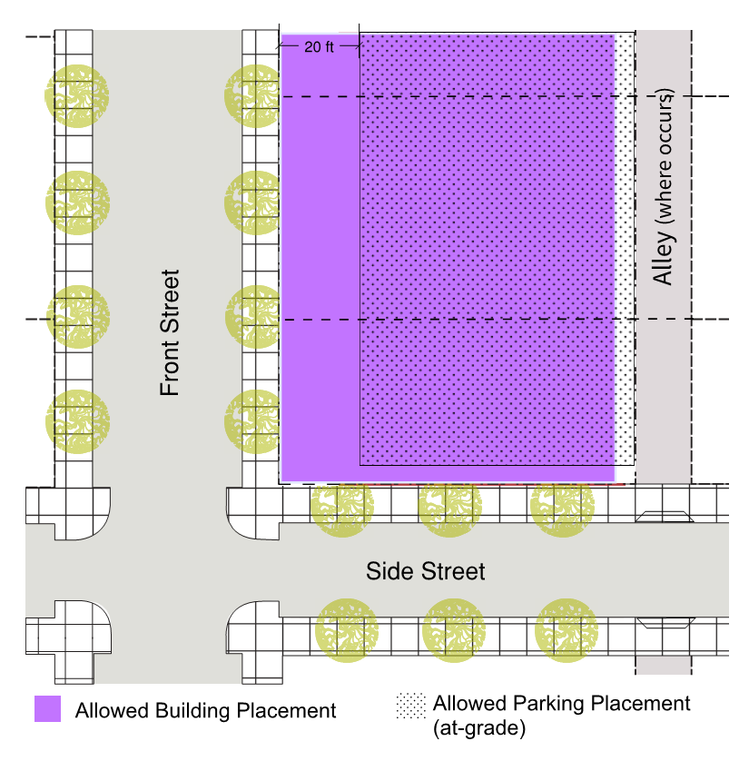
Frontage Types
• Forecourt
• Storefront
• Arcade
• Gallery
Encroachments: Buildings, architectural features, and signs may encroach into the required setbacks and right-of-way subject to the following requirements:
Description | Encroachment
Description | Horizontal |  |  |  | Vertical
Description | Front | St. Side | Rear | Side | min. 8 ft. clear
Arcade, gallery, awning | min. 2 ft. clear of curb |  | min. 5 ft. from PL | N/A | min. 8 ft. clear
Balcony | 4 ft. max. |  | min. 5 ft. from PL | min. 5 ft. from PL | min. 8 ft. clear
Bay window | 4 ft. max. on upper floors only |  | min. 5 ft. from PL | min. 5 ft. from PL | min. 8 ft. clear
Eave | min. 2 ft. clear of curb |  | min. 3 ft. from PL | min. 3 ft. from PL | min. 8 ft. clear

Sec. 30-370. Village district.
The Village district is intended to provide an alternative to conventional subdivision development with a mixture of housing types, neighborhood-service retail, and open space.
Residential or Mixed-Use |  | Minimum |  | Maximum
 |  | 2.1 units/acre |  | 24 units/acre
Commercial Floor Area Ratio (without residential component) |  | — |  | 1.0
Setback |  | Building setback from PL
 |  | Front |  | Side/Rear
 |  | Min. (ft.) | Max. (ft) | Min. (ft.)
i. | Front Street | 10 | 25 * | —
ii. | Side Street | 10 | 20 * | —
iii. | Side (Interior) | — | — | 5
iv. | Rear yard | — | — | 10

* Required setbacks for civic buildings may be modified with Planning Commission approval.

Allowed Building Types | Min |  | Max.
Allowed Building Types | Stories/ft. | Lot W/D | Stories/ft. | Lot W/D
Flex | 2/30 | 25/100 | 5/70 | 400/150
Hybrid | 2/30 | 150/160 | 5/70 | 400/150
Liner | 1/24 | 100/100 | 5/70 | 200/150
Live/Work | 1/24 | 75/80 | 3/40 | 150/150
Rowhouse | 2/24 | 125/125 | 3/40 | —
Court | 2/24 | 100/100 | 5/70 | 150/150
Single Family | 1/15 | 50/75 | 3/40 | 75/100
Duplex, Multiplex | 1/18 | 50/100 | 3/40 | 75/150
Rosewalk or Bungalow Ct. | 1/18 | 75/100 | 3/40 | 150/150
Frontage Coverage |  |  | 50% minimum
Story Height
Ground Floor |  | Upper Stories
Min. Height | 12 ft. | Minimum Height |  | 10 ft.

W = Building lot width along primary frontage; D = Building lot depth perpendicular to primary frontage.
Required Parking
Residential Uses | Studio or 1 bedroom | 1 space per unit
Residential Uses | 2+ bedrooms | 1.5 spaces per unit
Non-Residential Uses | 65% of cumulative parking requirements per FMC
Parking Placement: On-site above-ground parking and access shall be located in compliance with the following requirements:
Setback
Front Street | Min. 20 ft.
Side Street | Min. 5 ft.
Side interior | 0 ft.
Rear property/rear alley | 0 ft./min. ft.

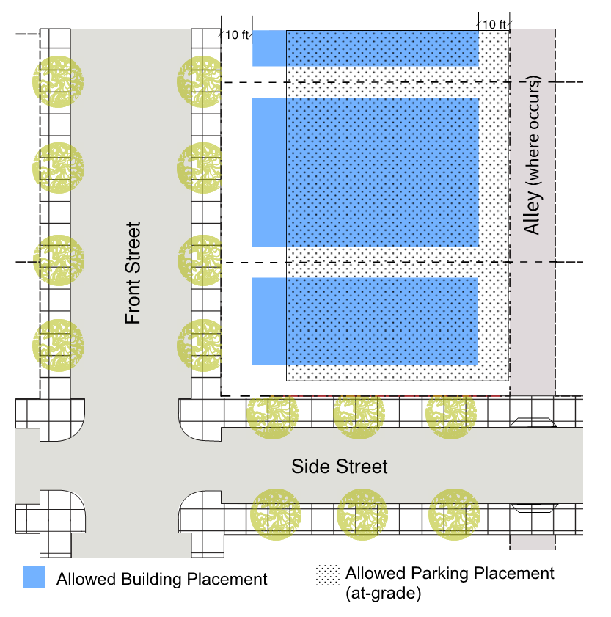
Frontage Types
• Forecourt
• Storefront
• Arcade
• Gallery
• Stoop
• Porch
• Dooryard
Encroachments: Buildings, architectural features, and signs may encroach into the required setbacks and right-of-way subject to the following requirements:
Description | Encroachment
Description | Horizontal |  |  |  | Vertical
Description | Front | St. Side | Rear | Side | min. 8 ft. clear
Arcade, gallery, awning | min. 2 ft. clear of curb |  | min. 5 ft. from PL | N/A | min. 8 ft. clear
Balcony | 4 ft. max. |  | min. 5 ft. from PL | min. 5 ft. from PL | min. 8 ft. clear
Bay window | 4 ft. max. on upper floors only |  | min. 5 ft. from PL | min. 5 ft. from PL | min. 8 ft. clear
Eave | min. 2 ft. clear of curb |  | min. 3 ft. from PL | min. 3 ft. from PL | min. 8 ft. clear

Sec. 30-371.2. Sierra core.
The Sierra core is the commercial core of Fontana and functions as the city center. Uses include a mixture of commercial, retail, entertainment, office, and residential.
Building placement shall be close to the streets and integrated within the pedestrian realm. Architectural features should provide shade and variation in building design.
Capacity
 | Min. | Max.
Residential or mixed-use density | 24 DU/Ac | 70 DU/Ac
Commercial FAR (retail and restaurants) | Refer to Sec. 30-405 for frontages that require ground floor commercial | 2.0

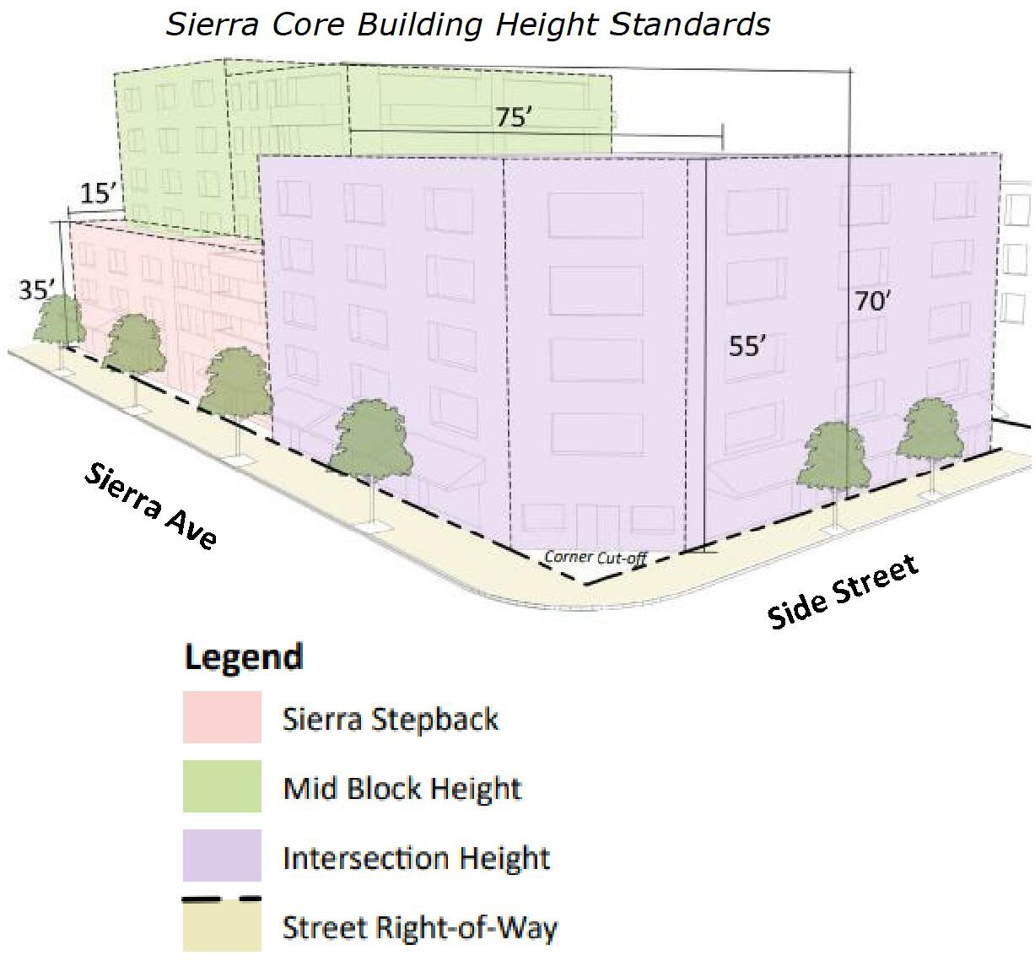

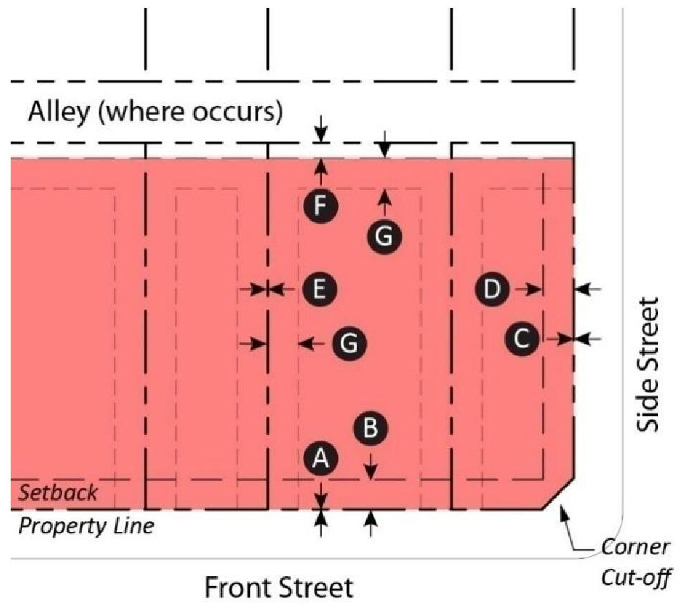

Setbacks
 | Min. (ft.) | Max. (ft.)
Front Street | 0  | 10 
Side Street | 0  | 10 
Side (Interior) | 0 | —
Rear Yard | 5  | —
Stepback* | 10  | —
* Applies to rear and side (interior) at 35' high, when adjacent to the neighborhood core.

Building Height
Frontage Coverage | 80% min.
Height** | 35' max.
Height** | 55' max. within 75' of side street property line 
Height** | 70' max. with min. 75' stepback from side street and 15' from Sierra Ave Property Line.*
Ground Floor Commercial Height** | 12 ft. Min. 
- The maximum height along Sierra Ave may be increased to 45’ and to 70’ along the side street stepbacks for projects that provide a rooftop amenity. The rooftop amenity must be located along a street frontage with a maximum height of 45’ and minimum width of 15’.

[Remaining text of 30-371.2 will remain, unmodified]

Sec. 30-372. Duplex, multiplex.
Description: The duplex building type is a small- to medium-sized structure that consists of two side-by-side or stacked dwelling units, both facing the street, and within a single building massing. This type has the appearance of a medium to large single-family home and is appropriately scaled to fit within primarily single-family neighborhoods or medium-density neighborhoods. It enables appropriately-scaled, well-designed higher densities and is important for providing a broad choice of housing types and promoting walkability.
The multiplex is a medium structure that consists of three—six side-by-side and/or stacked dwelling units, typically with one shared entry or individual entries along the front. This type has the appearance of a medium-sized family home and is appropriately scaled to fit sparingly within primarily single-family neighborhoods or into medium-density neighborhoods. This type enables appropriately-scaled, well-designed higher densities and is important for providing a broad choice of housing types and promoting walkability.
Allowed In: | Transitional, Multi-Family & Village
Lot Size: | Width: 50 ft. min.  Depth: 100 ft. min.
Pedestrian  Access: | Main entrance location: Primary street
Vehicle Access & Parking: | On corner lots, each lot shall front a separate street Parking spaces may be enclosed, covered, or open.
Frontages: | Porch  Stoop  Dooryard
Private Open Space: | Minimum width: 8 ft.  Minimum depth: 8 ft.  Minimum area: 64 sq. ft.
Building Size & Massing: | Length along frontage: 36 ft. max. for duplex and  350 ft. max. for multiplex  Length along side yard: 80 ft. max. 200 ft. max.

[Remaining text of 30-372 to remain, unmodified]

Sec. 30-374. Rowhouse.

Description: A small- to medium-sized building comprised of five or more attached dwelling units arrayed side by side., with Tthe ground floor can be raised above grade in order to provide privacy for ground floor rooms. The primary building should sit at the front of the property, with the garage at the rear, separated from the primary building by a rear yard. Each dwelling unit is directly accessed from the front yard/street or walking path leading to the street. This The Rowhouse type is typically located within medium-density neighborhoods or in a location that transitions from a primarily single-family neighborhood into a neighborhood main street. This type enables appropriately-scaled, well-designed higher densities and is important for providing a broad choice of housing types and promoting walkability.

[Remaining text of 30-374 to remain, unmodified]

Sec. 30-381. Porch.

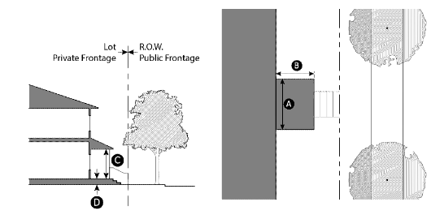

In the porch frontage type, the main facade of the building is set back from the frontage line. The resulting front yard can be is defined by a low wall or fence to spatially maintain the edge of the street, and is covered by a patio. A projecting porch uses part of the front yard space for a porch that is open on three sides above the low wall or fence. The engaged porch has two adjacent sides of the porch that are attached to the building while the other two sides are open.
Size
Width | 8 ft. min.
Depth | 6 ft. min.
Height | 8 ft. min.
Finish level above sidewalk (Optional) | 18 in. min.
Path of travel | 3 ft. wide min.

Design Standard
Porches must be open on at least two sides and have a roof.

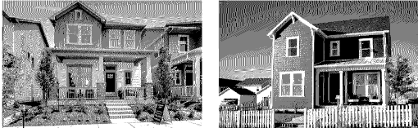

(Ord. No. 1923, § 5(Exh. A), 9-12-23)

Sec. 30-404.1. Downtown core open space requirements.
Common Open Space Required
Amenities Required
Developers shall provide on-site recreational facilities as a minimum requirement for all multi-family projects.
(1) Development with less than 35 units shall provide a minimum of 10 percent of the project lot area as common open space (private open space that exceeds the minimum may be counted towards the common open space requirement) and shall provide one of the following recreational facilities, or equivalent, as approved by the Director of Planning:
a. Indoor gym/fitness facility (minimum 500 square feet).
b. Tot-lot with multiple play equipment.
c. Spa and pool (minimum 25 yard by 15 yards).
d. Barbecue facility equipped with built-in grill, picnic benches, etc. (minimum of three areas).
[Remaining text of 30-404.1 to remain, unmodified]

