AmendmENT to FONTANA MUNICIPAL CODE CHAPTER 30
(*Additions shown in underline, deletions shown in strikeout)
(Divisions not referenced are to remain)

ARTICLE XII. SIGN REGULATIONS

DIVISION 2. APPLICABILITY

(Sections 30-719 to 30-721 to remain)

Table No. 30-721.A.
Exempt Signs with Limitations
Exempt signs do not require design review sign approval, but may require building permits
Sign Type | Maximum Number | Maximum Sign Area | Maximum Sign Height | Additional Requirements
1. Permanent Signs
a. Projecting signs (Downtown only) | In addition to wall signs: 1 per tenant space | 15 sf | Must be below eave line and maintain a minimum vertical clearance of at least eight feet from bottom of such sign to highest finished grade shall be maintained | • Permitted within downtown boundary only.  • A tenant space shall be allowed either a Downtown Core Projecting Sign or a Projecting Sign otherwise permitted under the provisions of this Section, but not both. (Refer to the Table in Section 30-743.A(h) for specific regulations pertaining to Downtown Core Projecting Signs.)  • Such signs shall project no more than four feet from the face of the building wall upon which the sign is mounted.  • Any encroachment into City right-of-way is subject to City Engineer approval and requires an encroachment permit.  • Such signs, including supporting structures, shall be designed as an integral design element of a building's architecture and shall be architecturally compatible with any building to which the sign is to be attached. Where more than one sign is provided, all signs shall be complementary to each other.
b. Suspended signs | 1 per each street frontage per nonresidential tenant | 4 sf | A minimum vertical clearance of at least eight feet from bottom of such sign to highest finished grade shall be maintained | • Such signs shall be limited to building frontages on the ground floor of nonresidential buildings.  • Any encroachment into City right-of-way is subject to City Engineer approval and requires an encroachment permit.  • Such signs, including supporting structures, shall be designed as an integral design element of a building's architecture and shall be architecturally compatible with any building to which the sign is to be attached. Where more than one sign is provided, all signs shall be complementary to each other.
c. Window signs | N/A | 25 percent of the total window glass area of the first floor, including glass doors, of the building frontage. | N/A | • Such signs shall be placed so that law enforcement and public safety personnel have a clear and unobstructed view of the interior of the establishment, including cash registers.  • Signs inside the building not mounted to windows shall not be located within three feet of the window.  • Illuminated and electronic message window signs shall comply with Section 30-734.
• Perforated and/or transparent window signs shall count towards the cumulative allowable sign area.
• Window signs shall not be located on any window above the second story.
• Window signs shall be maintained in good condition.
d. Downtown Core Holiday Window Signs | For all window areas | Fifty percent of window area | N/A | - Only permitted in the Downtown Core  - Windows signs as specified in subsection (c) above are permitted.  - Signs shall be positioned so as to ensure a clear and unobstructed view of the interior of the establishment.  - Signs located inside the building, but not mounted on windows, must be placed at least three feet from the window.  - Illuminated and electronic message window signs shall comply with Section 30-734.  - Sign display is restricted to federal and state recognized holidays  - Display of these signs are limited to the period beginning forty-five (45) days before a federal or state recognized holiday and ending fifteen (15) days after that holiday.

DIVISION 4. DESIGN REVIEW SIGN REQUIREMENTS

Sec. 30-725. Reviewing bodies.
The following reviewing bodies shall make decisions on the design review sign applications provided for in this article. All reviewing bodies shall be responsible for the design review sign applications indicated in Table No. 30-725.A.
DCD—Director of Community Development—Approval Body
PC—Planning Commission—Approval Body
CC—City Council—Approval Body
X—Indicates the reviewing and/or the Approval Body
Table No. 30-725.A.
Responsible Reviewing Bodies
 | Reviewing Body |  |  | Appeal Body
Permit Type | DCD | PC | CC | PC | CC
Design Review Temporary Sign | X |  |  | X
Design Review Permanent Sign—General | X |  |  | X
Design Review Permanent Sign—Freeway Sign |  | X |  |  | X
Design Review Permanent Sign—Electronic Message Sign | X |  |  | X
Design Review Creative Sign (Minor) | X |  |  | X
Design Review Creative Sign (PC) |  | X |  |  | X
Downtown Core Creative Sign | X |  |  | X
Downtown Core Sign Program | X |  |  | X

(Sections 30-726 to 30-730 to remain)

Sec. 30-731. Design review creative sign (PC).
(a) Purpose. The purposes of design review creative sign (PC) approvals are to:
(1) Encourage signs of unique design and signs that exhibit a high degree of thoughtfulness, imagination, and inventiveness;
(2) Provide a process for the application of sign regulations in ways that will allow creatively designed signs that make a positive visual contribution to the overall image of Fontana, while mitigating the impacts of large or unusually designed signs; and
(3) Provide a process for the approval of commercial murals and other emerging sign types that portray Fontana in a positive light and enhance the local aesthetic.

Figure No. 30-731.1

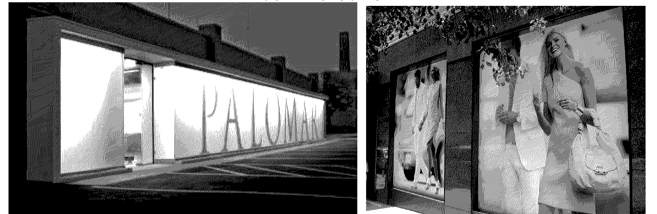
Examples of possible design review creative sign (PC) applications
(b) Applicability.
(1) Location. An applicant may request design review creative sign (PC) approval to authorize one on-site permanent creative sign in the following areas:
a. Within the downtown boundary. For creative signs in the Downtown Core, Section 30-371.1 shall apply; or
b. On properties with frontage on Baseline Avenue, Foothill Boulevard, Sierra Avenue, or Valley Boulevard.

(The rest of Section 30-731 to remain)

Sec. 30-731.1. Downtown Core Creative Sign.

(a) Purpose. The purpose of this section is to :

- Encourage distinctive signage that demonstrates unique design and exhibits a high degree of thoughtfulness, imagination, and inventiveness thereby creating a dynamic and attractive Downtown Core;

- Establish a process for implementing sign regulations that facilitate the approval of creatively designed signs that shall make a positive visual contribution to the overall image of the Downtown Core, while mitigating the impacts of large or unusually designed signs; and

- Provide a process for the approval of commercial or residential murals and other novel sign types that positively represent Fontana and enhance the local aesthetic.

(b) Applicability.

- Location. An applicant may seek approval to authorize the installation of one (1) on-site permanent creative sign within the Downtown Core.

- Requirements. An applicant may request approval to utilize standards that deviate from the requirements applicable to signs established in this Article, provided such deviation complies with the specific provisions of this Section, subject to the following conditions:

  - A Downtown Core Creative Sign may deviate from the applicable standards established in this article with façade modifications, when approved by the Director of Planning through a Design Review Sign Application.
    - Only one Downtown Core Creative Sign may be requested per Design Review Sign Application.
  - This subsection shall not authorize general advertising where it is not otherwise allowed.
  - A Downtown Core Creative Sign approval shall not authorize any prohibited sign type or feature set forth in Section 30-722 except where specifically authorized.
  - Electronic message signs are only permitted to promote live events and screenings. The site must have a business associated with live events and/or screenings. In addition, the electronic message sign must comply with Section 30-734(c).
  - Applicants proposing an electronic message sign must have the approval of a Minor Use Permit to ensure compliance with the findings below.

(c) Findings . The following findings are required to be made by the responsible reviewing body for the approval of a Downtown Core Creative Sign application:

- Design criteria.
The proposed creative sign shall meet the following design criteria:
- The sign complies with the design principles set forth in Section 30-727;
- The sign exhibits a unique design and a high degree of imagination, inventiveness, spirit, and thoughtfulness through the use of color, graphics, proportion, quality materials, scale, and texture;
- The sign contributes a substantial aesthetic improvement to the site and has a positive visual impact on the surrounding area;
- The sign utilizes or enhances the architectural elements of the building and is placed in an appropriate location in relation to the overall composition of the building's façade;
- Any proposed façade modifications are demonstrably necessary for the structural integration of the sign or are located in the immediate vicinity of the sign to enhance its visual interest;
- Any proposed commercial mural must depict imagery directly connected with the business and project a positive impression; and
- Electronic message signs may only be used for businesses to promote live events and screenings and must comply with Section 30-734.

- Contextual criteria. The creative sign shall be located and designed not to cause light and glare impacts on surrounding uses, especially residential uses. The sign shall also contain at least one of the following elements:
  - Creative image reflecting current or historic character of Fontana; or
  - Inventive representation of the logo, name, or use of the structure or business.

Sec. 30-731.12. - Sign programs.
(a) Purpose. The purpose of the sign programs are to:
(1) Provide coordinated signage within a development project;
(2) Create common design elements;
(3) Provide customed tailored site-specific standards; and
(4) Integrate the design of signs with the overall building and landscape design to form an architectural statement.

(b) Applicability.
(1) Location. An applicant may submit a comprehensive sign program application (design review sign program) if they meet the following criteria:
a. A new or existing shopping center with a site area of six acres or more;
b. Mixed-use or commercially zoned properties; and
c. On properties with frontage on Baseline Avenue, Foothill Boulevard, Sierra Avenue, or Valley Boulevard.; and
d. For sign programs within the Downtown Core, Section 30-732.1 shall apply.

(c) Findings and decision. The following findings are required to be made by the responsible reviewing body for approval of a design review creative sign (PC) application, with or without conditions:
(1) Design criteria. The proposed creative sign:
a. Complies with the design principles set forth in Section 30-727;
b. Has a unique design and exhibits a high degree of imagination, inventiveness, spirit, and thoughtfulness through the imaginative use of color, graphics, proportion, quality materials, scale, and texture;
c. Contributes a substantial aesthetic improvement to the site and has a positive visual impact on the surrounding area; and
d. Utilizes or enhances the architectural elements of the building and is placed in an appropriate location in relation to the overall composition of the building's façade.

(2) Contextual criteria. The creative sign shall be located and designed not to cause light and glare impacts on surrounding uses, especially residential uses. The sign shall also contain at least one of the following elements:
a. Creative image reflecting current or historic character of Fontana; or
b. Inventive representation of the logo, name, or use of the structure or business.

Sec. 30-731.3. – Downtown Core Sign Program.
(a) Purpose. The purpose of Downtown Core Sign Program is to:
(1) Provide coordinated signage within a Downtown Core site;
(2) Create common design elements;
(3) Provide custom tailored site-specific standards;
(4) Integrate the design of signs with the overall building and landscape design to form an architectural statement; and
(5) Allow façade improvements in direct vicinity of proposed signage.

(b) Applicability and Eligibility.
(1) Location. The Downtown Core Sign Program must pertain to sites situated within the Downtown Core.
(2) Eligibility. In addition to the general location requirement above, the site for which a Downtown Core Sign Program application is submitted must satisfy at least one of the following criteria:
a. The site is a commercial or mixed-use property with commercial or office space measuring one (1) acre or larger, excluding any stand-alone single-family residences (including ADU’s); or
b. The site is a commercial, mixed-use, or residential property that is two (2) stories or higher.

(3) Requirements. An applicant may request Director’s approval of a Downtown Core Sign Program through a Design Review Sign Application, consistent with the following:
a. A site plan showing the location of buildings, parking lots, driveways, lot size, building height, and landscaped area;
b. The maximum total sign area, the maximum area for individual signs, the height of signs and the number of signs allowed;
c. An accurate indication on the site plan of the proposed location of each proposed sign and existing sign which is to remain;
d. Show areas of all façade changes including color and material which must be architecturally compatible with the proposed signage and close proximity to proposed signage;
e. Lighting and sign construction materials;
f. Sign dimensions (if tenants are not known, generic dimensions may be presented);
g. Where proposed signage does not meet the requirements of existing sign regulations, the sign program shall provide enhanced design or other elements;
h. Sites along Route 66 must meet the requirements of Section 30-727; and
i. Electronic message signs are only permitted to promote live events and screenings. The site must have a business associated with live events and/or screenings. In addition, the electronic massage sign must comply with Section 30-734(c).
    - Applicants proposing an electronic message sign must have the approval of a Minor Use Permit to ensure compliance with this section.

DIVISION 6. PERMANENT SIGNS

Sec. 30-741. Permanent sign standards by zoning district/use.

All permanent signs shall comply with the standards set forth in this division. Additional permitted signs are included for specific uses listed under Section 30-747. Table No. 30-742.A, Table No. 30-743.A, Table No. 30-744.A, and Table No. 30-745.A identify the sign type, number, location, area, and height allowed within each zoning district, along with any applicable additional regulations. The standards contained in this section are maximums, unless otherwise stated.

Sec. 30-742. Permanent sign standards for residential uses in all zoning districts.
Table No. 30-742.A.
Residential Uses in All Zoning Districts
Sign Type | Maximum Number | Maximum Sign Area | Maximum Sign Height | Additional Regulations
1. Single-Family Residential Subdivision Development in Residential Zoning Districts
a. Monument sign | 1 per major neighborhood entrance | 30 sf | 5 ft (includes decorative base and cap) | • Permitted only at major neighborhood entrances  • See subsection 30-746(d)  • See subsection 30-736(f)
2. Multiple-Family Uses
a. Monument sign | 1 per street frontage with entrance | 24 sf | 5 ft (includes decorative base and cap) | • Permitted only at major neighborhood entrances  • See subsection 30-746(d)  • See subsection 30-736(f)
b. Wall sign | 1 per street frontage | 16 sf  Downtown Core:  16 sf for channel letters and 16 ft for logo | Shall not be displayed above second story and shall not extend above eave line | • See subsection 30-746(f)  • See subsection 30-736(g)
c. Driveway/on-site traffic directional sign | 1 per driveway  Downtown Core:  1 per frontage and 1 per driveway | 8 sf | 4 ft | • Permitted only for developments with more than 12 dwelling units  • See subsections 30-736(f) and 30-736(g)

Sec. 30-743. Permanent sign standards for nonresidential uses in commercial, mixed use, and form-based zoning districts (C-1, C-2, RMU, FBC).
Table No. 30-743.A.
Nonresidential Uses in Commercial, Mixed Use, and Form-Based Zoning Districts (C-1, C-2, RMU, FBC) and Specific Plans Without Sign Programs
Sign Type | Maximum Number | Maximum Sign Area | Maximum Sign Height | Additional Regulations
a. Awning sign | N/A | 25 percent of the surface area of the awning, including all valances  Downtown Core:  30 percent of the surface area of the awning, including all valances | Awning shall not extend above eave line | • See subsection 30-746(a)
b. Canopy sign | Single Tenant: 1 per building frontage  Multiple Tenant: 1 per tenant space | 25 percent of the surface area of the canopy  Downtown Core:  1 square foot of sign area permitted per each lineal foot of tenant frontage | 24 inches, as measured from the lowest point on the sign | • See subsection 30-746(b)
c. Monument sign | 1 for each 200 ft (lineal) of street frontage | 45 sf | 6 ft (includes decorative base and cap) | • See subsection 30-746(d)  • See subsection 30-736(f)
d. Pylon sign | Single Tenant: 1 per street frontage with a minimum of 165 lineal ft of street frontage  Multiple Tenant: 1 per street frontage  Street frontages of 300 ft or greater may have a second pylon sign | 100 sf | 25 ft (includes decorative base and cap) | • Pylon signs permitted only on lots with minimum area of two acres  • Pylon signs for single tenants permitted only for those lots with frontage along Baseline Avenue, Foothill Boulevard, Sierra Avenue, or Valley Boulevard  • See subsection 30-746(e)  • See subsection 30-736(f)
e. Wall sign | Business frontages less than 100 ft: 1 primary wall sign per business frontage  Business frontages 100 ft or more: 1 primary wall sign and 2 optional secondary wall signs per business frontage.  Downtown Core: Secondary wall signs are permitted on every frontage with a wall sign. | Business frontages less than 100 ft: 1 sf of sign area per lineal foot of business frontage up to 100 sf.  Business frontages 100 ft or more: 1 sf of sign area per lineal foot of business frontage up to 150 sf of combined primary and optional secondary wall sign areas per business frontage. Optional secondary wall signs shall not exceed 40 percent of the total wall sign area per business frontage.  Downtown Core: Secondary wall sign is permitted up to 40 square feet maximum | Shall not extend above eave line | • See subsection 30-746(f)  • See subsection 30-736(g)  • Downtown Core: Secondary wall signs must promote the primary business. Can be located below a canopy or façade, but must have a minimum vertical clearance of at least eight feet from bottom of the secondary sign to highest finished grade.
f. Driveway/on-site traffic directional sign | 1 per driveway or drive-through lane, plus:  • Single Tenant: 1 for every 300 parking spaces  • Multiple Tenant: 1 for every 200 parking spaces  Downtown Core:  1 per right-of-way frontage | Single Tenant: 8 sf per sign face  Multiple Tenant: 10 sf per sign face | 4 ft | • Such signs may be in the form of a monument sign, pylon sign, projecting or wall sign.  • See subsections 30-736(f) and 30-736(g)
g. Freeway sign | 1 per parcel having a minimum of 800 ft of freeway frontage, and is developed as a single entity | 150 sf for businesses occupying less than 250,000 sf of building area  300 sf for businesses occupying 250,000 sf or more building area | 50 ft (includes decorative base and cap) | • See subsection 30-746(c)  • See subsection 30-736(f)
h. Projecting signs (Downtown Core) | • 1 per tenant space with 50 feet of linear frontage adjacent to the public right-of-way and 5,000 square feet of floor space  • May exist instead of, but not in addition to, a freestanding ground sign | Shall not exceed one and one-half (1½) square feet for each linear foot of building frontage facing the right-of-way (Area is measured by maximum width by maximum height of the sign) | N/A | • Permitted within Downtown Core only.  • Tenant spaces are not permitted to have both a Projecting Sign permitted in Table 30-721.A and a Projecting Sign (Downtown Core).  • Must be located fifty feet from any other Projecting Signs (Downtown Core)  • Such signs shall project no more than six feet from the face of the building wall upon which they are mounted.  • Any encroachment by a Downtown Core Projecting Sign into the City right-of-way is subject to the approval of the City Engineer and shall require an encroachment permit.  • Downtown Core Projecting Signs, including supporting structures, shall be designed as an integral architectural element of the building and must be architecturally compatible with the building to which the sign is to be attached.  • The bottom edge of a Downtown Core Projecting Sign shall maintain a minimum clearance of nine (9) feet from ground level.  • Downtown Core Projecting signs must be constructed with vertical orientation.

(Sections 30-744 to 30-745 to remain)

Sec. 30-746. - Standards by permanent sign type.

(a) Awning sign. Awning signs are permitted pursuant to Section 30-743 and Section 30-744 and the following regulations:
(1) Location. Awnings that display signage shall be limited to building frontages on the ground floor of buildings.
Figure No. 30-746.1.
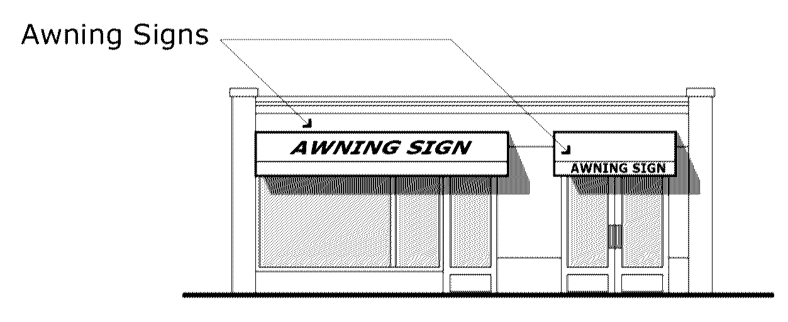
(2) Combined sign area. Combinations of signs on awnings, canopies, and walls are permitted but shall not exceed the maximum allowable sign area for wall signs per business frontage or building frontage. Awning signs may count as a primary wall sign or secondary wall sign.

Downtown Core: Awning signs within the Downtown Core are exempt from the maximum allowable sign area limitations that apply to wall signs.

(3) Vertical clearance. A minimum vertical clearance of at least eight feet from bottom of the awning, including valance, to highest finished grade shall be maintained.
Figure No. 30-746.2.
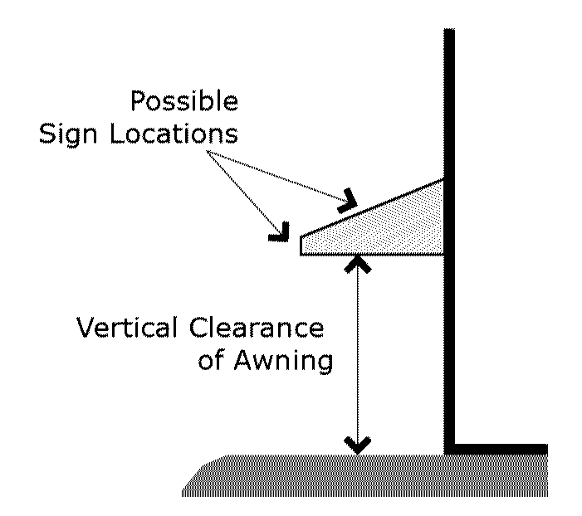
(4) Setback and projection into public right-of-way. A minimum of two feet between the edge of the awning and the outer curb face shall be maintained. Any encroachment into City right-of-way is subject to City Engineer approval and requires an encroachment permit.

(b) Canopy sign. Canopy signs are permitted pursuant to Section 30-743 and Section 30-744 and the following regulations:
(1) Location. Canopies that display signage shall be limited to building frontages on the ground floor of buildings.
(2) Height. Canopy signs shall not project more than 24 inches above the highest point of any canopy, except for fueling station canopies pursuant to subsection 30-747(c). Downtown Core: Signage located beneath a canopy is permitted, provided a minimum vertical clearance of eight (8) feet is maintained from the bottom of the sign to the highest finished grade. The maximum height of such signage shall not exceed twenty-four (24) inches..
Figure No. 30-746.3.
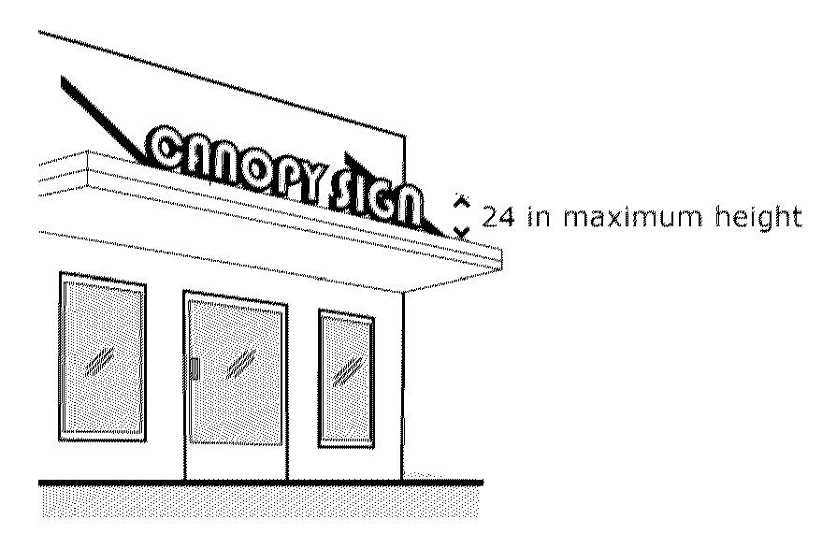
(3) Combined sign area. Combinations of signs on awnings, canopies, and walls are permitted but shall not exceed the maximum allowable sign area for wall signs per business frontage or building frontage (Does not apply to the Downtown Core). Canopy signs may count as a primary wall sign or secondary wall sign.
(4) Canopy signs prohibited in combination with projecting signs. Canopy signs shall not be permitted on street frontages with projecting signs, except for the Downtown Core.
(5) Setback and projection into public right-of-way. A minimum of two feet between the edge of the canopy and the outer curb face shall be maintained. Any encroachment into City right-of-way is subject to City Engineer approval and requires an encroachment permit.

(Subsections (c) to (e) to remain)

(f) Wall sign. Wall signs are permitted pursuant to Section 30-742, Section 30-743, Section 30-744, and Section 30-745 and the following regulations:

(1) Location.
a. No wall sign shall cover, wholly or partially, any wall opening.
b. Wall signs shall be placed flat against the wall of the structure and shall not project from the wall more than 12 inches.

(2) Letter height. Within multiple tenant commercial complexes, for tenants with less than 50 feet of business frontage, letter height shall be limited to 24 inches or 70 percent of the adjacent surface height, whichever is greater.

Figure No. 30-746.7.
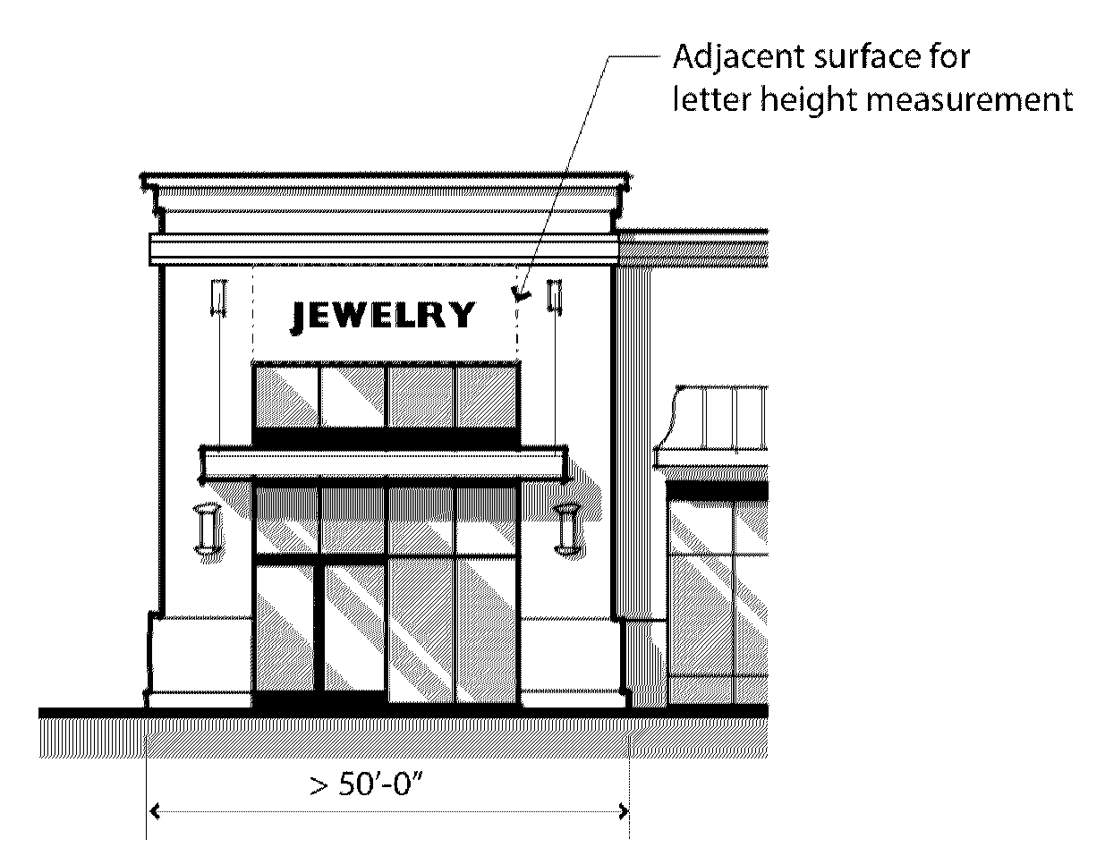

- Roofs signs in lieu of primary wall signs. Where a roof sign is permitted due to a lack of available building mansard for a sign, such roof sign's allowable area shall be equivalent to the allowed sign area for wall signs. Roof signs shall count as primary wall signs.

- Exposed raceways. Exposed raceways for wall signs shall only be permitted by the Director of Community Development under the following circumstances:
a. The architecture of a building prevents the enclosure of a raceway within a wall (e.g., sign located on a pitched roof below the roofline of a building). In these cases, the area behind the sign shall not be visible to the public; or

b. Older complexes that extensively use cabinet signs may utilize exposed raceways, if the applicant can demonstrate that an enclosed raceway will require extensive structural changes to the exterior of a wall.

- Downtown Core: The area the wall sign is being constructed on (including the immediate adjacent area and plane surface area of the sign) may be modified when such changes enhance the visual quality of the sign. These modifications must be architecturally compatible with or enhance the aesthetic design of the attached building, including the materials, shapes and colors.

Sec. 30-747. Permanent signs for specific uses.
(All text before Table 30-747.A to remain)

Table No. 30-747.A.
Nonresidential Uses within the Downtown Boundary
Sign Type | Maximum Number | Maximum Sign Area | Maximum Sign Height | Additional Requirements
a. Floor Inlay Sign | 1 per tenant entryway | 25 sf | Such signs shall be installed flush with the pavement. | Such signs shall not be located within the public right-of-way. Downtown Core: May be approved in the public right of way. Any encroachment into City right-of-way is subject to City Engineer approval and requires an encroachment permit.
b. Graphic Projection Sign | 1 per tenant entryway  Downtown Core:  One per frontage | 10 sf  Downtown Core:  20 sf | A minimum vertical clearance of at least eight feet from the bottom of the device projecting the sign to the highest finished grade shall be maintained. | • Graphic projection shall not blink, flash, flutter, or change light intensity, brightness, or color.  • The illumination source of the projector shall not be exposed to a public right-of-way or adjacent property.  • Sign projection shall not interfere with the use and enjoyment of adjacent properties, create a public nuisance, or create public safety hazards.
c. Holiday Window Signs | For all window areas | Fifty percent of window area | N/A | - Does not require permit  - For cultural holidays  - Limited display between forty-five days prior and fifteen days after holiday
d. Roof Sign | 1 per building over 20,000 square feet | Not exceed 3 square feet for each linear foot of building frontage where the sign is located, or  two hundred (200) square feet in total, whichever is lesser. | The height of the sign can only be a ratio of 2 feet of width to 1 foot of height. | - The tenant area must be 20,000 square feet or more.  - The sign may contain the text identifying the local area such as the building, District, City, Downtown or Street.  - The design of the sign must be superior or equal to the architecture of the building and immediate area.

DIVISION 7. - TEMPORARY SIGNS

(Sections 30-748 to 30-750 to remain)

Sec. 30-751. Temporary sign standards for nonresidential zoning districts.
Temporary signs shall comply with the standards set forth in this division. Table No. 30-751.A identifies the sign type, number, location, area, and height allowed within nonresidential zoning districts, along with any applicable additional regulations. The standards contained in Table No. 30-751.A are maximums, unless otherwise stated. The signs in Table No. 30-751.A are allowed in any combination unless otherwise noted in this division.
Table No. 30-751.A.
Nonresidential Zoning Districts
Sign Type | Maximum Number | Maximum Sign Area | Maximum Sign Height | Additional Regulations
a. Banner sign | 1 per business frontage | 30 sf or 10 percent of business frontage on which banner is placed, whichever is greater | N/A | • For the purposes of calculating allowed banner sign area, the height of a business frontage shall be eight feet regardless of existing conditions  • See subsection 30-752(a)
b. Feather sign | 1 per 25 linear feet of street frontage up to 4 signs per street frontage | 12 sf | 10 ft | • See subsection 30-752(b)  • Not permitted in the Downtown Core
c. Yard sign | 1 per business frontage | 12 sf (lots < 1 acre) | 6 ft (lots < 1 acre) | • See subsection 30-752(c)  • See subsection 30-721(b)  • Not permitted in the Downtown Core
c. Yard sign | 1 per business frontage | 32 sf (lots ≥ 1 acre) | 8 ft (lots ≥ 1 acre)

(Section 30-752 to remain)

