ORDINANCE NO. 1995

AN ORDINANCE OF THE CITY COUNCIL OF THE CITY OF FONTANA, CALIFORNIA, APPROVING A THIRD AMENDMENT TO THE ARBORETUM SPECIFIC PLAN DEVELOPMENT AGREEMENT, PURSUANT TO AN ADDENDUM TO THE ARBORETUM SPECIFIC PLAN ENVIRONMENTAL IMPACT REPORT (STATE CLEARINGHOUSE [SCH] NO. 2006071109), AND DIRECT STAFF TO FILE A NOTICE OF DETERMINATION.

WHEREAS, California Government Code Sections 65864 et seq. (“Development Agreement Statutes”) and Section 30-322 of the City of Fontana’s Zoning and Development Code (“ZDC”) authorizes the City Council of the City of Fontana (“City Council”) to enter into development agreements with those having a legal or equitable interest in real property in order to establish certain development rights in such property to strengthen the public planning process, encourage private participation in comprehensive planning, and reduce the economic risk of development in connection with the development of real property within its jurisdiction; and

WHEREAS, City of Fontana (“City”) has found that development agreements strengthen the public planning process, encourage private participation in comprehensive planning reduces the economic costs of development, allows for the orderly planning of public improvements and services, allocates costs to achieve maximum utilization of public and private resources in the development process, and ensures that appropriate measures to enhance and protect the environment are achieved; and

WHEREAS, on September 23, 2009, the City adopted the Arboretum Specific Plan through a General Plan Amendment (GPA 06-000006), Zone Change (ZC No. 07-000005), Specific Plan Amendment (SPL No. 04-000006), Tentative Parcel Map (TPM 19-000002), Design Review (DRP 19-000005), and the certification of the Arboretum Specific Plan Environmental Impact Report (EIR) (State Clearinghouse (SCH) No. 200607119); and

WHEREAS, concurrently with the adoption of the foregoing entitlements, the City Council also adopted Ordinance No. 1608 for a Development Agreement (DA No. 09-000001) for the project (“Arboretum DA”); and

WHEREAS, on November 8, 2016, the City Council approved entitlements for the Arboretum Meadows Village Project , a residential development, which forms a portion of the larger Arboretum Project. The Arboretum Madows Village Project included a General Plan Amendment (GPA No. 15-000003), Specific Plan Amendment (SPA No. 15-000001), three Tentative Tract Maps (TTM No. 15-000009, TTM No. 15-000010, and TTM No. 15-000011), and two Administrative Site Plans (ASP No. 15-000035 and ASP No. 15-000037), together with an Addendum to the Arboretum Specific Plan EIR (SCH No. 2006071109) (collective, Arboretum Meadows Village Project); and

WHEREAS, concurrently with approval of the foregoing entitlements, the City Council also adopted Ordinance No. 1753 authorizing an amendment to the Arboretum DA (Development Agreement No. 15-000037); and

WHEREAS, on June 22, 2021, the City Council approved entitlements for the Arboretum Gardens Village Project, a residential development consisting of 278 dwelling units and an approximate 6,610 square foot fitness center/clubhouse and community park, a portion of the larger Arboretum Project. The Arboretum Gardens Village Project included a Specific Plan Amendment (SPA No. 20-000005), two Tentative Tract Maps (TTM No. 20-000026 and TTM No. 20-000010), Tentative Parcel Map (TPM No. 20-000024), four Design Reviews (DRP No. 20-000035, DRP No. 20-000036, DRP No. 20-000037, and DRP No. 20-000038), together with an Addendum to the Arboretum Specific Plan EIR (SCH No. 2006071109); and

WHEREAS, concurrently with approval of the foregoing entitlements, the City Council approved Ordinance No. 1871 authorizing a second amendment to the Arboretum Specific Plan DA; and

WHEREAS, on May 18, 2023, the City received an application for the Arboretum Specific Plan Amendment and Retail Projects, a 69,617 square foot commercial center, a portion of the larger Arboretum Project. The Arboretum Specific Plan Amendment and Retail Projects includes a General Plan Amendment (“GPA No. 23-000002”), Specific Plan Amendment (“SPA No. 23-000002”), Tentative Tract Map (“TTM No. 26-0006”), Tentative Parcel Map (“TPM No. 23-000008”), Design Review (“DRP No. 23-000011”), Conditional Use Permit (“CUP No. 23-000005”); and

WHEREAS, SPA No. 23-000002 was initiated to amend the Arboretum Specific Plan to modify the permitted land uses within the specific plan areas and to reconfigure the planning areas and designated park site; and

WHEREAS, concurrently with the submittal of the foregoing entitlements, the City received an application from for a third amendment to the Arboretum DA (“AGR No. 23-000012”) to reflect the changes made in the SPA No. 23-000012 and to provide for associated construction fee credits; and

WHEREAS, the terms and conditions of AGR No. 23-000012 were reviewed by the Planning Commission at a duly noticed public hearing held on June 2, 2026, at which time the Planning Commission recommended that the City Council approve the amendment; and

WHEREAS, the terms and conditions of AGR No. 23-000012 were found to be fair, just and reasonable, and it was further determined that (i) the economic interests of the City's residents, as well as the public health, safety and welfare, will be best served by the amendment; (ii) the amendment is consistent with the General Plan; (iii) the amendment conforms to public convenience, general welfare and sound land use practices; (iv) the amendment will not be detrimental to the public health, safety and general welfare; and (v) the amendment will not adversely affect the orderly development or the preservation of property values for the subject property or any other property; and

WHEREAS, on July 14, 2026, the City Council held a public hearing on AGR No. 23-000012 where it received evidence and public testimony and documentation from the Planning Commission’s public hearing on June 2, 2026; and

WHEREAS, the City Council carefully considered all information pertaining to AGR No. 23-000012 presented at its public hearing on July 14, 2026; and

WHEREAS, all other legal prerequisites to the adoption of this Ordinance have occurred.

THE CITY COUNCIL OF THE CITY OF FONTANA, CALIFORNIA DOES ORDAIN AS FOLLOWS:

Section 1. Recitals. The above recitals are true, correct and incorporated herein by reference.

Section 2. CEQA. Compliance with California Environmental Quality Act. As the decision-making body for the Project, the City Council has reviewed and considered the Arboretum Specific Plan FEIR and Addendum, any oral or written comments received, and the administrative record prior to making any decision on the Proposed Project. The City Council finds that the Addendum and Arboretum Specific Plan FEIR contain a complete and accurate reporting of all of the environmental impacts associated with the proposed project. The City Council further finds that the Addendum has been completed in compliance with the State CEQA Guidelines and Section 8.06 of the City of Fontana’s 2019 Local Guidelines for Implementing CEQA.
Section 3. Findings on the Necessity for a Subsequent or Supplemental Environmental Impact Report. Based on the substantial evidence set forth in the record, including but not limited to, the Arboretum Specific Plan FEIR, the Addendum, and all related information presented to the City Council, the City Council finds that the proposed project necessitates only minor modifications to the Arboretum Specific Plan FEIR. Therefore, pursuant to State CEQA section 15164 and Section 8.06 of the City of Fontana’s 2019 Local Guidelines for Implementing CEQA, an Addendum to the Arboretum Specific Plan FEIR is the appropriate document for the project.

The City Council further finds that the preparation of a subsequent or supplemental EIR is not required for the proposed projects because the project:

- Will not result in substantial changes that would require major revisions of the Arboretum Specific Plan FEIR due to the involvement of new significant environmental effects or a substantial increase in the severity of previously identified significant effects; and
- Will not result in substantial changes with respect to the circumstances under which the proposed project are developed that would require major revisions of the Arboretum Specific Plan FEIR due to the involvement of new significant environmental effects or a substantial increase in the severity of the previously identified significant effects; and
- Does not present new information of substantial importance that was not known and could not have been known with the exercise of reasonable diligence at the time the Arboretum Specific Plan FEIR documents were certified showing any of the following:
  - The proposed project would have one or more significant effects not discussed in the EIR;
  - That significant effects previously examined would be substantially more severe than shown in the EIR;
  - That mitigation measures or alternatives previously found not to be feasible would in fact be feasible and would substantially reduce one or more significant effects, but the lead agency declined to adopt such measures; and
  - That mitigation measures or alternatives considerably different from those analyzed would substantially reduce one or more significant effects on the environment, but which the lead agency declined to adopt.

Section 4. Findings on Environmental Impacts. Having considered the Addendum, the administrative record, the Arboretum Specific Plan FEIR and all written and oral evidence presented to the City Council, the City Council finds that all environmental impacts of the proposed project have been addressed within the Arboretum Specific Plan FEIR and the Addendum. The City Council finds that no new or additional mitigation measures or alternatives are required. The City Council further finds that there is no substantial evidence in the administrative record supporting a fair argument that the proposed project may result in any significant environmental impacts beyond those analyzed in the Arboretum Specific Plan FEIR. The City Council finds that the Addendum contains a complete, objective, and accurate reporting of the environmental impacts associated with the proposed project and reflects the independent judgment and analysis of the City Council.

Section 5. Adoption of the Addendum to the Arboretum Specific Plan FEIR. The City Council hereby adopts the Addendum to the EIR for the Arboretum Specific Plan Program Environmental Impact Report (SCH No. 2006071109) and Mitigation, Monitoring, and Reporting Program (MMRP) that have been prepared pursuant State CEQA Guidelines Sections 15162 and 15164 along with the City of Fontana’s 2019 Local Guidelines for Implementing CEQA. The Commission further directs staff to file a Notice of Determination.

Section 6. Public Health, Safety and Welfare. Based on the entire record before the City Council and all written and oral evidence presented to the City Council, the City Council finds that AGR No. 23-000012 promotes the public health, safety and welfare of the community because it will enable needed public improvements at the Property and the economic development of the Property will benefit the citizens of the City.

Section 7. Approval. The City Council hereby approves AGR No. 23-000012, in substantially the form attached hereto as “Exhibit A” and incorporated herein by this reference.

Section 8. Effective Date/Publication. This Ordinance shall take effect thirty (30) days after the date of the adoption and prior to the expiration of fifteen (15) days from the passage thereof, shall be published by the City Clerk at least once in the Fontana Herald News, a local newspaper of the general circulation, published and circulated in the City of Fontana, and henceforth and thereafter the same shall be in full force and effect.

Section 9. Custodian of Records. The documents and materials that constitute the record of proceedings on which this Ordinance is based are located at the City Clerk’s office located at 16860 Valencia Avenue, Fontana, CA 92335. The custodian or records is the City Clerk.

Section 10. Certification. The City Clerk shall cause to be recorded with the San Bernardino County Recorder a copy of the executed Development Agreement at the time and in the manner provided for in the Development Agreement.

Section 11. Severability. If any provision of the Ordinance or the application of any such provision to any person or circumstance is held invalid, such invalidity shall not affect other provisions or applications of this Ordinance that can be given effect without the invalid provision or application.

APPROVED and ADOPTED this 11th day of August 2026.

READ AND APPROVED AS TO LEGAL FORM:

City Attorney

I, Germaine Key, City Clerk of the City of Fontana, and Ex-Officio Clerk of the City Council, do hereby certify that the foregoing Ordinance is the actual Ordinance adopted by the City Council and was introduced at a regular meeting on the 14th day of July 2026, and was finally passed and adopted not less than five days thereafter on the 11th day of August 2026 by the following vote to wit:

AYES:
NOES:
ABSENT:
ABSTAIN:

City Clerk of the City of Fontana

Mayor of the City of Fontana

ATTEST:

City Clerk

EXHIBIT "A"
DEVELOPMENT AGREEMENT
(FOLLOWING THIS PAGE)

Recorded at request of )
Clerk, City Council )
City of Fontana )
)
When recorded return to: )
)
City of Fontana )
8353 Sierra Avenue )
Fontana, CA 92335 )
Attention: City Clerk )
)
)
) Exempt from Filing Fees Gov. Code section 6103

THIRD AMENDMENT TO
ARBORETUM DEVELOPMENT AGREEMENT

A STATUTORY DEVELOPMENT AGREEMENT

between

CITY OF FONTANA
a California municipal corporation

and

NORTH FONTANA INVESTMENT COMPANY, LLC,
a Delaware limited liability company

THIRD AMENDMENT TO
ARBORETUM DEVELOPMENT AGREEMENT

THIS THIRD AMENDMENT TO ARBORETUM DEVELOPMENT AGREEMENT (hereinafter “Third Amendment”) is entered into effective on the date that the ordinance adopting this Third Amendment becomes effective (the “Effective Date”) and amends that certain Arboretum Development Agreement made by and between the CITY OF FONTANA (hereinafter "CITY") and NORTH FONTANA INVESTMENT COMPANY, LLC, a Delaware limited liability company ("DEVELOPER"), recorded as Document No. 2009-0501456 on November 19, 2009, as amended by that certain First Amendment to Development Agreement recorded as Document No. 2017-0142267 on April 5, 2017, and that certain Second Amendment to Development Agreement recorded as Document No. 2021-0420491 on September 15, 2021, all in the Official Records of San Bernardino County (collectively, the "Agreement" or “Development Agreement”). This Third Amendment concerns all of the Property covered by the Agreement described in Exhibit “A” attached hereto.

CITY and DEVELOPER hereby agree to amend the Agreement as set forth herein. All capitalized terms used herein shall have the same meanings given those terms in the Agreement unless otherwise defined herein.

RECITALS

WHEREAS, CITY is authorized to amend the Agreement pursuant to Section 2.5 of the Agreement and Section 65868 of the Government Code; and

WHEREAS, the CITY has determined that there exists no uncured default by DEVELOPER under the Agreement as set forth in Section 2.3(ii) of the Agreement; and

WHEREAS, the CITY has determined that this Third Amendment will not result in any significant effects on the environment not previously analyzed in the Project’s EIR (SCH #2006071109) and is not a “Project” as defined in Public Resources Code Section 21065 of the California Environmental Quality Act (“CEQA”), and has determined that all requirements of CEQA have been met with respect to this Third Amendment; and

WHEREAS, the CITY has approved an Amendment to the Specific Plan concurrent with its approval of this Third Amendment (the “SPA Amendment”).

NOW, THEREFORE, CITY and DEVELOPER agree to amend the Agreement as follows:

Term. Section 2.3 of the Agreement is deleted in its entirety, and is amended and restated as follows:
“2.3 Term. The term of this Agreement shall commence on the Effective Date of the Second Amendment which was August 12, 2021, and shall continue for a period of ten (10) years thereafter (the “Agreement Term”). The Agreement Term shall extend without modification or amendment of this Agreement for one (1) additional five (5) year period following the expiration of the aforementioned ten (10) year Agreement Term provided that there exists no uncured default of which DEVELOPER has been given notice as to this Agreement or any other agreement or condition of approval relative to the development of the Property. The Agreement Term shall further extend without modification or amendment of this Agreement for one (1) additional five (5) year period following the expiration of the aforementioned fifteen (15) year Agreement Term provided:

- DEVELOPER shall have applied for and obtained building permits for at least forty percent (40%) of the residential DU’s in accordance with the Development Approvals by January 1, 2030; and

- There exists no uncured default of which DEVELOPER has been given notices as to this Agreement or any other agreement or condition of approval relative to the development of the Property.

This final additional five (5) year period shall terminate unless DEVELOPER shall have applied for and obtained building permits for at least seventy percent (70%) of the residential DU’s in accordance with the Development Approvals by January 1, 2040.”

Development Impact Fees. Exhibit “E” to the Agreement is deleted in its entirety and replaced by Exhibit “E” attached hereto.

Circulation Improvement Fee Credit. The requirement in the former Exhibit “E” to the Agreement for the construction of the Citrus/Duncan Canyon traffic signal has been removed in Exhibit “E” attached hereto by the City resulting in a Circulation Fee adjustment of $114.48 per multi-family dwelling unit (556 DUs at Gardens) and $187.07 per single family dwelling unit (943 DUs at Meadows and Gardens) for a total true up payment obligation of $240,057.89 as set forth in Exhibit “E” attached hereto (the “True Up Payment”). Developer shall pay to City the True-Up Payment upon the earlier to occur of (i) City’s issuance of the final dwelling unit building permit within the Resort Village, or (ii) City’s issuance of a total of 2,962 building permits within the overall Project. Further, Section 4.2.7 of the Agreement is hereby amended by deleting the first two sentences of Section 4.2.7 in their entirety and replacing them with the following, which shall read as follows and inserting the following in replace thereof:

“DEVELOPER shall construct and dedicate the regional circulation improvements having a value of Eight Million One Hundred Seventy-Five Thousand Two Hundred Sixty-Four and 07/100 Dollars ($8,175,264.07) (the "Circulation Credit") set forth in Exhibit “E” in accordance with the phasing schedule attached hereto as Exhibit “E 1” and shall receive credit against the Project’s Circulation Improvement Fee, which is Fourteen Million Four Hundred Forty-Two Thousand Four Hundred Seventy-Six and 00/100 Dollars ($14,442,476.00), for constructing those improvements in accordance with Exhibit “E”. The remaining Fair Share Obligation of Six Million Two Hundred Sixty-Seven Thousand Two Hundred Eleven and 93/100 Dollars ($6,267,211.93) shall be paid as follows: for the first 1,028 single-family DU’s, $2,488.23 per DU, and for the first 2,436 condominium/townhouse DU’s, $1,522.71 per DU.”

Planning Area C-1. A new Section 4.3.5 and new Exhibits “E-3” and “L-1”, attached hereto, are hereby added to Section 4 of the Agreement, which shall read as follows:
“4.3.5. Planning Area C-1/Development Impact Fees/Excess Fee Credits. Notwithstanding anything to the contrary in Section 4.2 of the Agreement, the following shall apply to Planning Area C-1 (“PA C-1”) in the Resort Village area of the Project as identified in Exhibit "B” attached hereto:

4.3.5.1 Development Impact Fees. The SPA, in part, modified the Land Use Plan for the Resort Village area of the Project to provide for the commercial development of PA C-1 which the City and Developer agree shall be deemed to contain approximately 65 EDUs (to be determined in accordance with City’s calculation of EDU’s for commercial facilities in the Land Use Regulations). Subject to the “Excess Fee Credits” defined below, DEVELOPER shall pay to CITY the Development Impact Fees labeled “Commercial” in Exhibit “L-1” attached hereto (the “Commercial DIF”) which will be collected for each building permit issued within PA C-1 and paid at the time required for payment in the City’s Land Use Regulations. During the remainder of the Agreement Term, inclusive of all extensions thereof, commencing as of the Effective Date, the Commercial DIF set forth in Exhibit “L-1” shall not be increased with respect to PA C-1, nor shall any new Development Impact Fees be levied upon PA C-1; provided that DEVELOPER shall be subject to any new or increased Pass Through Fees. Any reduction in any Commercial DIF shall apply only to building permits for which the Commercial DIF was not previously paid. Upon expiration of the Agreement Term, inclusive of all extensions thereof, the DEVELOPER shall thereafter pay the amount of Commercial DIF legally adopted and in effect by then-applicable CITY Land Use Regulations.

4.3.5.2 Excess Fee Credits. CITY acknowledges and agrees that the total amount of fee credits received or to be received by DEVELOPER for its construction of certain public improvements under each of Sections 4.2.5 (Storm Drainage), 4.2.6 (Median Landscape), and 4.2.8 (Sewer Connection Credit) of the Agreement exceed the amount of Development Impact Fees payable by DEVELOPER for Storm Drainage, Median Landscape and Sewer Connection for all of the SFD and MF residential units approved for development in the Project as set forth in Exhibit “E” of the Agreement (the “Excess Fee Credits”). For that eighteen (18) month period commencing on the Effective Date of the Third Amendment to the Development Agreement, the CITY agrees that the Excess Fee Credits may be used by DEVELOPER as credits against the Commercial DIF charged for Storm Drainage, Median Landscape and Sewer Connection and payable by DEVELOPER for development of PA C-1 for commercial use. Exhibit “E-3” attached hereto identifies all of the Excess Fee Credits available for use by DEVELOPER to pay the Commercial DIF. Each application for a building permit within PA C-1 shall identify the type and amount of Excess Fee Credits being applied by Developer to that building permit. If building permits are issued within PA C-1 to the purchaser or lessee of a commercial lot from Developer, Excess Fee Credits necessary to pay the Commercial DIF charged for Storm Drainage, Median Landscape and Sewer Connection for such permits may be assigned by Developer to such purchaser or lessee. Any Excess Fee Credits not used by DEVELOPER during the aforementioned 18-month period shall be forfeited by DEVELOPER.

Exhibit B. Exhibit “B” in the Agreement is deleted and replaced by the new Exhibit “B” attached to this Third Amendment.

Integration. This Third Amendment reflects the complete understanding of the parties with respect to the subject matter hereof. Except as expressly modified by this Third Amendment, the provisions of the Agreement shall govern the conduct of the parties. To the extent this Third Amendment conflicts with the Agreement, this Third Amendment supersedes such previous document. In all other respects, the parties hereto re-affirm and ratify all other provisions of the Agreement.

SIGNATURES FOLLOWS IMMEDIATELY ON NEXT PAGE
IN WITNESS WHEREOF, the parties hereto have executed this Third Amendment as of the dates set forth below and this Third Amendment shall be effective on the date that the ordinance adopting this Agreement becomes effective. The term “Effective Date” as used in this Third Amendment means the Effective Date of the Agreement as defined in Section 1.1.13 of the Agreement.

“CITY”  CITY OF FONTANA  By:  Name:  Title:  Dated:  ATTEST:  _____________________________  City Clerk, Fontana  _____________________________  City Manager  _____________________________  Deputy City Manager
  “DEVELOPER”
  NORTH FONTANA INVESTMENT COMPANY, LLC,
  a Delaware limited liability company
  By: LC NORTH FONTANA, LLC,
  a Delaware limited liability company - Its Member
  By: LEWIS MANAGEMENT CORP.,
  a Delaware corporation - Its Sole Manager
  By:
  Name: John M. Goodman
  Its: Sr. EVP/CEO
  By: YH SUMMIT LLC,
  a California limited liability company - Its Member
  By: YH COMMUNITIES, LLC,
  a Delaware limited liability company
  Its Manager
  By:
  Name: Jack H. Young
  Its: Executive Vice President
APPROVED AS TO LEGAL FORM:

BEST, BEST & KRIEGER

By:
City Attorney

A notary public or other officer completing this certificate verifies only the identity of the individual who signed the document to which this certificate is attached, and not the truthfulness, accuracy, or validity of that document.

STATE OF CALIFORNIA )
) ss:
county of __________________________________ )
On ___________, 20___, before me, ________________________________________ a Notary Public,
personally appeared _____________________________________, who proved to me on the basis of satisfactory evidence to be the person(s) whose name(s) is/are subscribed to the within instrument and acknowledged to me that he/she/they executed the same in his/her/their authorized capacity(ies), and that by his/her/their signature(s) on the instrument the person(s), or the entity upon behalf of which the person(s) acted, executed the instrument.
I certify under PENALTY OF PERJURY under the laws of the State of California that the foregoing paragraph is true and correct.
WITNESS my hand and official seal.

[SEAL] __________________________________

A notary public or other officer completing this certificate verifies only the identity of the individual who signed the document to which this certificate is attached, and not the truthfulness, accuracy, or validity of that document.

STATE OF CALIFORNIA )
) ss:
county of __________________________________ )
On ___________, 20___, before me, _________________________________________ a Notary Public,
personally appeared _____________________________________, who proved to me on the basis of satisfactory evidence to be the person(s) whose name(s) is/are subscribed to the within instrument and acknowledged to me that he/she/they executed the same in his/her/their authorized capacity(ies), and that by his/her/their signature(s) on the instrument the person(s), or the entity upon behalf of which the person(s) acted, executed the instrument.
I certify under PENALTY OF PERJURY under the laws of the State of California that the foregoing paragraph is true and correct.
WITNESS my hand and official seal.

[SEAL] __________________________________

A notary public or other officer completing this certificate verifies only the identity of the individual who signed the document to which this certificate is attached, and not the truthfulness, accuracy, or validity of that document.

STATE OF CALIFORNIA )
) ss:
county of _________________________________ )
On ___________, 20___, before me, _________________________________________ a Notary Public,
personally appeared _____________________________________, who proved to me on the basis of satisfactory evidence to be the person(s) whose name(s) is/are subscribed to the within instrument and acknowledged to me that he/she/they executed the same in his/her/their authorized capacity(ies), and that by his/her/their signature(s) on the instrument the person(s), or the entity upon behalf of which the person(s) acted, executed the instrument.
I certify under PENALTY OF PERJURY under the laws of the State of California that the foregoing paragraph is true and correct.
WITNESS my hand and official seal.

[SEAL] __________________________________

A notary public or other officer completing this certificate verifies only the identity of the individual who signed the document to which this certificate is attached, and not the truthfulness, accuracy, or validity of that document.

STATE OF CALIFORNIA )
) ss:
county of _________________________________ )
On ___________, 20___, before me, _________________________________________ a Notary Public,
personally appeared _____________________________________, who proved to me on the basis of satisfactory evidence to be the person(s) whose name(s) is/are subscribed to the within instrument and acknowledged to me that he/she/they executed the same in his/her/their authorized capacity(ies), and that by his/her/their signature(s) on the instrument the person(s), or the entity upon behalf of which the person(s) acted, executed the instrument.
I certify under PENALTY OF PERJURY under the laws of the State of California that the foregoing paragraph is true and correct.
WITNESS my hand and official seal.

[SEAL] __________________________________
EXHIBIT “A”
TO ARBORETUM DEVELOPMENT AGREEMENT
Description of Property
PARCEL 1:
THE EAST 1/2 OF THE NORTH 1/2 OF THE NORTHEAST 1/4 OF THE SOUTHWEST 1/4; THE SOUTHWEST 1/4 OF THE SOUTHEAST 1/4 OF THE SOUTHWEST 1/4; THE SOUTH ONE-HALF OF THE NORTHEAST ONE-QUARTER OF THE SOUTHWEST ONE-QUARTER; THE NORTH ONE-HALF OF THE SOUTHEAST ONE-QUARTER OF THE SOUTHWEST ONE-QUARTER; AND THE SOUTHEAST ONE-QUARTER OF THE SOUTHEAST QUARTER OF THE SOUTHWEST ONE-QUARTER, ALL IN SECTION 18, TOWNSHIP 1 NORTH, RANGE 5 WEST, SAN BERNARDINO BASE AND MERIDIAN, IN THE CITY OF FONTANA, COUNTY OF SAN BERNARDINO, STATE OF CALIFORNIA, AS PER MAP OFFICIAL GOVERNMENT SURVEY THEREOF.
EXCEPTING FROM THE EAST 1/2 OF THE NORTH 1/2 OF THE NORTHEAST 1/4 OF THE SOUTHWEST 1/4 50% OF ALL OIL, GAS AND HYDROCARBONS IN AND UNDER SAID LAND, WITHOUT SURFACE RIGHTS, AS RESERVED IN THE DEED FROM LOUISE MATTIS, ET UX, RECORDED JUNE 3, 1964, IN BOOK 6161, PAGE 333, OFFICIAL RECORDS.
APN: 0239-081-04, 0239-081-12, 0239-081-13, 0239-081-14, 0239-081-20 AND 0239-081-21
PARCEL 2:
THE EAST 1/3 OF THE SOUTH 1/2 OF GOVERNMENT LOT 4 OF THE SOUTHWEST 1/4 OF SECTION 18, TOWNSHIP 1 NORTH, RANGE 5 WEST, SAN BERNARDINO BASE AND MERIDIAN, IN THE CITY OF FONTANA, COUNTY OF SAN BERNARDINO, STATE OF CALIFORNIA, ACCORDING TO OFFICIAL GOVERNMENT PLAT THEREOF, AND BEING MORE PARTICULARLY DESCRIBED AS FOLLOWS:
COMMENCING AT A POINT 1320 FEET EAST OF THE SOUTHWEST CORNER OF SAID SECTION; THENCE NORTH 660 FEET; THENCE WEST 440 FEET; THENCE SOUTH 660 FEET; THENCE EAST 440 FEET TO THE POINT OF BEGINNING.
EXCEPT THEREFROM THE SOUTH 10 FEET THEREOF, AS CONVEYED TO J. P. LARKIN BY DEED DATED MAY 5, 1890, AND RECORDED MAY 16, 1890 IN BOOK 112, PAGE 395 OF DEEDS.
ALSO EXCEPTING THEREFROM ALL THAT PORTION THEREOF CONVEYED TO SOUTHERN CALIFORNIA GAS COMPANY AS TO A 70% INTEREST AND SOUTHERN COUNTIES GAS COMPANY OF CALIFORNIA, AS TO A 30% INTEREST, AS TENANTS IN COMMON, IN GRANT DEED RECORDED JANUARY 15, 1960 IN BOOK 5032, PAGE 276, OFFICIAL RECORDS.
APN: 0239-081-31
PARCEL 3A:
PARCELS 1, 2, 3 AND 4 OF PARCEL MAP NO. 4544, IN THE CITY OF FONTANA, COUNTY OF SAN BERNARDINO, STATE OF CALIFORNIA, AS PER PLAT RECORDED IN BOOK 69 OF PARCEL MAPS, PAGES 55 AND 56, RECORDS OF SAID COUNTY.
APN: 0239-081-40 THROUGH 0239-081-43
PARCEL 3B:
A PERPETUAL EASEMENT FOR INGRESS AND EGRESS OVER THE MOST SOUTHERLY 30 FEET OF THE SOUTH 1/2 OF THE NORTHEAST 1/4 OF THE SOUTHEAST 1/4 OF SECTION 18, TOWNSHIP 1 NORTH, RANGE 5 WEST, SAN BERNARDINO BASE AND MERIDIAN, IN THE CITY OF FONTANA, COUNTY OF SAN BERNARDINO, STATE OF CALIFORNIA, ACCORDING TO THE OFFICIAL PLAT OF SAID LAND APPROVED BY THE UNITED STATES SURVEYOR GENERAL, DATED OCTOBER 14, 1875 AS CONVEYED TO ANTHONY J. RIZZO, ET UX, BY DEEDS RECORDED CONCURRENTLY ON APRIL 3, 1981 AS INSTRUMENT NOS. 81-072264, 81-072265 AND 81-072267, ALL OF OFFICIAL RECORDS.
PARCEL 4A:
THE SOUTHWEST QUARTER OF THE NORTH HALF OF THE SOUTHWEST QUARTER OF THE NORTHEAST QUARTER; THE NORTHWEST QUARTER OF THE NORTH HALF OF THE SOUTHWEST QUARTER OF THE NORTHEAST QUARTER; THE NORTHEAST QUARTER OF THE NORTH HALF OF THE SOUTHWEST QUARTER OF THE NORTHEAST QUARTER AND THE SOUTHEAST QUARTER OF THE NORTH HALF OF THE SOUTHWEST QUARTER OF THE NORTHEAST QUARTER, ALL IN SECTION 19, TOWNSHIP 1 NORTH, RANGE 5 WEST, SAN BERNARDINO BASE AND MERIDIAN, IN THE CITY OF FONTANA, COUNTY OF SAN BERNARDINO, STATE OF CALIFORNIA, ACCORDING TO THE OFFICIAL PLAT OF SAID LAND ON FILE IN THE DISTRICT LAND OFFICE.
APN: 0239-131-18 THROUGH 0239-131-21
PARCEL 4B:
AN EASEMENT FOR INGRESS AND EGRESS OVER THE EAST 20 FEET OF THE SOUTH HALF OF THE NORTHWEST QUARTER OF THE NORTHEAST QUARTER OF SECTION 19, TOWNSHIP 1 NORTH, RANGE 5 WEST, DESCRIBED IN A DEED RECORDED IN BOOK 4349, PAGE 358 OF OFFICIAL RECORDS, SAN BERNARDINO BASE AND MERIDIAN AND AN EASEMENT FOR INGRESS AND EGRESS OVER THE EAST 20 FEET OF THE NORTH HALF OF THE NORTHWEST QUARTER OF THE NORTHEAST QUARTER OF SECTION 19, TOWNSHIP 1 NORTH, RANGE 5 WEST, DESCRIBED IN A DEED RECORDED IN BOOK 4349, PAGE 359 OF OFFICIAL RECORDS, SAN BERNARDINO BASE AND MERIDIAN.
PARCEL 5:
THE NORTH 10 ACRES OF THE SOUTH 18 ACRES OF THE FRACTIONAL NORTHWEST ONE-QUARTER OF THE NORTHWEST ONE-QUARTER; THE SOUTH 8 ACRES OF THE FRACTIONAL NORTHWEST ONE-QUARTER OF THE NORTHWEST ONE-QUARTER AND THE NORTH 2 ACRES OF THE FRACTIONAL SOUTHWEST ONE-QUARTER OF THE NORTHWEST ONE-QUARTER, ALL IN SECTION 19, TOWNSHIP 1 NORTH, RANGE 5 WEST, SAN BERNARDINO MERIDIAN, IN THE CITY OF FONTANA, COUNTY OF SAN BERNARDINO, STATE OF CALIFORNIA, ACCORDING TO THE OFFICIAL MAP THEREOF.
APN: 0239-131-35, 0239-131-36, 0239-131-38 AND 0239-131-39
PARCEL 6:
THE SOUTH 1/2 OF THE SOUTHWEST 1/4 OF THE SOUTHEAST 1/4; THE SOUTHWEST 1/4 OF THE SOUTHEAST 1/4 OF THE SOUTHEAST 1/4; THE NORTH 1/2 OF THE SOUTHWEST 1/4 OF THE SOUTHEAST 1/4; THE NORTHWEST 1/4 OF THE SOUTHEAST 1/4 OF THE SOUTHEAST 1/4 AND THE NORTHEAST 1/4 OF THE SOUTHEAST 1/4 OF THE SOUTHEAST ¼, ALL IN SECTION 18, TOWNSHIP 1 NORTH, RANGE 5 WEST, SAN BERNARDINO BASE AND MERIDIAN, IN THE CITY OF FONTANA, COUNTY OF SAN BERNARDINO, STATE OF CALIFORNIA, ACCORDING TO THE OFFICIAL PLAT THEREOF.
APN: 0239-081-15, 029-081-16, 029-081-18 AND 029-081-19
PARCEL 7:
THE SOUTH 1/2 OF THE NORTHEAST 1/4 OF THE SOUTHEAST 1/4; THE NORTHWEST 1/4 OF THE NORTHEAST 1/4 OF THE SOUTHEAST 1/4 AND THE NORTHEAST 1/4 OF THE NORTHEAST 1/4 OF THE SOUTHEAST ¼, ALL IN SECTION 18, TOWNSHIP 1 NORTH, RANGE 5 WEST, SAN BERNARDINO BASE AND MERIDIAN, IN THE CITY OF FONTANA, COUNTY OF SAN BERNARDINO, STATE OF CALIFORNIA, ACCORDING TO GOVERNMENT SURVEY FILED IN THE DISTRICT LAND OFFICE, OCTOBER 18, 1875.
APN: 0239-081-09, 029-081-28 AND 029-081-29
PARCEL 8:
THE SOUTH 1/2 OF THE SOUTHEAST 1/4 OF THE NORTHWEST 1/4 OF SECTION 19, TOWNSHIP 1 NORTH, RANGE 5 WEST, SAN BERNARDINO BASE AND MERIDIAN, IN THE CITY OF FONTANA, COUNTY OF SAN BERNARDINO, STATE OF CALIFORNIA, ACCORDING TO OFFICIAL GOVERNMENT TOWNSHIP PLAT THEREOF.
EXCEPTING THEREFROM AN UNDIVIDED 1/2 OF ALL OIL, MINERALS, ASPHALTUM AND HYDRO-CARBON SUBSTANCES LYING BELOW A DEPTH OF 500 FEET FROM THE SURFACE OF SAID LAND AS RESERVED BY DEED FROM JAMES R. JOHNSON AND MILDRED E. JOHNSON, HUSBAND AND WIFE, TO A. K. BERRY AND ELIZABETH H. BERRY, HUSBAND AND WIFE, RECORDED NOVEMBER 25, 1957 IN BOOK 4376, PAGE 205, OFFICIAL RECORDS.
ALSO EXCEPTING THEREFROM THE SOUTH 80 FEET OF THE SOUTH HALF OF THE SOUTHEAST QUARTER OF THE NORTHWEST QUARTER OF SECTION 19, TOWNSHIP 1 NORTH, RANGE 5 WEST, SAN BERNARDINO BASE AND MERIDIAN, IN THE COUNTY OF SAN BERNARDINO, STATE OF CALIFORNIA, ACCORDING TO THE OFFICIAL PLAT OF SAID LAND APPROVED BY THE SURVEYOR GENERAL DATED OCTOBER 14, 1875, AS SET OUT IN THAT CERTAIN DEED TO THE METROPOLITAN WATER DISTRICT OF SOUTHERN CALIFORNIA, A PUBLIC CORPORATION, RECORDED FEBRUARY 8, 1971 IN BOOK 7605, PAGE 289, OFFICIAL RECORDS OF SAID COUNTY.
SAID 80-FOOT DIMENSION BEING MEASURED AT RIGHT ANGLES FROM THE SOUTH LINE OF SAID NORTHWEST QUARTER OF SECTION 19.
ALSO EXCEPTING THEREFROM THE NORTH 32.88 FEET OF THE SOUTH 112.88 FEET OF THE SOUTH HALF OF THE SOUTHEAST QUARTER OF THE NORTHWEST QUARTER OF SECTION 19, TOWNSHIP 1 NORTH, RANGE 5 WEST, SAN BERNARDINO MERIDIAN, ACCORDING TO THE OFFICIAL PLAT OF SAID LAND APPROVED BY THE SURVEYOR GENERAL, DATED OCTOBER 14, 1875, AS SET OUT IN THAT CERTAIN DEED TO THE METROPOLITAN WATER DISTRICT OF SOUTHERN CALIFORNIA, A PUBLIC CORPORATION, RECORDED JUNE 30, 1977 IN BOOK 9210, PAGE 1812, OFFICIAL RECORDS OF SAID COUNTY.
APN: 0239-131-43
PARCEL 9:
THE SOUTH 1/2 OF THE SOUTH 1/2 OF THE NORTHWEST 1/4 OF NORTHEAST 1/4 AND THE NORTH 1/2 OF THE NORTHWEST 1/4 OF NORTHEAST 1/4, ALL IN SECTION 19, TOWNSHIP 1 NORTH, RANGE 5 WEST, SAN BERNARDINO BASE AND MERIDIAN, IN THE CITY OF FONTANA, COUNTY OF SAN BERNARDINO, STATE OF CALIFORNIA, ACCORDING TO UNITED STATES GOVERNMENT TOWNSHIP PLAT THEREOF.
APN: 0239-131-14 AND 0239-131-22
PARCEL 10:
THE NORTHWEST 1/4 OF THE NORTHWEST 1/4 OF SECTION 19, TOWNSHIP 1 NORTH, RANGE 5 WEST, SAN BERNARDINO BASE AND MERIDIAN, IN THE CITY OF FONTANA, COUNTY OF SAN BERNARDINO, STATE OF CALIFORNIA, ACCORDING TO THE OFFICIAL MAP THEREOF.
EXCEPTING THEREFROM THE SOUTH 18 ACRES THEREOF.
APN: 0239-131-09
PARCEL 11:
THE NORTH ½ OF THE FRACTIONAL SOUTHWEST ¼ OF THE NORTHWEST ¼ OF SECTION 19, TOWNSHIP 1 NORTH, RANGE 5 WEST, SAN BERNARDINO BASE AND MERIDIAN, IN THE CITY OF FONTANA, COUNTY OF SAN BERNARDINO, STATE OF CALIFORNIA, ACCORDING TO THE OFFICIAL PLAT THEREOF.
SAVING AND EXCEPTING THEREFROM THE NORTH 2 ACRES AND THE SOUTH 8 ACRES THEREOF, RUNNING ACROSS THE ENTIRE TRACT.
APN: 0239-131-06
PARCEL 12A:
THE SOUTH 1/2 OF THE NORTHWEST 1/4 OF THE NORTHWEST 1/4 OF THE SOUTHEAST 1/4 OF SECTION 18, TOWNSHIP 1 NORTH, RANGE 5 WEST, SAN BERNARDINO BASE AND MERIDIAN, IN THE CITY OF FONTANA, COUNTY OF SAN BERNARDINO, STATE OF CALIFORNIA, ACCORDING TO THE OFFICIAL PLAT OF SAID LAND APPROVED BY THE SURVEYOR GENERAL, DATED OCTOBER 14, 1875.
APN: 0239-081-36
PARCEL 12B:
AN EASEMENT FOR INGRESS AND EGRESS OVER AND ACROSS THE SOUTH 20 FEET OF GOVERNMENT LOT 5, SECTION 18, TOWNSHIP 1 NORTH, RANGE 5 WEST, SAN BERNARDINO BASE AND MERIDIAN, IN THE CITY OF FONTANA, COUNTY OF SAN BERNARDINO, STATE OF CALIFORNIA, ACCORDING TO GOVERNMENT TOWNSHIP PLAT THEREOF.
PARCEL 12C:
AN EASEMENT FOR INGRESS AND EGRESS OVER AND ACROSS THE NORTH 20 FEET OF THE NORTHEAST 1/4 OF THE NORTHWEST 1/4 OF THE SOUTHEAST 1/4, AND THE EAST 20 FEET OF THE NORTHWEST 1/4 OF THE NORTHWEST 1/4 OF THE SOUTHEAST 1/4 OF SECTION 18, TOWNSHIP 1 NORTH, RANGE 5 WEST, SAN BERNARDINO BASE AND MERIDIAN, IN THE CITY OF FONTANA, COUNTY OF SAN BERNARDINO, STATE OF CALIFORNIA, ACCORDING TO GOVERNMENT TOWNSHIP PLAT THEREOF.
PARCEL 12D:
AN EASEMENT FOR INGRESS AND EGRESS OVER AND ACROSS THE NORTH 20 FEET OF THE WEST 200 FEET OF THE NORTHEAST 1/4 OF THE SOUTHEAST 1/4 OF SECTION 18, TOWNSHIP 1 NORTH, RANGE 5 WEST, SAN BERNARDINO BASE AND MERIDIAN, IN THE CITY OF FONTANA, COUNTY OF SAN BERNARDINO, STATE OF CALIFORNIA, ACCORDING TO GOVERNMENT TOWNSHIP PLAT THEREOF.
PARCEL 13:
THE SOUTHWEST 1/4 OF THE NORTHWEST 1/4 OF THE SOUTHEAST 1/4 OF SECTION 18, TOWNSHIP 1 NORTH, RANGE 5 WEST, SAN BERNARDINO BASE AND MERIDIAN, IN THE CITY OF FONTANA, COUNTY OF SAN BERNARDINO, STATE OF CALIFORNIA, ACCORDING TO THE OFFICIAL PLAT OF SAID LAND APPROVED BY THE SURVEYOR GENERAL DATED 14, 1875.
APN: 0239-081-11
PARCEL 14A:
THE EAST 1/2 OF THE NORTH 1/2 OF THE NORTHWEST 1/4 OF THE SOUTHEAST 1/4 OF SECTION 18, TOWNSHIP 1 NORTH, RANGE 5 WEST, SAN BERNARDINO BASE AND MERIDIAN, IN THE CITY OF FONTANA, COUNTY OF SAN BERNARDINO, STATE OF CALIFORNIA, ACCORDING TO THE OFFICIAL GOVERNMENT PLAT THEREOF.
APN: 0239-081-06
PARCEL 14B:
A RIGHT OF WAY AND EASEMENT FOR THE PURPOSE OF INGRESS AND EGRESS OVER AND ACROSS THE SOUTH 20 FEET OF GOVERNMENT LOT 5, SECTION 18, TOWNSHIP 1 NORTH, RANGE 5 WEST, SAN BERNARDINO BASE AND MERIDIAN, IN THE CITY OF FONTANA, COUNTY OF SAN BERNARDINO, STATE OF CALIFORNIA, ACCORDING TO THE OFFICIAL GOVERNMENT PLAT THEREOF.
PARCEL 15:
THE NORTH ONE-HALF OF THE SOUTHEAST ONE-QUARTER OF FRACTIONAL NORTHWEST ONE-QUARTER AND THE NORTHEAST 1/4 OF FRACTIONAL NORTHWEST 1/4, ALL IN SECTION 19, TOWNSHIP 1 NORTH, RANGE 5 WEST, SAN BERNARDINO BASE AND MERIDIAN, IN THE CITY OF FONTANA, COUNTY OF SAN BERNARDINO, STATE OF CALIFORNIA, ACCORDING TO UNITED STATES GOVERNMENT TOWNSHIP PLAT THEREOF, APPROVED BY THE SURVEYOR GENERAL.
APN: 0239-131-03 AND 0239-131-10
PARCEL 16:
THE EAST 1/2 OF THE NORTHEAST 1/4 OF SECTION 19, TOWNSHIP 1 NORTH, RANGE 5 WEST, SAN BERNARDINO MERIDIAN, IN THE CITY OF FONTANA, COUNTY OF SAN BERNARDINO, STATE OF CALIFORNIA, ACCORDING TO THE OFFICIAL PLAT THEREOF.
EXCEPT THEREFROM THE SOUTH 80 FEET AS CONVEYED TO THE METROPOLITAN WATER DISTRICT OF SOUTH CALIFORNIA, A PUBLIC CORPORATION, IN DEED RECORDED FEBRUARY 27, 1970, IN BOOK 7395, PAGE 840, OFFICIAL RECORDS.
ALSO EXCEPTING THEREFROM THAT PORTION AS CONVEYED TO THE METROPOLITAN WATER DISTRICT OF SOUTHERN CALIFORNIA, A PUBLIC CORPORATION, IN DEED RECORDED MARCH 1, 1977, IN BOOK 9124, PAGE 110, OFFICIAL RECORDS.
APN: 0239-131-45
PARCEL 17:
THE NORTH 1/2 OF THE NORTHWEST 1/4 OF THE NORTHWEST 1/4 OF THE SOUTHEAST 1/4 OF SECTION 18, TOWNSHIP 1 NORTH, RANGE 5 WEST, SAN BERNARDINO BASE AND MERIDIAN, IN THE CITY OF FONTANA, COUNTY OF SAN BERNARDINO, STATE OF CALIFORNIA, ACCORDING TO THE OFFICIAL PLAT OF SAID LAND APPROVED BY THE SURVEYOR GENERAL, DATED OCTOBER 14, 1875.
EXCEPTING THEREFROM ALL OIL, GAS, MINERALS AND OTHER HYDROCARBON SUBSTANCES, LYING BELOW A DEPTH OF 500 FEET, WITHOUT THE RIGHT OF SURFACE ENTRY, AS EXCEPTED IN A DEED RECORDED AUGUST 18, 2014 AS INSTRUMENT NO. 2014-0298227 OF OFFICIAL RECORDS.
APN: 0239-081-37
PARCEL 18:
THE NORTH 1/2 OF THE SOUTH 1/2 OF THE NORTHWEST 1/4 OF THE NORTHEAST 1/4 OF SECTION 19, TOWNSHIP 1 NORTH, RANGE 5 WEST, SAN BERNARDINO BASE AND MERIDIAN, IN THE CITY OF FONTANA, COUNTY OF SAN BERNARDINO, STATE OF CALIFORNIA, ACCORDING TO GOVERNMENT SURVEY.
APN: 0239-131-23

EXHIBIT “B”
TO ARBORETUM DEVELOPMENT AGREEMENT
OVERALL LAND USE PLAN (UPDATED)

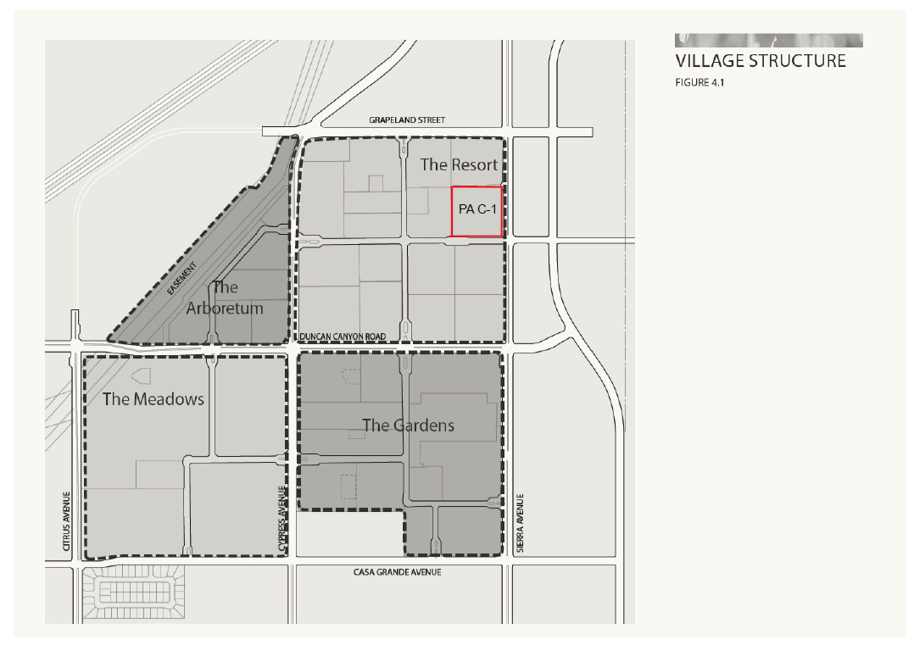

EXHIBIT “E”
TO ARBORETUM DEVELOPMENT AGREEMENT

[SEE ATTACHED]

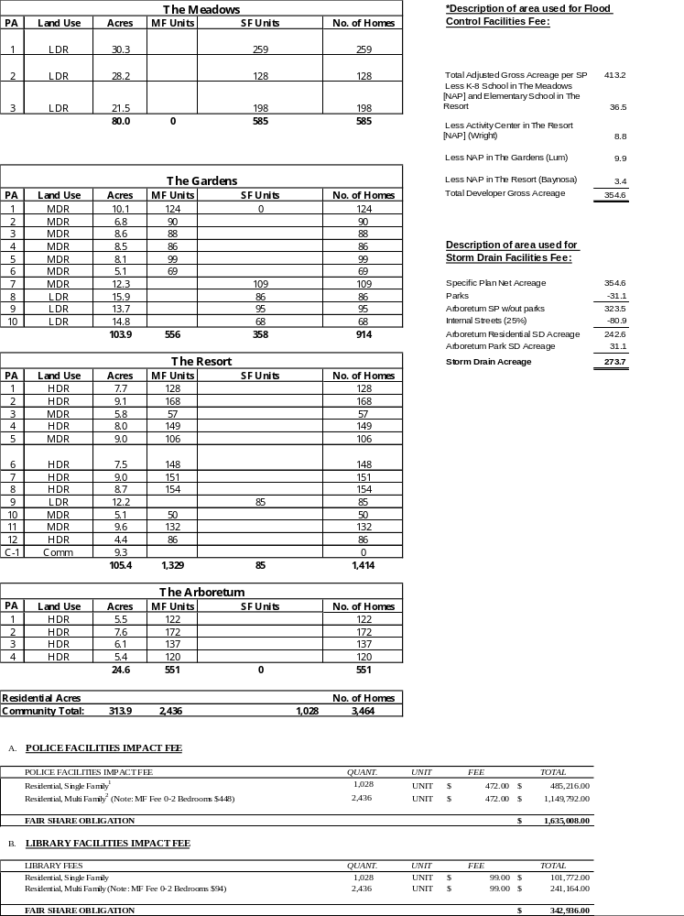
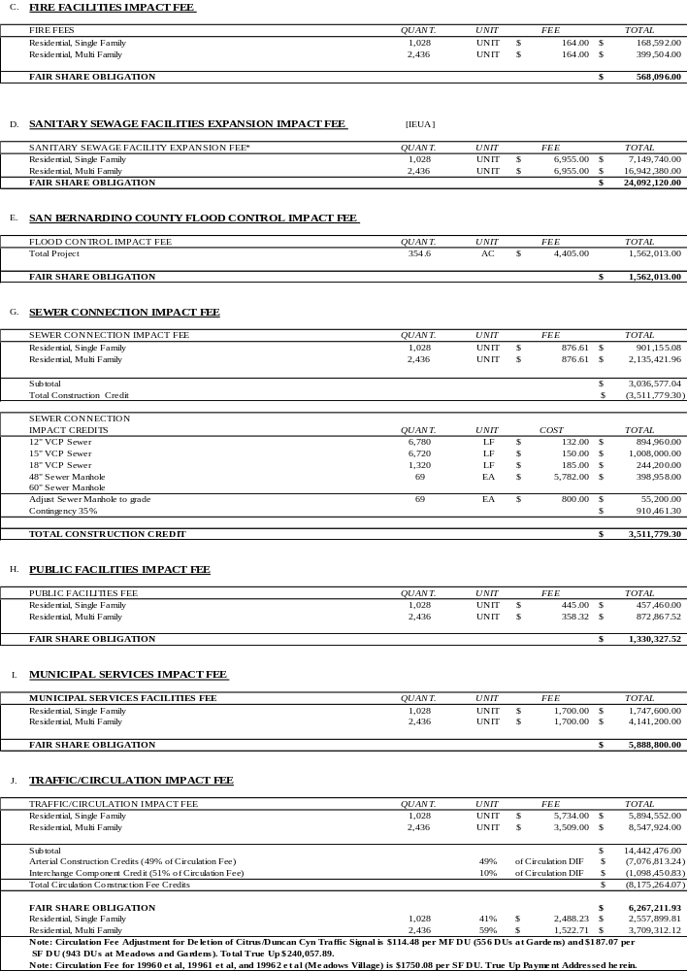
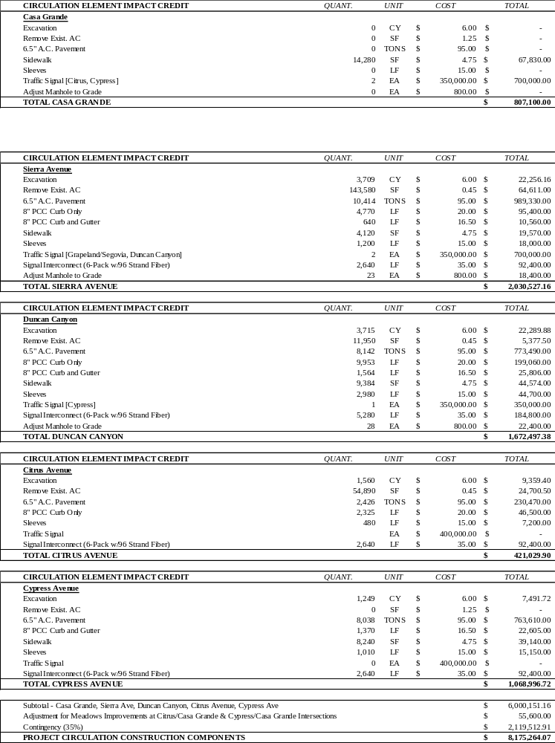

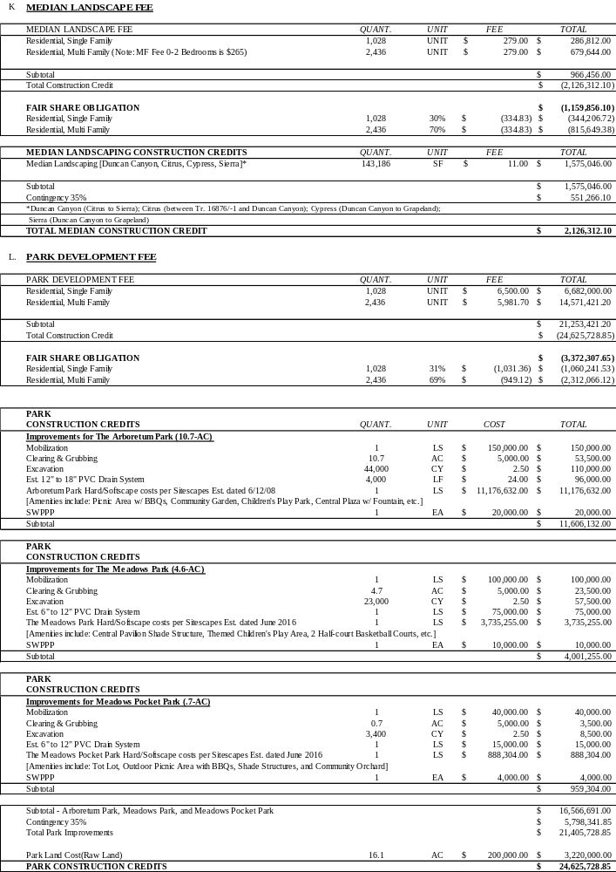
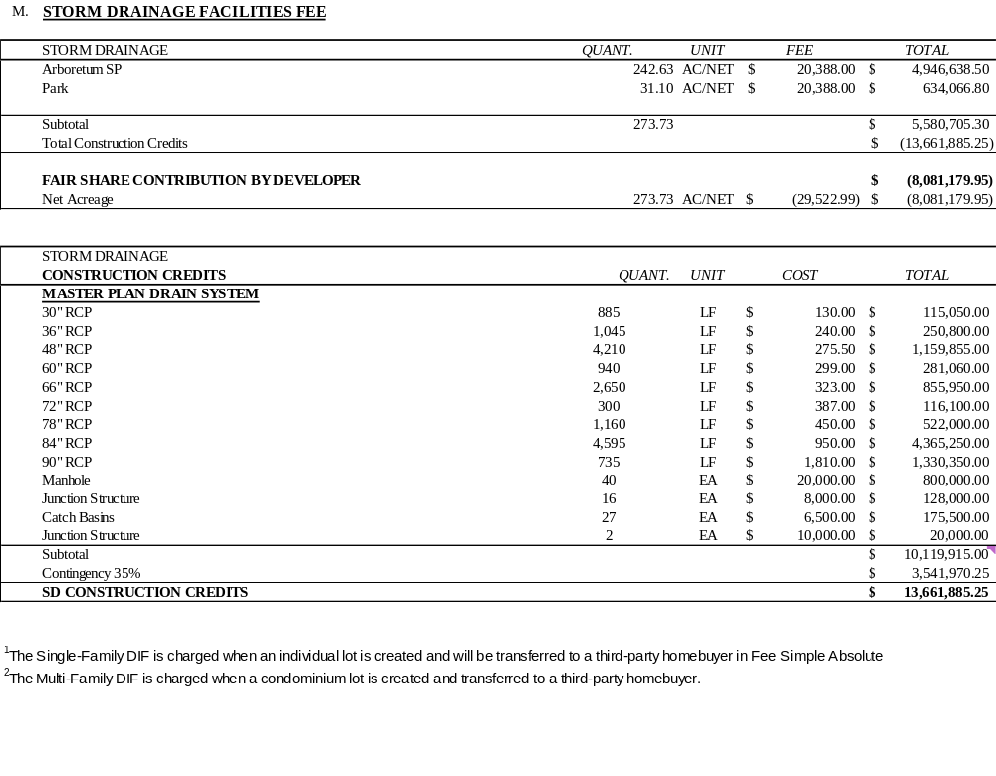

EXHIBIT “E-3”
TO ARBORETUM DEVELOPMENT AGREEMENT
Excess Fee Credits
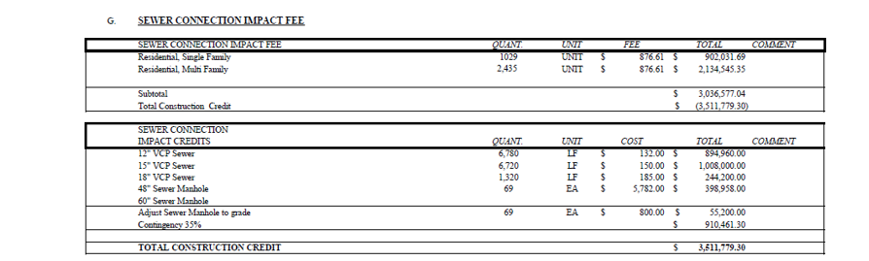
Excess Sewer Connection Credits $ 475,202.26

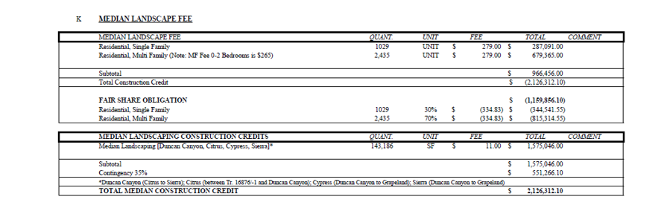

Excess Median Landscape Credits $ 1,159,856.10

- 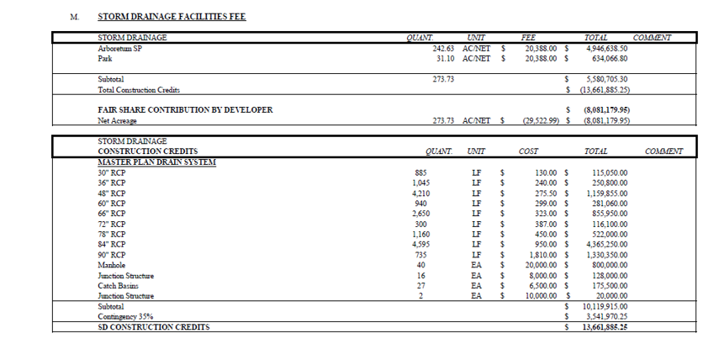

Excess Storm Drain Credits $ 8,081,179.95

EXHIBIT “L-1”
TO ARBORETUM DEVELOPMENT AGREEMENT
Arboretum Fee Schedule-Commercial
[As of Effective Date of Third Amendment]
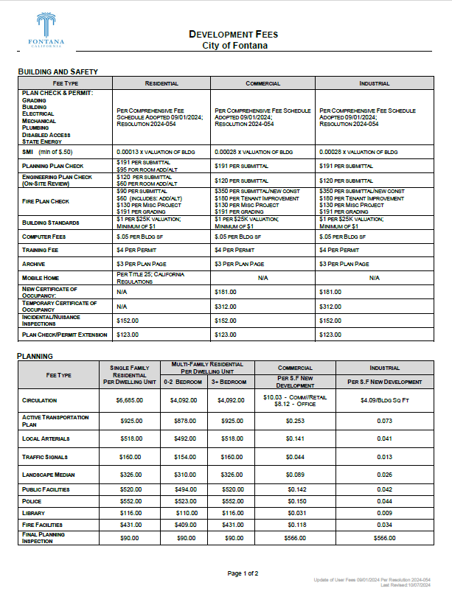
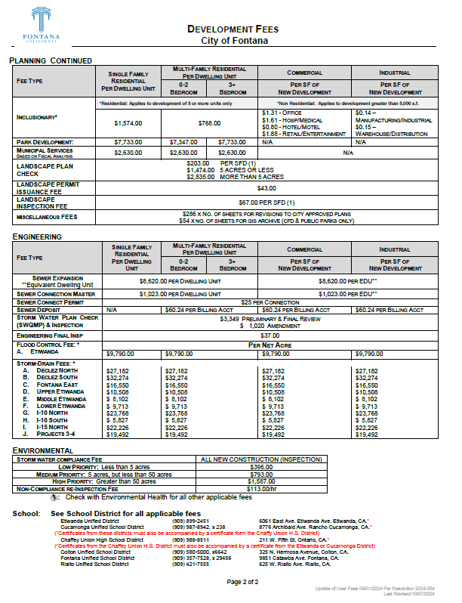
** Approximately 65 EDUs (To be determined in accordance with City calculation of EDU’s for commercial facilities in the Land Use Regulations)

