NOTICE OF PUBLIC HEARING

SI DESEA INFORMACION EN ESPAÑOL REFERENTE A ESTA NOTIFICACION O PROYECTO, FAVOR DE COMUNICARSE AL (909) 350-6728.

In compliance with Section 202 of the Americans with Disabilities Act of 1990 (42 U.S.C. Sec. 12132) and the federal rules and regulations adopted in implementation thereof, the Agenda will be made available in appropriate alternative formats to persons with a disability. Should you need special assistance to participate in this meeting, please contact the City Clerk’s Department by calling (909) 350-7602. Notification 48 hours prior to the meeting will enable the City to make reasonable arrangements to ensure accessibility to this meeting.

A PUBLIC HEARING HAS BEEN SCHEDULED BEFORE THE CITY COUNCIL OF THE CITY OF FONTANA FOR THE FOLLOWING:

Appeal (APL) No. 25-0002 & Master Case No. 23-0101

A request by Supporters Alliance for Environmental Responsibility (“SAFER”) (“The Appellant”) to appeal the Planning Commission’s decision on August 19, 2025, which approved Master Case No. 23-0101 for Conditional Use Permit No. 24-0022 and Design Review No. 23-0024 along with the Categorical Exemption (Section 15332, Class No. 32 – Infill Development) for the development of a mixed use project (163 multi-family units and 5,000 square feet of commercial retail) within the R-5 zoning district and for site and architectural review of a five-story 83,125 square foot mixed-use building and associate improvements, on a 3.5 gross acre project site. Additionally, the project would include associated fitness centers, pool areas, fire pits, lounge areas, roof top amenity and other amenities on a site located at the northeast corner of Foothill Boulevard and Sultana Avenue (APNs: 1110-331-13 and 1110-331-25).

Environmental Determination: | On August 19, 2025, the Planning Commission adopted a Categorical Exemption for the development of the property for Master Case No. 23-0101: Conditional Use Permit No. 24-0022 and Design Review No. 23-0024, in accordance with Section 15332 (Class No. 32 – Infill Development) of the California Environmental Quality Act (CEQA) and Section 3.22 of the 2019 City of Fontana Local Guidelines for Implementing the CEQA.
Location of Property: | The project site is located at the northeast corner of Foothill Boulevard and Sultana Avenue. (APN Nos.: 1110-331-13 and 1110-331-25) | 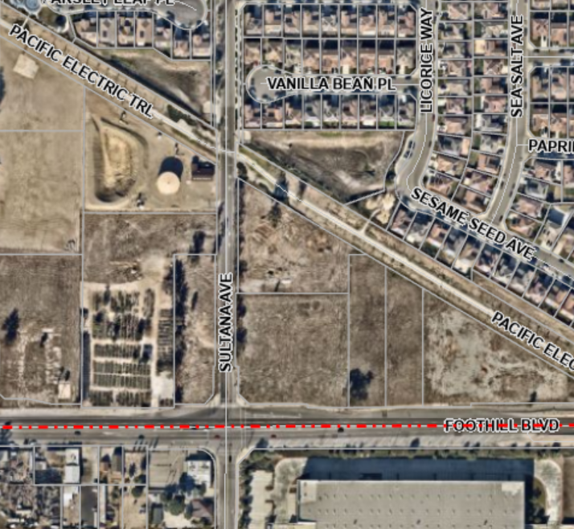  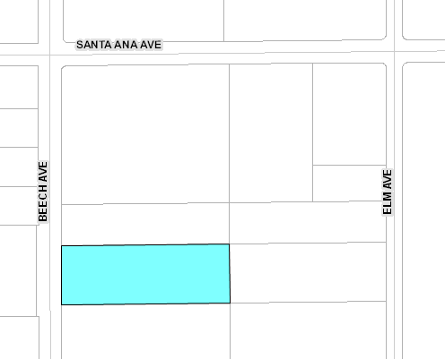  Foothill Blvd.  Sultana Ave.
Date of Hearing: | October 28, 2025  Project Site
Place of Hearing: | City Hall Council Chambers  8353 Sierra Avenue  Fontana, CA 92335
Time of Hearing: | 2:00 P.M.

Should you have any questions concerning this project, please contact Salvador Quintanilla, Senior Planner, at (909) 350-6656 or squintanilla@fontanaca.gov.

ANY INTERESTED PARTY MAY APPEAR AND PRESENT ANY INFORMATION BY LETTER OR EMAIL WHICH MAY BE OF ASSISTANCE TO THE CITY COUNCIL. A COPY OF THE APPLICATION AND ENVIRONMENTAL DOCUMENTATION IS AVAILABLE FOR INSPECTION. PLEASE CONTACT THE PLANNER LISTED ABOVE.

IF YOU CHALLENGE IN COURT ANY ACTION TAKEN CONCERNING A PUBLIC HEARING ITEM, YOU MAY BE LIMITED TO RAISING ONLY THOSE ISSUES YOU OR SOMEONE ELSE RAISED AT THE PUBLIC HEARING DESCRIBED IN THIS NOTICE, OR IN WRITTEN CORRESPONDENCE TO THE CITY AT, OR PRIOR TO, THE PUBLIC HEARING.

Publish: October 17, 2025

