ORDINANCE NO. 1996

AN ORDINANCE OF THE CITY COUNCIL OF THE CITY OF FONTANA, CALIFORNIA APPROVING, PURSUANT TO THE PROJECT ADDENDUM TO THE VENTANA AT DUNCAN CANYON SPECIFIC PLAN, SPECIFIC PLAN AMENDMENT NO. 26-0001, AN AMENDMENT TO THE VENTANA AT DUNCAN CANYON SPECIFIC PLAN TO MODIFY ALLOWED LAND USES.

WHEREAS, the City of Fontana (the “City”) received an application on January 26, 2026 from The Previti Group (“Applicant”) for a Specific Plan Amendment (“SPA No. 26-0001”) to add gas station and drive through uses to Planning Area 4 of the Ventana at Duncan Canyon Specific Plan, four Conditional Use Permits to establish a gas station use and Type 20 (Beer & Wine, Off-Sale) Alcohol Beverage Control (“ABC”) License for a convenience store as part of a gas station (“CUP No. 26-0001”), to establish an ABC Type 21 (General, Off-Sale) and Type 86 (Sampling) License for a grocery store (“CUP No. 26-0002”), to establish a drive-through use for a standalone building (“CUP No. 26-0003”), to establish a drive-through use for a suite as part of a multi-tenant building “CUP No 26-0011”), and a Design Review (“DR No. 26-0002”), for site and architectural review of a new 98,783 square foot retail shopping center with associated site improvements, at the Project Site (“Project”); and

WHEREAS, pursuant to the California Environmental Quality Act (Pub. Res. Code Section 2100) (“CEQA”) Guidelines and the State CEQA Guidelines (14. Cal Code Regs. Section 1500), the city, acting as the lead agency under CEQA, previously determined that an Environmental Impact Report (EIR) must be prepared to evaluate and disclose all potential significant environmental impacts associated with the Ventana at Duncan Canyon Specific Plan; and

WHEREAS, on September 13, 2022, the City certified the Final Environmental Impact Report ("FEIR") (SCH No. 2021100400) for the Ventana Specific Plan. The FEIR consists of the Draft EIR, comments received during the 45-day public review and comment period on the Draft EIR, written responses to those comments, and revisions documented in an errata section. For purposes of this Resolution, the term "FEIR" refers to the Draft EIR as revised by the errata, along with all other sections comprising the Final EIR; and

WHEREAS, pursuant to CEQA, when taking when taking subsequent discretionary actions on a project for which an EIR has been certified, the lead agency is required to review any changed circumstances to determine whether any of the circumstances under Public Resources Code Section 21166 and State CEQA Guidelines Section 15162 require additional environmental review; and

WHEREAS, pursuant to CEQA Guidelines Section 15164, a lead agency shall prepare an addendum to a previously certified EIR if some changes or additions are necessary but none of the conditions described in Section 15162 calling for preparation of a subsequent EIR have occurred; and

WHEREAS, the City evaluated the proposed Project in light of the standards for subsequent environmental review outlined in Public Resources Code Section 21166, State CEQA Guidelines Section 14162 and the City of Fontana’s 2019 Local Guidelines for Implementing CEQA and concluded that the proposed Project would not result in new significant environmental effects that were previously disclosed in the FEIR and therefore, no subsequent EIR or mitigated negative declaration is required; and

WHEREAS, the proposed Project would nonetheless necessitate minor changes or additions to the FEIR, and thus, the City has prepared an Addendum to the FEIR pursuant to State CEQA Guidelines Section 15164; and

WHEREAS, pursuant to State CEQA guidelines Section 15164, subdivision (c), the Addendum is not required to be circulated for public review, but can be attached to the FEIR; and
WHEREAS, on June 16, 2026, the Fontana Planning Commission (“Planning Commission”) held a noticed public hearing and received public testimony and evidence by the Applicant, City staff, and other interested parties for MCN 26-0004 and Addendum to the Ventana at Duncan Canyon Specific Plan Environmental Impact Report (“Ventana EIR”) and Mitigation Monitoring and Reporting Program (“MMRP”). After carefully considering all information pertaining to the project, the Planning Commission voted 3-0 to recommend approval to City Council (“City Council”) by Resolution No. PC 2026-023; and
WHEREAS, on July 14, 2026, the City Council held a noticed public hearing on the Addendum to the Ventana at Duncan Canyon Specific Plan Environmental Impact Report, MMRP, and MCN No. 26-0004, received testimony from all parties and documentation from the Planning Commission’s public hearing on June 16, 2026; and
WHEREAS, based on the information presented to the City Council at the public hearing held on July 14, 2026, the City Council found that the amendments and project are in conformance with the goals and policies of the General Plan to provide a community that is balanced between residential, commercial, and industrial uses, is developed with high standards, and provides diverse economic and social opportunities for our citizens and those who wish to invest in the City.

NOW, THEREFORE, THE CITY COUNCIL OF THE CITY OF FONTANA, CALIFORNIA DOES ORDAIN AS FOLLOWS:

Section 1. Recitals. The recitals are true, correct and incorporated herein by this reference.
Section 2. Compliance with California Environmental Quality Act. As the decision-making body for the Project, the City Council has reviewed and considered the Ventana at Duncan Canyon Specific Plan FEIR and Addendum, any oral or written comments received, and the administrative record prior to making any decision on the proposed project. The City Council finds that the Addendum and Ventana at Duncan Canyon Specific Plan FEIR contain a complete and accurate reporting of all of the environmental impacts associated with the proposed project. The City Council further finds that the Addendum has been completed in compliance with the State CEQA Guidelines and Section 8.06 of the City of Fontana’s 2019 Local Guidelines for Implementing CEQA.

Section 3. Findings on the Necessity for a Subsequent or Supplemental Environmental Impact Report. Based on the substantial evidence set forth in the record, including but not limited to, the Ventana at Duncan Canyon Specific Plan FEIR, the Addendum, and all related information presented to the City Council, the City Council finds that the Proposed Project necessitates only minor modifications to the Ventana at Duncan Canyon Specific Plan FEIR. Therefore, pursuant to State CEQA section 15164 and Section 8.06 of the City of Fontana’s 2019 Local Guidelines for Implementing CEQA, an Addendum to the Ventana at Duncan Canyon Specific Plan FEIR is the appropriate document for the project.

The City Council further finds that the preparation of a subsequent or supplemental EIR is not required for the proposed projects because the projects:

- Will not result in substantial changes that would require major revisions of the Ventana at Duncan Canyon Specific Plan FEIR due to the involvement of new significant environmental effects or a substantial increase in the severity of previously identified significant effects; and
- Will not result in substantial changes with respect to the circumstances under which the roposed roject are developed that would require major revisions of the Ventana at Duncan Canyon Specific Plan FEIR due to the involvement of new significant environmental effects or a substantial increase in the severity of the previously identified significant effects; and
- Does not present new information of substantial importance that was not known and could not have been known with the exercise of reasonable diligence at the time the Ventana at Duncan Canyon Specific Plan FEIR documents were certified showing any of the following:
  - The proposed project would have one or more significant effects not discussed in the EIR;
  - That significant effects previously examined would be substantially more severe than shown in the EIR;
  - That mitigation measures or alternatives previously found not to be feasible would in fact be feasible and would substantially reduce one or more significant effects, but the lead agency declined to adopt such measures; and
  - That mitigation measures or alternatives considerably different from those analyzed would substantially reduce one or more significant effects on the environment, but which the lead agency declined to adopt.

Section 4. Findings on Environmental Impacts. Having considered the Addendum, the administrative record, the Ventana Specific Plan FEIR and all written and oral evidence presented to the City Council, the City Council finds that all environmental impacts of the proposed project have been addressed within the Ventana Specific Plan FEIR and the Addendum. The City Council finds that no new or additional mitigation measures or alternatives are required. The City Council further finds that there is no substantial evidence in the administrative record that the proposed project may result in any significant environmental impacts beyond those analyzed in the Ventana Specific Plan FEIR. The City Council finds that the Addendum contains a complete, objective, and accurate reporting of the environmental impacts associated with the proposed project and reflects the independent judgment and analysis of the City Council.

Section 5. Adoption of the Addendum to the Ventana at Duncan Canyon Specific Plan FEIR. The City Council hereby adopts the Addendum to the EIR for the Ventana at Duncan Canyon Specific Plan Program Environmental Impact Report (SCH No. 2021100400) and Mitigation, Monitoring, and Reporting Program (MMRP) that have been prepared pursuant State CEQA Guidelines Sections 15162 and 15164 along with the City of Fontana’s 2019 Local Guidelines for Implementing CEQA. The City Council further directs staff to file a Notice of Determination.

Section 6. Specific Plan Amendment Findings. The City Council hereby makes the following findings for Specific Plan Amendment No. 26-0001 in accordance with Section 30-67 “Purpose” of the Fontana Zoning and Development Code:

Finding: A Specific Plan may be amended by changing the development standards or zoning designation of any zone whenever such an amendment is deemed necessary to protect or promote the public's health, safety or general welfare or when modification is viewed as appropriate in the context of generally accepted planning principles, surrounding land uses, and the General Plan.

Findings of Fact: The Ventana at Duncan Canyon Specific Plan was adopted March 27, 2007. The Applicant is proposing to add gas stations and drive-through uses as conditionally permitted uses within Planning Area 4. Currently gas stations and drive-throughs are prohibited uses within Planning Area 4. Gas stations and drive-throughs are reasonable uses to add to Planning Area 4 because Planning Area 4 is located at the southwest corner of Duncan Canyon Road and John Previti Avenue—which is in close proximity to the freeway. This will attract residents and other visitors to the commercial center, which will include a gas station with a convenience store, generating additional revenue for the local economy and increasing customer traffic to surrounding businesses. Allowing gas stations and drive-throughs as conditionally permitted uses will enable the City to regulate the land uses by imposing conditions of approval to address site-specific operational and compatibility considerations. Additionally, drive-through restaurants will be subject to the Special Use Regulations in Chapter 30.

Section 7. Approval. Based on the findings in Section 6, Specific Plan Amendment No. 26-0001 is hereby approved and the Ventana at Duncan Canyon Specific Plan is amended to modify the allowed land uses in the specific plan area as shown in Exhibit “A”, attached hereto and by this reference incorporated herein.

Section 8. Effective Date/Publication. This Ordinance shall take effect thirty (30) days after the date of the adoption and prior to the expiration of fifteen (15) days from the passage thereof, shall be published by the City Clerk at least once in the Fontana Herald News, a local newspaper of the general circulation, published and circulated in the City of Fontana, and henceforth and thereafter the same shall be in full force and effect.

Section 9. Custodian of Records. The documents and materials that constitute the record of proceedings on which this Ordinance is based are located at the City Clerk’s office located at 16860 Valencia Avenue, Fontana, CA 92335. The custodian or records is the City Clerk.

Section 10. Certification. The City Clerk of the City Council shall certify to the adoption of this Ordinance.

Section 11. Severability. If any provision of this Ordinance or the application of any such provision to any person or circumstance is held invalid, such invalidity shall not affect other provisions or applications of this Ordinance that can be given effect without the invalid provision or application.

APPROVED AND ADOPTED this 11th day of August 2026.

READ AND APPROVED AS TO LEGAL FORM:

______________________________
City Attorney

I, Germaine Key, City Clerk of the City of Fontana, and Ex-Officio Clerk of the City Council, do hereby certify that the foregoing Ordinance is the actual Ordinance adopted by the City Council and was introduced at a regular meeting on the 14th day of July 2026, and was finally passed and adopted not less than five days thereafter on the 11th day of August 2026, by the following vote to wit:

AYES:
NOES:
ABSENT:
ABSTAIN:

______________________________
City Clerk of the City of Fontana

______________________________
Mayor of the City of Fontana

ATTEST:

______________________________
City Clerk

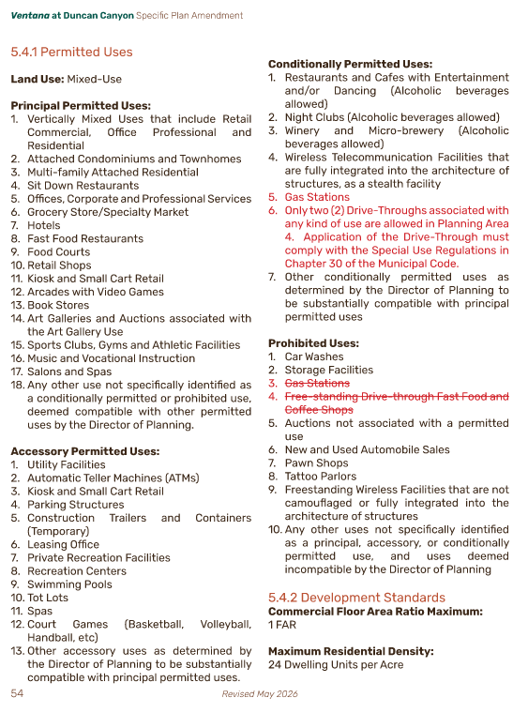
EXHIBIT “A”

