RESOLUTION NO. 2023-____
A RESOLUTION OF THE CITY COUNCIL OF THE CITY OF FONTANA ADOPTING THE MITIGATED NEGATIVE DECLARATION (MND) ALONG WITH A Mitigation Monitoring and Reporting Program (MMRP) PURSUANT TO THE CALIFORNIA ENVIRONMENTAL QUALITY ACT (CEQA) , AND APPROVING GENERAL PLAN AMENDMENT NO. 22-005, (PART NO. 2 OF GENERAL PLAN AMENDMENT CYCLE NO. 4 OF 2023) TO CHANGE THE GENERAL PLAN LAND USE MAP ON EXHIBIT NO. 15.8 IN CHAPTER 15 OF THE GENERAL PLAN FOR APNS: 0230-041-33, -44, -52, -60, AND -61, TOTALING APPROXIMATELY 2.4 ADJUSTED GROSS ACRES, FROM SINGLE-FAMILY RESIDENTIAL (R-SF) TO WALKABLE MIXED USE CORRIDOR & DOWNTOWN (WMXU-1) AND A DESIGN REVIEW PROJECT (DRP) 22-020 TO DEVELOP A NEW 24-UNIT MULTI-FAMILY- PROJECT ON TWO (2) PARCELS, APNS 0230-041-52 AND -60, TOTALING APPROXIMATELY 0.9 GROSS ACRES
WHEREAS, assessor parcel numbers 0230-041-33, -44, -52, -60, and -61 were annexed from San Bernardino County and incorporated into the City of Fontana on June 21, 2005 (Annex 2968); and
WHEREAS, on November 13, 2018, the most recent edition of the City of Fontana General Plan (“General Plan”) was adopted by the Fontana City Council (“City Council”); and
WHEREAS, on March 8, 2022, the City of Fontana (“the City”) received an application from SA Golden Investment, Inc. (“Applicant”), for five (5) existing lots on the east side of Banana Avenue approximately 270 feet south of the southeast corner of the intersection of Foothill Boulevard and Banana Avenue, more specifically known as APNs: 0230-041-33, -44, -52, -60, and -61 (“Project Site”), for a General Plan Amendment (“GPA No. 22-005”) to amend the land use designation as illustrated on Exhibit 15.8 in Chapter 15 of the General Plan from Single-Family Residential (R-SF) to Walkable Mixed Use Corridor & Downtown (WMXU-1) for the Project Site, a Zoning District Map Amendment (“ZCA No. 22-006”) to amend the Zoning District Map from Residential-Single Family (R-1) to Form-Based Code (FBC) for the Project Site, a Development Code Amendment (“ZCA No. 22-007”) to update the Form-Based Code map to identify the Project Site as a Route 66 Gateway sub district and a Design Review (DRP No. 22-020) to develop a new 24-unit multi-family project on APNs: 0230-041-52 and 60. All of the amendments together are known as Master Case Number 22-037 (“MCN 22-037”); and,
WHEREAS, the amendments to the General Plan will contribute to additional residential dwelling units that will provide a sustainable community where future occupants of the Project Site could live and utilize the services in the area as anticipated in the General Plan; and
WHEREAS, an amendment to the General Plan will assist the City in meeting its Regional Housing Needs Assessment (RHNA) number and will increase the unit count from the existing maximum of 12 residential units to a maximum of 93 residential units; and
WHEREAS, MCN 22-037 is supported by the goals and policies of the General Plan; and
WHEREAS, the General Plan Amendment is considered a “Project” as defined by the California Environmental Quality Act (CEQA); and

WHEREAS, pursuant to the California Environmental Act (CEQA), an Initial Study/Mitigated Negative Declaration and Mitigation Monitoring and Reporting Program was published on August 9, 2023, and determined that, with mitigation, no significant impacts would be result from the project, therefore, a Mitigated Negative Declaration has been recommended for adoption; and
WHEREAS, all the notices required by statute and the Fontana Municipal Code have been given as required; and
WHEREAS, on October 17, 2023, the Fontana Planning Commission (“Planning Commission”) conducted a publicly noticed hearing and received public testimony and evidence presented by the Applicant, City staff, and other interested parties, at the Public Hearing held on the project, MND, MMRP and MCN 22-037, and recommended approval with a vote of 3-0 to the City Council by Resolution No. 2023-036; and
WHEREAS, on November 14, 2023, the City Council conducted a noticed public hearing on the project, MND, MMRP and MCN 22-037, received testimony from all parties and documentation from the Planning Commission’s public hearing on October 17, 2023; and
WHEREAS, based on the information presented to and evidence received by the City Council at the public hearing held on November 14, 2023 for the project, MND, MMRP, and MCN 22-037, the City Council found that the amendments and project are in conformance with the goals and policies of the General Plan; and
WHEREAS, the City wishes to protect and preserve the quality of the life through effective land use and planning; and

WHEREAS, pursuant to Government Code Section 65358 on November 14, 2023 the City Council adopted one General Plan Amendment in the following five parts: Part No. 1 – GPA No. 22-001, Merrill Land Use Re designation; Part No. 2 – GPA No. 22-005, Banana North Apartments; Part No. 3–GPA No. 22-007, Poplar South Distribution Center Project Part No. 4– GPA No. 23-003, Arrow and Tokay Land Use Re designation; and Part No. 5 – GPA No. 23-004, Citrus/Oleander Industrial Commerce Center; and
NOW, THEREFORE, the City Council RESOLVES as follows:
SECTION 1. Recitals. The recitals are true and correct and incorporated herein by this reference.
SECTION 2. CEQA. The City Council hereby adopts the Mitigated Negative Declaration along with the MMRP for the proposed project. The City Council finds that the Mitigated Negative Declaration contains a complete and accurate reporting of all the environmental impacts associated with the Project. The City Council further finds that the Mitigated Negative Declaration has been completed in compliance with CEQA, 2019 Local Guidelines for Implementing the California Environmental Quality Act, and the State CEQA Guidelines.
Section 3. General Plan Amendment Findings. The City Council hereby makes the following findings for GPA No. 22-005 in accordance with Section 30-31 “Purpose” of the Fontana Zoning and Development Code:
Finding: The purpose and intent is to keep an updated General Plan to reflect the current desires and needs of the citizens for the long -term growth of the City.
Findings of Fact: The project includes an amendment to the General Plan land use designation (GPA No. 22-005) to change General Plan land use map, Exhibit No. 15.8, from Single--Family Residential (R-SF) to Walkable Mixed Used Corridor & Downtown (WMXU-1); a Zoning District Map Amendment (ZCA No. 22-006) to update the zoning map from Single--Family Residential (R-1) to Form-Based Code (FBC), a Development Code Amendment (ZCA No. 22-007) to change the Form-Based Code map to identify the Project Site as a Route 66 Gateway, and a Design Review Project (DRP 22-020) to construct a new 24-unit apartment project on two (2) parcels (APNs 0230-041-52 and -60) totaling approximately 0.9 gross acres. The GPA will continue to provide a land use designation to allow for the development of various housing types, which meets the long term goal of the City.
SECTION 4. Design Review Findings. The City of Fontana’s, Planning Commission hereby makes the following findings for Design Review No. 22-020 in accordance with Section No. 30-120 “Findings for Approval” for Design Review of the Zoning and Development Code:
Finding No. 1: The proposal is consistent with the General Plan, Zoning and Development Code, and any applicable Specific Plan.
Findings of Fact: The project site is located on east side of Banana Avenue approximately 270 feet south of the southeast corner of the intersection of Foothill Boulevard and Banana Avenue. The project site has a General Plan land use designation of Single-Family Residential (R-SF). After the approval of General Plan Amendment No. 22-005, to change the General Plan land use map from Single-Family Residential (R-SF) to Walkable Mixed Use Corridor & Downtown (WMXU-1) for the properties of APNs: 0230-041-33, -44, -52, -60, and -61, totaling approximately 2.4 adjusted gross acres total, the project site will be consistent with the WMXU-1 land use designation. The WMXU-1 designation is intended to provide for the creation of areas that allow residents and visitors to walk, bike and take transit to other uses for work, study, shopping, entertainment, recreation and civic activities. Furthermore, the project will provide compact residential development within walking distance of planned public transit stops and neighborhood shopping areas. Uses include a variety of medium-density to high-density residential types, commercial and open space. WMXU-1 residential densities range from 3 to 39 dwelling units per acre. The designation was created to cover the half-mile walking distance radii (known as “walksheds”) from planned public transit stops. This use will be allowed within the applicable General Plan land use area.
The General Plan is the document that sets the framework for the City of Fontana and provides the overall policies for development within the community. Furthermore, the General Plan encourages variety of development including residential uses.
The Applicant has request a site and architectural review of a new 24-unit apartment project over two parcels, APNs 0230-041-52 and -60, totaling approximately 0.9 gross acres. The total building area is approximately 43,986 square feet, within one (1) three-story building with 1-bedrooms (944 square feet), 2-bedrooms (1,090 square feet), and 3-bedrooms (1,333 square feet) units.
The project will encompass a Tuscan architectural style for the apartment buildings. The elevations include varying warm and neutral hues. A variety of design features and materials are provided on the elevations such as stone veneer, arched wall openings, decorative window treatment and shutters, varied rooflines, and other features appropriate to the Tuscan architecture. The variety in color and material will provide for an architecturally pleasing project that will enhance the character of the neighborhood.
This development meets the criteria contained in the Design Review section of the Municipal Code. Additionally, the project is aesthetically enhanced with architectural detail and the site design incorporates elements resulting in a desirable development. The buildings will not exceed the maximum height of 38-foot. The project has high-quality architectural design and will be an appropriate and desirable development for the community.
Finding No. 2: The proposal meets or exceeds the criteria contained in this chapter and will result in an appropriate, safe, and desirable development promoting the public health, safety, and welfare of the community.
Findings of Fact: The project is located within the Route 66 Gateway subdistrict of the Form-Base Code (FBC) zoning district and has been determined to be aesthetically and architecturally pleasing and compatible with the neighborhood. The apartment complex is contemporary and true to style and compatible with the surrounding homes, resulting in high-quality architectural design appropriate and desirable for the surrounding community. The development will enhance the character of the surrounding residential area through appropriate attention to aesthetics and design.
The project includes street improvements: sidewalks, drainage, grading, and perimeter walls to provide a safe and well-designed complex. The project has been reviewed by the City of Fontana’s Planning, Engineering, Building and Safety, and Fire Prevention Departments (“Departments”) for site circulation, access, and safety. The Departments have determined that the project meets or exceeds the standards of the Zoning and Development Code and will provide a safe design for normal public access provided the project complies with the Conditions of Approval.
Finding No. 3: The proposal, in its design and appearance, is aesthetically and architecturally pleasing resulting in a safe, well-designed facility while enhancing the character of the surrounding neighborhood.
Findings of Fact: The project will provide much needed improvements to the project site and surrounding area. The project includes street improvements: sidewalks, drainage, grading and perimeter walls to provide a safe and well-designed complex. The apartment complex has been reviewed by the City of Fontana’s Planning, Engineering, Building and Safety, and Fire Prevention Departments (“Departments”) for site circulation, access, and safety. The Departments have determined that the project meets or exceeds the standards of the Zoning and Development Code and will provide a safe design for normal public access provided the project complies with the Conditions of Approval. This structure will be built pursuant to all applicable building, zoning and fire codes standards and therefore, shall promote the public health, safety, and welfare of the surrounding community.
Finding No. 4: The site improvements are appropriate and will result in a safe, well-designed facility.
Findings of Fact: The project has been determined to be appropriate and will result in a safe, well-designed facility. There will be one (1) main vehicle access points to the site. The main entrance will be accessed from Banana Avenue. The driveway is designed to accommodate passenger vehicle traffic and service vehicles, as necessary. The project has been reviewed by the City of Fontana’s Planning, Engineering, Building and Safety, and Fire Prevention Departments (“Departments”) for site circulation, access, and safety. The Departments have determined that the project meets or exceeds the standards of the Zoning and Development Code and will result in a safe, well-designed facility provided the project complies with the Conditions of Approval. The character of the surrounding neighborhood reflects residential uses consisting primarily of multi-family dwellings, attached and detached single-family homes.
section 5. General Plan Amendment Approval. Based on the findings in Section 3, the City Council hereby approves GPA No. 22-005 to change General Plan land use designation for the Project Site as illustrated in Exhibit No. 15.8 (General Plan land use map) from Single Family Residential (RSF) to Walkable Mixed Used Corridor & Downtown (WMXU1), which is comprised of five (5) parcels as shown as Exhibit “A” attached hereto and incorporated herein by reference as fully set forth herein.

SECTION 6. Design Review Approval. Based on the findings in Section 4 the City Council of the City of Fontana hereby approves Design Review No. 22-020 subject to the Conditions of Approval, which are attached hereto as Exhibit “B” and incorporated herein by reference as though fully set forth herein.
SECTION 7. Effective Date. This Resolution shall take effect thirty (30) days after the adoption of the City Council Ordinance adopting Zoning District Map Amendment (ZCA No. 22-006) and City Council Ordinance adopting Development Code Amendment (ZCA No. 22-007) whichever is adopted later, provided however, if either of those Ordinances are for any reason held to be invalid or unconstitutional by the decision of any court of competent jurisdiction, or otherwise do not go into effect for any reason, then this Resolution shall be null and void and have no further force and effect.
SECTION 8. Resolution Regarding Custodian of Record. The documents and materials that constitute the record of proceedings on which this Resolution has been based are located at the Planning Department, 8353 Sierra Avenue, Fontana, CA 92335. This information is provided in compliance with Public Resources Code, Section No. 21081.6.
Section 9. Certification. The City Clerk of the City Council shall certify to the adoption of this Resolution.
SECTION 10. Severability. If any provision of this Resolution or the application of any such provision to any person or circumstance is held invalid, such invalidity shall not affect other provisions or applications of this Resolution that can be given effect without the invalid provision or application.

PASSED, APPROVED AND ADOPTED this 14th day of November 2023.

READ AND APPROVED AS TO LEGAL FORM:

_____________________
City Attorney
ATTEST:
I, Germaine Key, City Clerk of the City of Fontana and Ex-Officio Clerk of the City Council, do hereby certify that the foregoing resolution is the actual resolution duly and regularly adopted by the City of Fontana at a regular meeting thereof, held on the 14th day of November 2023, by the following vote to wit:

AYES:
NOES:
ABSENT:
ABSTAIN:

City Clerk of the City of Fontana

Mayor of the City of Fontana

ATTEST:

______________________________________

City Clerk
EXHIBIT “A”
EXISTING AND PROPOSED GENERAL PLAN LAND USE DESIGNATION - FOR FIVE (5) PARCELS, (APNS: 0230-041-33, -44, -52, -60, AND -61) GROSS ACRES, FROM SINGLE-FAMILY RESIDENTIAL (R-SF) TO WALKABLE MIXED USED CORRIDOR & DOWNTOWN (WMXU-1) TOTALING APPROXIMATELY 2.4 ADJUSTED
Existing General Plan Land Use Designation – R-SF
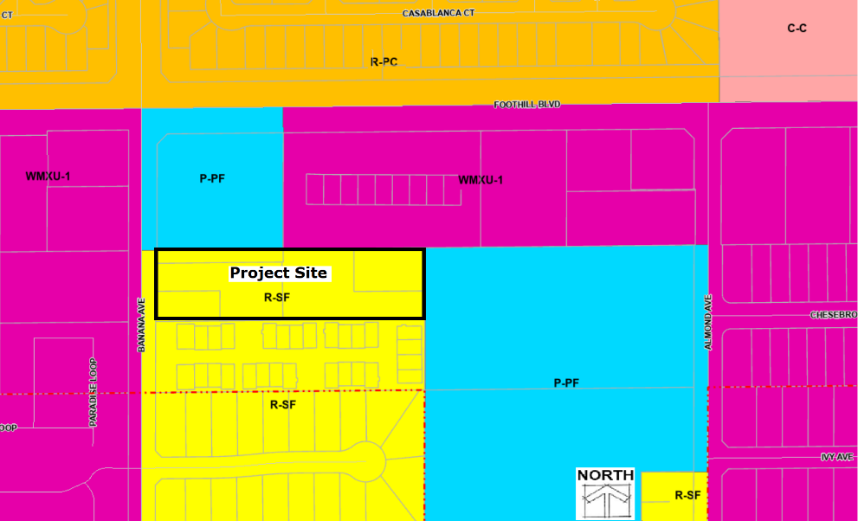
Proposed Walkable Mixed-Use Corridor and Downtown (WMXU-1)
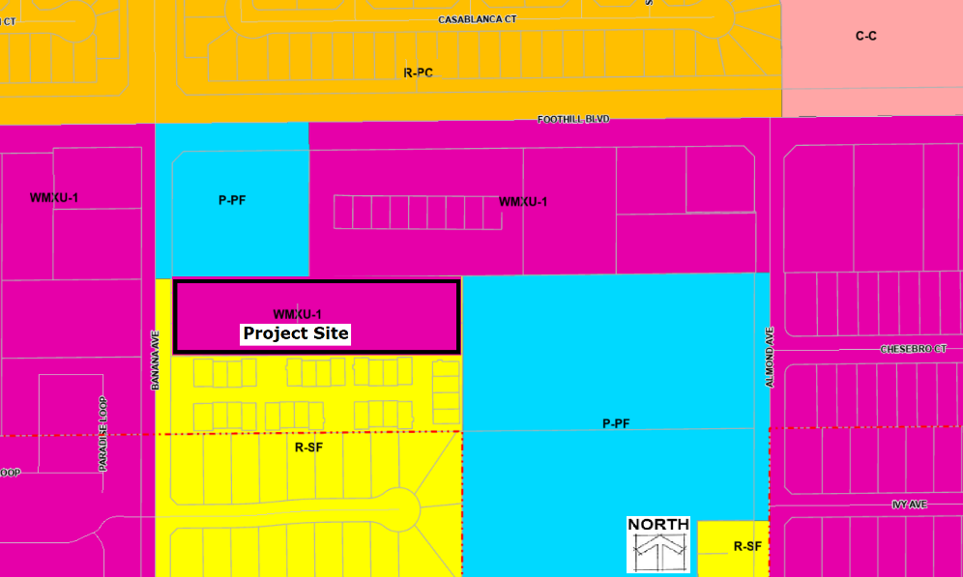
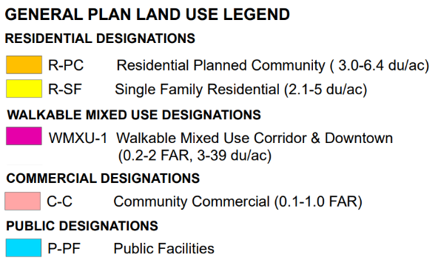

“EXHIBIT B”



CITY OF FONTANA

CONDITIONS OF APPROVAL
PROJECT: Design Review No. 22-020 DATE: November 14, 2023
Master Case No. 22-037
LOCATION: The project site is located at 8155 Banana Avenue APNs: 0230-041-33, -44, -52, -60, and -61
PLANNING DEPARTMENT:
- The applicant/developer/property owner shall defend, indemnify, protect and hold harmless the City of Fontana or its agents, officers, attorneys and employees from any and all actual or alleged claims, actions or proceedings against the City of Fontana or its agents, officers, attorneys or employees to attack, set aside, void, annul or seek monetary damages arising out of any challenge to the applicant’s proposed project or to any approvals of the Planning Commission and/or City Council concerning this project, including but not limited to actions challenging CEQA actions, permits, variances, plot plans, design plans, maps, licenses, and amendments. The City of Fontana shall promptly notify the applicant of any claim, action, or proceeding and the City of Fontana shall cooperate in the defense.
In the event of any such third-party action or proceeding, the City shall have the right to retain legal counsel. The applicant shall be responsible and reimburse the City for such legal fees and costs, in their entirety, including actual attorneys’ fees, which may be incurred by the City in defense of such action or proceeding. This indemnification shall also include, but not be limited to, damages, fees and/or costs awarded against the City, if any, and cost of suit, attorneys’ fees, and other costs, liabilities and expenses incurred in connection with such claim, action, or proceeding whether incurred by applicant, the City and/or any parties bringing such forth.
The City of Fontana and the applicant acknowledge that the City would not have approved this project if the City were to be liable to applicant in damages under or with respect to all or any part of this application or this condition of approval. Accordingly, applicant shall not sue the City for damages or monetary relief for any matter arising from or related to this condition of approval. Applicant’s sole and exclusive remedy shall be limited to declaratory/injunctive relief, mandate, and/or specific performance.
- This Design Review shall become null and void two (2) years from the date of approval, unless the appropriate permits have been obtained and construction, defined as permit obtainment, commencement of construction of the primary building on site, and successful completion of the first Building and Safety Department inspection, has commenced within this period.
- All Conditions of Approval contained herein shall be incorporated into all applicable final construction plans and shall be placed on a sheet in the final building and grading plans prior to issuance of any building or grading permits.
- This project shall comply with all applicable provisions, regulations and development standards of the City of Fontana Municipal Code
- The rights and privileges granted by this project shall not become effective, nor shall the applicant commence the use for which this project is granted, until all of the following have occurred:
              - All requirements of the City of Fontana’s Municipal Code shall be complied with.
              - All Conditions of Approval imposed on this project have been fulfilled.
              - All of the improvements, construction, alteration, and other work set forth in this project have been completed and have been accepted by the City, as evidenced by the City’s final inspection and acceptance of the work.
- Upon discovery of any cultural tribal cultural or archaeological resources, cease construction activities in the immediate vicinity of the find until the find can be assessed. All cultural tribal and archaeological resources unearthed by project construction activities shall be evaluated by the qualified archaeologist and tribal monitor/consultant. If the resources are Native American in origin, interested Tribes (as a result of correspondence with area Tribes) shall coordinate with the landowner regarding treatment and curation of these resources. Typically, the Tribe will request preservation in place or recovery for educational purposes. Work may continue on other parts of the project while evaluation takes place.
Preservation in place shall be the preferred manner of treatment. If preservation in place is not feasible, treatment may include implementation of archaeological data recovery excavation to remove the resource along the subsequent laboratory processing and analysis. All Tribal Cultural Resources shall be returned to the Tribe. Any historic archaeological material that is not Native American in origin shall be curated at a public, non-profit institution with a research interest in the materials, if such an institution agrees to accept the material. If no institution accepts the archaeological material, they shall be offered to the Tribe or a local school or historical society in the area for educational purposes.
Archaeological and Native American monitoring and excavation during construction projects shall be consistent with current professional standards. All feasible care to avoid any unnecessary disturbance, physical modification, or separation of human remains and associated funerary objects shall be taken. Principal personnel shall meet the Secretary of the Interior standards for archaeology and have a minimum of 10 years’ experience as a principal investigator working with Native American archaeological sites in southern California. The Qualified Archaeologist shall ensure that all other personnel are appropriately trained and qualified.
- Prior to the construction of any modifications, all structural and aesthetic changes to the project design must be requested and approved in writing by the Director of Planning or his/her designee. Major structural and aesthetic changes exceeding the codified parameters of administrative policy shall be presented to the Planning Commission for approval. Changes made without approval as stated herein, will prevent the occupancy of the residential structure until corrections are approved in writing by all appropriate staff.
- The construction contractor will use the following source controls at all times:
  - Use of noise-producing equipment will be limited to the interval from 8:00 a.m. to 5:00 p.m., Monday through Friday.
  - For all noise-producing equipment, use types and models that have the lowest horsepower and the lowest noise generating potential practical for their intended use.
  - The construction contractor will ensure that all construction equipment, fixed or mobile, is properly operating (tuned-up) and lubricated, and that mufflers are working adequately.
  - Have only necessary equipment onsite.
  - Use manually adjustable or ambient-sensitive backup alarms. When working adjacent to residential use(s), the construction contractor will also use the following path controls, except where not physically feasible, when necessary:
    - Install portable noise barriers, including solid structures and noise blankets, between the active noise sources and the nearest noise receivers.
    - Temporarily enclose localized and stationary noise sources.
- Prior to Certificate of Occupancy, a Property Maintenance Agreement shall be entered into, with the City of Fontana to maintain all landscaping, parking lot, drainage, lighting, and paved areas within the project in accordance with the standards of repair, maintenance and cleanliness specified in the plans submitted and approved by the Planning Department. If such landscaping, parking lot, drainage, lighting and paved areas are not maintained, such Agreement grants to the City such rights of access, ingress and egress upon and across the project site as deemed necessary to undertake and complete corrective action and assess actual City cost against the applicant/owner/tenant and against the property. The Agreement shall also be incorporated by referencing the Covenants, Conditions and Restrictions (CC&R’s) recorded against the property, if any, and recorded with the County Recorder’s office.
- The Director of Planning, or his/her designee, shall have the authority for minor architectural changes focusing around items such as window treatments, color combinations, façade treatments, and architectural relief. Questions on the interpretation of this provision or changes not clearly within the scope of this provision shall be submitted to the Planning Commission for consideration under a Revision to the Design Review.
- Foam treatment used for architecture features and/or projections located on the first floor (under 14 feet) shall be covered with concrete or similar durable material of a minimum of ¼ inch thick, or as determined by the Director of Planning.
- If solar panel systems are installed on the roof of any residential structure, the installation shall be on top or above the approved roof tile. If a solar panel system is flush-mounted to the roof, matching roof tiles shall be replaced immediately upon removal of the solar panels.
- No solid masonry wall shall be less than a minimum of six (6) foot tall and no higher than nine (9) foot from top of ground when used in combination with a retaining wall unless otherwise stated in mitigations for this project.
- All new block walls shall be constructed with a decorative block and capped with a prefabricated block cap to match the existing walls on the adjacent properties, where applicable.
- Wall-mounted decorative lighting fixtures shall be provided at the front porch area.
- Prior to the issuance of a Certificate of Occupancy, the applicant shall underground all utilities, which for the purpose of this condition shall also include all boxes, structures and/or other equipment located in the public right-of-way, any public utility easement(s) and on any private property, to the satisfaction of the Director of Planning.
- The applicant/developer/property owner shall employ a certified professional manager or management company to provide maintenance, security, and other services. The professional manager or management company shall be California Association of Community Managers (CACM) certified or equivalent.
- In the event that one or more of the Conditions of Approval for this project needs to be amended and/or deleted due to health, safety or welfare concerns, the City Manager is authorized to approve or conditionally approve such amendment/deletion, provided that City manager shall bring such proposed amendment/deletion to the City Council at the next available meeting for City Council ratification, but in no event later than sixty (60) days following the City Manger’s decision. The noticing of such City Council meeting for possible ratification shall be pursuant to Section No. 30-30 of the Municipal Code.
- The current Development Fees shall be paid.
- All future monument signs shall be reviewed under a separate Design Review Sign application.
- The applicant/developer/property owner shall comply with the mitigation measures identified in the Initial Study/Mitigated Negative Declaration Mitigation Monitoring and Reporting Program as approved by the City Council on November 14, 2023.
- The applicant/developer/property owner shall pay all applicable service fees pursuant to the City of Fontana Municipal Code.
Prior to Issuance of Building /Construction Permits
- The applicant/developer/property owner shall post a publicly visible sign on the project site with the telephone number and 24-hour point of contact for dust, noise, and construction complaints. The 24-hour point of contact shall be available 24 hours a day, 7 days a week and have authority to commit additional assets to control dust, or respond to construction complaints after hours, on weekends and on holidays. Construction shall be limited to 7:00 am to 6:00 pm on weekdays, 8:00 am to 5:00 pm on Saturdays, and no construction on Sundays and Holidays.
ENGINEERING LAND DEVELOPMENT:
- The project shall be served by the City’s sanitary sewer system, all sewer facilities shall be constructed in accordance with the City Standards. Main trunk sewer line shall be in accordance with master sanitary sewer plan or as approved by the City Engineer.
- The applicant/developer/property owner shall obtain design and plan approval from all utility providers having jurisdiction over the on-site and off-site utilities. Completion of all undergrounding of on-site and off-site utilities is required by Section No. 27-52 of the City Municipal Code and in accordance with plans and specifications approved by the City Engineer.
- The applicant/developer/property owner shall maintain all improvements and utilities within the public right-of-way, including street sweeping, prior to issuance of final certificate of occupancy by the City.
Prior To Issuance of Grading Permit
- The applicant/developer/property owner shall submit and gain approval of a complete Water Quality Management Plan report in accordance with the County of San Bernardino Technical Guidance Document and latest template.
- The applicant/developer/property owner shall submit and gain approval of a final drainage study prepared in accordance with the County of San Bernardino Hydrology Manual and Fontana Master Plan of Drainage.
Prior To Issuance of Construction Permits
- The applicant/developer/property owner shall provide a Land Improvement Agreement with accompanying security. The agreement shall be executed on City-provided forms.
- The applicant/developer/property owner shall provide a Land Improvement Agreement with accompanying security. The agreement shall be executed on City-provided forms.
- The applicant shall a) record a lot line adjustment to merge both parcels together and b) dedicate right-of-way on Banana Avenue.
- The applicant shall record an easement with the adjacent property owner for proposed improvements through the frontage of 8161 Banana Avenue.
- The applicant/developer/property owner shall submit engineered improvement plans and obtain full approval. All required public improvements, including but not limited to streets, storm drainage systems, sewers, traffic signals, streetlights, striping, signs, landscape, and any required traffic control and/or detour plans. All plans shall conform to City Standards and Specifications, and as approved by the City Engineer.
Prior to Issuance of Final Certificate of Occupancy
- The Applicant/Engineer to provide the City of Fontana with As Built/Record Drawings for all public improvement plans.
- The Applicant/Engineer shall replace any existing survey monuments damaged or removed during construction.
- The Applicant/Landscape Architect shall provide a “Landscape Certificate of Compliance” certifying that the work has been designed, installed, and will be maintained in accordance with the City of Fontana’s Model Water Efficiency Landscape Ordinance (Ordinance 1743, FCC Section 28).
- All sewers shall be video inspected by applicant/contractor. Sewer video shall include clean-out connection, clean-out to lateral segment, lateral, and main line. Contractor performing the video inspection must have a NASSCO PACP, LACP, and MACP certification. Applicant shall provide a copy of the video on DVD or flash drive to inspection staff with an accompanying full report. Videos to be inspected and approved by City Inspector. If removal and replacement of any utility is required, a subsequent video of the repair will be required.
- All storm drains shall be video inspected by applicant/contractor. Storm drain video shall include main lines and laterals. Applicant shall provide a copy of the video on DVD or flash drive to inspection staff. Videos to be inspected and approved by City Inspector. If removal and replacement of any utility is required, a subsequent video of the repair will be required.
- The Applicant/Engineer of Record shall submit a conforming copy of the recorded Memorandum of Agreement for the Water Quality Management Plan and Storm Water Best Management Practices transfer. The Access, Maintenance, and the WQMP Certification for BMP Completion must be submitted to the City Project Engineer.

BUILDING AND SAFETY DEPARTMENT:
- The applicant/developer/property owner shall design the project to show compliance with the latest adopted edition of the following codes as applicable:
  - California Building Code
  - California Residential Code
  - California Electrical Code
  - California Mechanical Code
  - California Plumbing Code
  - California Energy Code
  - California Fire Code
  - California Green Building Standards Code
- The applicant/developer/property owner shall install an automatic fire suppression system, which is required in all new construction per FMC Chapter 11 Article II. Design and type of system shall be based upon the requirements of the Building Code, Fire Code and the requirements of the Fontana Fire Prevention District.
- The requirements of the Department of Environmental Health Services and the South Coast Air Quality Management District shall be satisfied prior to the issuance of any permit if hazardous materials are stored and/or used.
- The applicant/developer/property owner shall verify that any temporary building, trailer, commercial coach, etc. installed and/or used in connection with a construction project complies with FMC Chapter 5 Article XIV.
- The applicant/developer/property owner shall verify that all perimeter/boundary walls are designed and constructed so that the outer/exterior face of the wall is as close as possible to the lot line. In any case, the outer/exterior face of the wall shall be within two (2) inches of the lot line. Distances greater than two (2) inches may be approved prior to construction by the Building Official on a case-by-case basis for extenuating circumstances.
- The applicant/developer/property owner shall comply with the following grading requirements:
- Grading plans shall be submitted to and approved by Building & Safety. The grading plans shall indicate all site improvements and shall indicate complete drainage paths of all drainage water run-offs.
- All drainage water shall drain via approved methods to an approved location, such as a public street, a public drainage system, etc.
- Drainage water shall not cross over a public sidewalk. Drainage water may, however, cross under a sidewalk if an approved drainage structure is used.
- A recorded drainage acceptance agreement is required from adjoining property(s) receiving flows from this property.
- No water course or natural drainage shall be obstructed.
- Minimum slope or grade for ALL drainage structures shall be one half (0.5) percent for concrete and one (1.0) percent for all other, or as otherwise approved by the Building Official.
- Drainage water shall not pass from an ‘improved’ type of drainage structure to an ‘unimproved’ type of drainage structure (e.g., concrete swale to a dirt swale) unless otherwise approved by the Building Official.
- A complete hydrology study using the latest edition of the San Bernardino County Flood Control Hydrology Manual, and complete hydraulic calculations justifying the size, slope, capacity, etc. of any and all drainage structures being utilized, shall be submitted to and approved by Building and Safety Department.
The on-site drainage system shall, as a minimum, be designed to handle the run-off generated by a ten (10) year storm. Check for flooding of all on-site structures (buildings) and all adjacent properties during a hundred (100) year storm.
- The grading plans shall, as a minimum, contain sections at all lot lines and/or permit boundary lines. These sections shall clearly indicate:
- The relationship between the proposed finished on-site grade elevations and the existing adjacent property grade elevations (Indicate any additional drainage water that may come from an adjacent property.); and
- The ground cover/finished surface material being proposed (e.g., type of pavement, plant material, etc.); and
- All proposed drainage structures; and
- Any proposed and/or required walls or fencing.
- The applicant/developer/property owner is required to obtain permits prior to the removal and/or demolition of structures.
- The applicant/developer/property owner shall verify that all exterior lighting shall be oriented, directed, and/or shielded as much as possible so that direct illumination does not infringe onto adjoining properties.
Prior To Issuance of Building/Construction Permits
- The following items (as applicable) shall be completed and/or submitted to Building and Safety Department prior to the issuance of building permits for this project:
  - Precise grading plans shall be approved
  - Rough grading completed
  - Compaction certification
  - Pad elevation certification
  - Rough grade inspection signed off by a City Building Inspector
- A complete accessibility plan will be required to show compliance with CBC Ch 11.
- Please be aware that a Construction Waste Management Plan (CWMP) will be required at time of plan check submittal. For more information regarding waste diversion, please contact Burrtec Waste at (909) 889-0911.
- For more information related to Building & Safety, please visit our web page at https://www.fontana.org/136/Building-Safety.
FIRE PROTECTION DISTRICT:
- Jurisdiction: The above referenced project is under the jurisdiction of the Fontana fire Protection District (herein “Fire Department”). Prior to any construction occurring on any parcel, the applicant/developer/property owner shall contact the Fire Department for verification of current fire protection requirements. All new construction shall comply with the current California Fire Code requirements and all applicable statutes, codes, ordinances and standards of the Fire Department.
- Fire Access Road Width: Prior to map recordation, (if applicable), all fire access roadways shall be designed to meet the requirements for this development and shall be approved by the Fire Department. All buildings shall have access provided by approved roads, alleys and private drives with a minimum twenty-six (26) foot unobstructed width and vertically to fourteen (14) feet six (6) inches in height. Buildings three (3) stories in height or more shall have a minimum access of thirty (30) feet unobstructed width and vertically to fourteen (14) feet six (6) inches in height. California Fire Code Chapter 5 & SBCoFD Standard A-1
- Turnaround: An approved turnaround shall be provided at the end of each roadway one hundred and fifty (150) feet or more in length. The applicant/developer/property owner shall construct and maintain the approved turnaround at all times.
- Street Signs: Approved temporary or permanent street signs shall be installed throughout the project prior any combustible materials being placed on the construction site. California Fire Code Chapter 5 & SBCoFD Standard A-2
- Water System: Prior to Lot Line Adjustment recordation, all water supply systems shall be designed to meet the required fire flow for this development and shall be approved by the Fire Department. The required fire flow shall be determined by using Appendix BB of the California Fire Code. A minimum of one new six (6) inch fire hydrant assembly with two (2) two and one half (2 1/2) inch and one (1) four (4) inch outlet (4”x2.5”x2.5”) shall be provided. All fire hydrants shall be spaced no more than three hundred (300) feet apart as measured along vehicular travel-ways. California Fire Code Chapter 5 & SBCoFD Standard W-2
The Fire Flow for this project shall be: 2,500 GPM for a two-hour duration at 20 psi residual operating pressure. Fire Flow is based on a 43,986 square foot structure.
- Hydrant Marking: Blue reflective pavement markers indicating fire hydrant locations shall be installed as specified by the Fire Department. SBCoFD Standard W-2
- Water System Certification. The applicant/developer/property owner shall provide the Fire Department with a letter from the serving water company, certifying that the required water improvements have been made or that the existing fire hydrants and water system will meet distance and fire flow requirements. Fire flow water supply shall be in place prior to placing combustible materials on the jobsite. California Fire Code Chapter 5
- Combustible Protection: Prior to combustibles being placed on the project site an approved paved roadway providing fire access and fire hydrants providing an acceptable fire flow shall be installed. California Fire Code Chapter 5
- Fire Sprinkler-NFPA #13: An automatic fire sprinkler system complying with National Fire Protection Association (NFPA) 13 and Fire Department standards are required. A fire sprinkler contractor shall submit three (3) sets of detailed plans to the Fire Department for review and approval. The plans shall include hydraulic calculations and manufacturer specification sheets. The required fees shall be paid at the time of plan submittal. California Fire Code Chapter 9 & SBCoFD Standard F-1
- Fire Sprinkler-NFPA #13R: An automatic fire sprinkler system complying with National Fire Protection Association (NFPA) 13R and Fire Department standards are required. A fire sprinkler contractor shall submit three (3) sets of detailed plans to the Fire Department for review and approval. The plans shall include hydraulic calculations and manufacturer specification sheets. The required fees shall be paid at the time of plan submittal. California Fire Code Chapter 9 & SBCoFD Standard F-3
- Fire Alarm, Waterflow Monitoring: A water flow monitoring fire alarm system complying with the California Fire Code, National Fire Protection Association (NFPA) and all applicable codes is required for fire sprinkler systems with twenty (20) sprinkler heads or more. A fire alarm contractor shall submit three (3) sets of detailed plans to the Fire Department for review and approval. The required fees shall be paid at the time of plan submittal. California Fire Code Chapter 9, NFPA 72 & SBCoFD Standard F-5
- Fire Extinguishers: Hand portable fire extinguishers are required. The location, type, and cabinet design shall be approved by the Fire Department. California Fire Code Chapter 9
- Addressing: The street address shall be installed on the building with numbers that are a minimum of four (4) inches in height and with a one half (½) inch stroke. The address shall be visible from the street. During the hours of darkness, the numbers shall be internally and electrically illuminated with a low voltage power source. Numbers shall contrast with their background and be legible from the street. Where the building is fifty (50) feet or more from the roadway, additional contrasting four (4) inch numbers shall be displayed at the property access entrances. California Fire Code Chapter 5 & SBCoFD Standard B-1
- Illuminated Site Diagram: The applicant/developer/property owner shall submit for review and approval a site diagram plan to the Fire Department. The applicant/developer/property owner shall install at each entrance to a multi-family complex an illuminated diagrammatic representation of the complex, which shows the location of each unit and each fire hydrant. California Fire Code Chapter 5 & SBCoFD Standard B-1
- Key Box. An approved Fire Department key box is required. The key box shall be provided with a tamper switch and shall be monitored by a Fire Department approved central monitoring service. California Fire Code Chapter 5 & SBCoFD Standard A-4
END OF CONDITIONS OF APPROVAL

