ORDINANCE NO. 1970

AN ORDINANCE OF THE CITY COUNCIL OF THE CITY OF FONTANA, CALIFORNIA, APPROVING MUNICIPAL CODE AMENDMENT No. 25-0006 to amend multiple sections OF CHAPTER 30 (zoning and development code) RELATING TO PARKING REQUIREMENTS IN THE SIERRA CORE DISTRICT OF THE FORM-BASED CODE, MINIMUM DIMENSIONS FOR PRIVATE OPEN SPACE; THE MINIMUM WIDTH OF ROWHOUSES; MINIMUM QUEUING AND STUDY REQUIREMENTS FOR DRIVE THRU RESTAURANTS, SCREENING REQUIREMENTS FOR MECHANICAL/UTILITY EQUIPMENT, AND TO ELIMINATE REDUNDANT CODE LANGUAGE, PURSUANT TO AN EXEMPTION IN ACCORDANCE WITH CEQA GUIDELINES SECTION 15378 AND DIRECTING STAFF TO FILE A NOTICE OF EXEMPTION.

WHEREAS, pursuant to article XI, Section 5 of the California Constitution and Government Code section 37100, the legislative body of a city may pass ordinances not in conflict with the Constitution and laws of the State or the United States; and

WHEREAS, Government Code sections 50022.1 to 50022.10 authorizes a city to codify and recodify its ordinances; and

WHEREAS, the City of Fontana (“City”) desires to restate without substantive revision, amend and recodify certain ordinances codified in the Fontana Municipal Code (“Code”) through Municipal Code Amendment (“MCA”) No. 25-0006; and

WHEREAS, the City of Fontana General Plan (“General Plan”) includes policies and actions calling for numerous updates to the Code; and

WHEREAS, Section 30-371.2. – Sierra core. is amended to remove parking requirements for commercial uses within 400 feet of a City-owned parking facility; and

WHEREAS, Section 30-372. – Duplex, multiplex. is amended to require a minimum dimension of four feet for private open space and to remove redundant language pertaining to the districts in which the building type is allowed; and

WHEREAS, Section 30-373. – Rosewalk and Bungalow Court. is amended to require a minimum dimension of four feet for private open space and to remove redundant language pertaining to the districts in which the building type is allowed; and

WHEREAS, Section 30-374. – Rowhouse. is amended to require a minimum dimension of four feet for private open space, require a minimum of 15 feet for a rowhouse, and to remove redundant language pertaining to the districts in which the building type is allowed; and

WHEREAS, Section 30-375. – Single-family home. is amended to remove redundant language pertaining to the districts in which the building type is allowed; and

WHEREAS, Section 30-376. – Live/work. is amended to require a minimum dimension of four feet for private open space and to remove redundant language pertaining to the districts in which the building type is allowed; and

WHEREAS, Section 30-377. – Court. is amended to require a minimum dimension of four feet for private open space and to remove redundant language pertaining to the districts in which the building type is allowed; and

WHEREAS, Section 30-378. – Hybrid. is amended to require a minimum dimension of four feet for private open space and to remove redundant language pertaining to the districts in which the building type is allowed; and

WHEREAS, Section 30-379. – Flex building. is amended to require a minimum dimension of four feet for private open space and to remove redundant language pertaining to the districts in which the building type is allowed; and

WHEREAS, Section 30-380. – Liner building. is amended to require a minimum dimension of four feet for private open space and to remove redundant language pertaining to the districts in which the building type is allowed; and

WHEREAS, Section 30-398. – Private open space types. is amended to require a minimum dimension of four feet for private open space; and

WHEREAS, Section 30-477. – Building design. is amended to authorize the Director of Planning to evaluate whether screening of equipment in residential zones is adequate considering physical feasibility; and

WHEREAS, Section 30-491. – Special use regulations*. is amended to change the queuing and study requirements for drive thru restaurants; and

WHEREAS, Section 30-508. – Building design. is amended to authorize the Director of Planning to evaluate whether screening of equipment in commercial zones is adequate considering physical feasibility; and

WHEREAS, Section 30-538. – Building design. is amended to authorize the Director of Planning to evaluate whether screening of equipment in industrial zones is adequate considering physical feasibility; and

WHEREAS, Section 30-619. – Building design. is amended to authorize the Director of Planning to evaluate whether screening of equipment in public facility zones is adequate considering physical feasibility; and

WHEREAS, State law requires zoning regulations to be consistent with the general plan and therefore updating the Code would contribute to consistency with the General Plan; and

WHEREAS, the amendments in MCA No. 25-0006 are consistent and compatible with the General Plan and are in line with goals, policies and objectives of the City; the Housing Element policies and the Zoning and Development Code; and

WHEREAS, the amendments in MCA No. 25-0006 are in conformity with appropriate land use practices and will establish appropriate development standards for the land use designations; and

WHEREAS, the amendments in MCA No. 25-0006 are attached hereto as Exhibit “A” and incorporated herein by reference, will not be detrimental to the public health, safety and general welfare, nor will it adversely affect the orderly development of property; and

WHEREAS, the amendments in MCA No. 25-0006 will better express the City’s policies and will generally promote good land use planning and regulation; and

WHEREAS, on May 6, 2025, the Planning Commission held a public meeting on MCA No. 25-0006 where it received evidence and public testimony on the Code amendments and recommended that the Fontana City Council (“City Council”) determine that the amendments are exempt pursuant to the California Environmental Quality Act (CEQA) Guidelines Sections 15060(c), 15061(B)(3) (the common-sense exemption), and Sections No. 3.01, 3.22, and 10.59 of the 2019 Local Guidelines for Implementing CEQA. in that the activity is covered by the general rule that CEQA applies only to projects which have the potential for causing a significant effect on the environment. Where it can be with certainty that there is no possibility that the activity in question may have a significant effect on the environment, the activity is not subject to CEQA; and

WHEREAS, the Planning Commission carefully considered all evidence and testimony presented at its public hearing on May 6, 2025 regarding MCA No. 25-0006 and approved Resolution No. 2025-015 recommending that the City Council adopt the modifications to the Zoning and Development Code contained therein; and

WHEREAS, on May 27, 2025, the City Council held a public hearing on MCA No. 25-0006 where City Council received evidence and public testimony pertaining to the Zoning and Development Code amendments as well as documentation from the Planning Commission’s public hearing on May 6, 2025; and

WHEREAS, the City Council carefully considered all information pertaining to MCA No. 25-0006 presented at its public hearing on May 27, 2025; and

WHEREAS, all other legal prerequisites to the adoption of this Ordinance have occurred.
NOW, the City Council of the City of Fontana, California, DOES ORDAIN as follows:
Section 1. Recitals. The recitals are true, correct and incorporated herein by this reference.

Section 2. CEQA. The Planning Commission hereby recommends that the City Council determine that this ordinance is categorically exempt pursuant to the California Environmental Quality Act (CEQA) Guidelines Section 15378 and Sections No. 3.01 and 3.22 of the 2019 Local Guidelines for Implementing CEQA, and that this Ordinance is nonetheless exempt from the requirements of CEQA in that the activity is covered by the general rule that CEQA applies only to projects which have the potential for causing a significant effect on the environment. Where it can be with certainty that there is no possibility that the activity in question may have a significant effect on the environment, the activity is not subject to CEQA.

Section 3. Development Code Amendment Findings. The City Council hereby makes the following findings for Municipal Code Amendment No. 25-0006 accordance with Section 30-40 “Purpose” of the Fontana Zoning and Development Code:

Finding: A Zoning and Development Code may be amended by changing the development standards (text) or zoning designation map boundaries of any zone whenever such an amendment is deemed necessary to protect or promote the public's health, safety or general welfare or when modification is viewed as appropriate in the context of generally accepted planning principles, surrounding land uses, and the General Plan.

Findings of Fact: The Municipal code amendments clarify and streamline the City’s development requirements and processes and facilitate housing and commercial development. As such, the municipal code amendments promote the General Plan goals of adequate housing to meet the needs of all residents in Fontana. Furthermore, the amendments promote a diversified economy.

Section 4. Development Code Amendment Approval. Based on the foregoing, the City Council hereby approves the amendments as set forth in MCA No. 25-0006, which is attached hereto as Exhibit “A” and incorporated herein by reference as fully set forth herein.

Section 5. Effective Date/Publication. This Ordinance shall take effect thirty (30) days after the date of the adoption and prior to the expiration of fifteen (15) days from the passage thereof, shall be published by the City Clerk at least once in the Fontana Herald News, a local newspaper of the general circulation, published and circulated in the City of Fontana, and henceforth and thereafter the same shall be in full force and effect.

Section 6. Custodian of Records. The documents and materials that constitute the record of proceedings on which this Ordinance is based are located at the City Clerk’s office located at 8353 Sierra Avenue, Fontana, CA 92335. The custodian or records is the City Clerk.

Section 7. Certification. The City Clerk of the City Council shall certify to the adoption of this Ordinance.

Section 8. Severability. If any provision of this Ordinance or the application of any such provision to any person or circumstance is held invalid, such invalidity shall not affect other provisions or applications of this Ordinance that can be given effect without the invalid provision or application.

APPROVED AND ADOPTED this 10th day of June 2025.

READ AND APPROVED AS TO LEGAL FORM:

______________________________
City Attorney

I, Germaine Key, City Clerk of the City of Fontana, and Ex-Officio Clerk of the City Council, do hereby certify that the foregoing Ordinance is the actual Ordinance adopted by the City Council and was introduced at a regular meeting on the 27th day of May 2025, and was finally passed and adopted not less than five days thereafter on the 10th day of June 2025, by the following vote to wit:
AYES:
NOES:
ABSENT:
ABSTAIN:

______________________________
City Clerk of the City of Fontana

______________________________
Mayor of the City of Fontana

ATTEST:

______________________________
City Clerk

EXHIBIT “A”

Amendments to Chapter 30 of the Municipal Code
(Deletions are shown as strike outs. Additions are shown as underlines.)

Sec. 30-371.2. Sierra core.

The Sierra core is the commercial core of Fontana and functions as the city center. Uses include a mixture of commercial, retail, entertainment, office, and residential.

Building placement shall be close to the streets and integrated within the pedestrian realm. Architectural features should provide shade and variation in building design.

Capacity

 | Min. | Max.
Residential or mixed-use density | 24 DU/Ac | 70 DU/Ac
Commercial FAR (retail and restaurants) | Refer to Sec. 30-405 for frontages that require ground floor commercial | 2.0

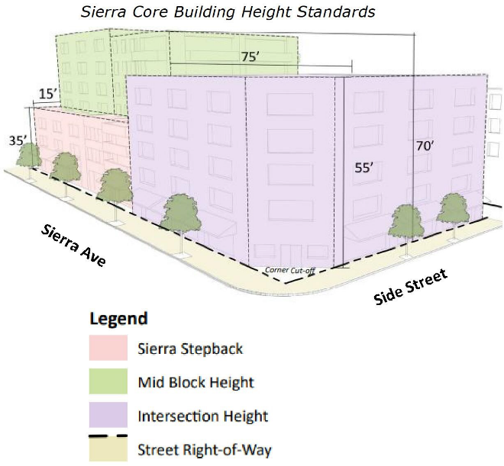
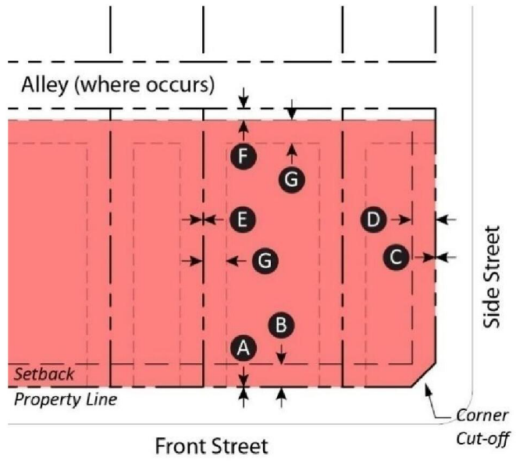
Setbacks
 | Min. (ft.) | Max. (ft.)
Front Street | 0  | 10 
Side Street | 0  | 10 
Side (Interior) | 0  | —
Rear Yard | 5  | —
Stepback* | 10  | —
* Applies to rear and side (interior) at 35' high, when adjacent to the neighborhood core.

Building Height
Frontage Coverage | 80% min.
Height** | 35' max.
Height** | 55' max. within 75' of side street property line 
Height** | 70' max. with min. stepback 75' from side street and 15' from Sierra Ave Property Line*
Ground Floor Commercial Height** | 12 ft. Min. 

* The maximum height along Sierra Ave may be increased to 45 feet and to 70 feet along the side street stepbacks for projects that provide a rooftop amenity. The rooftop amenity must be located along a street frontage with a maximum height of 45 feet and minimum width of 15 feet.

Public and private spaces should be integrated to act as one. Awnings or canopies extending over sidewalks and significant glazing should be included in all new construction or renovation.
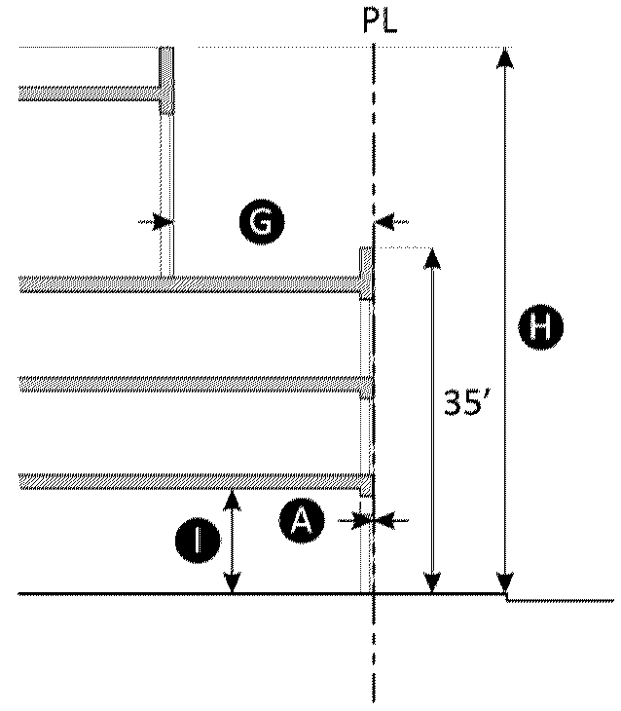
Encroachments

Buildings, architectural features, and signs may encroach into the required setbacks and right-of-way subject to the following requirements and City Engineer approval:

 | Arcade, Gallery, Awning | Balcony | Bay Window | Eave
Front Street | Min. 2 ft. clear of curb | 6 ft. max. | 4 ft. max. on upper floors only | Min. 2 ft. clear of curb
Side Street | Min. 2 ft. clear of curb | 6 ft. Max. | 4 ft. Max. on upper floors only | Min. 2 ft. clear of curb
Side Interior | — | Min. 5 ft. from PL | Min. 5 ft. from PL | Min. 3 ft. from PL
Rear Yard | Min. 5 ft. from PL | Min. 5 ft. from PL | Min. 5 ft. from PL | Min. 3 ft. from PL
Vertical | Min. 8 ft. clear | Min. 8 ft. clear | Min. 8 ft. clear | Min. 8 ft. clear

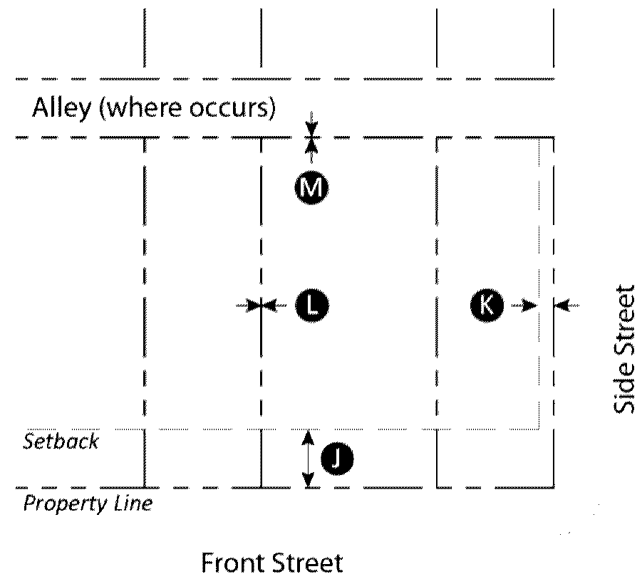
Parking

 | Required Spaces
Residential | 1.25 per unit
Non-Residential Uses Under 6,000 Square Feet | No parking required
Non-Residential Uses Over 6,000 Square Feet | 50% of the requirements in the Zoning Code (30-685.A)
Retail, Entertainment and Restaurant Uses Over 6,000 Square Feet Within 400 Feet of City-Owned Public Parking Lot or Structure | No parking required

On-site above-ground parking and access shall be located in compliance with the following setback requirements:

 | Min. (ft.)
Front Street | 20 | 
Side Street | 5 | 
Side Interior | — | 
Rear Yard | — | 

Minimum lot size:
5,000 square feet

Required frontage:
Forecourt, shopfront, gallery and arcade

Sec. 30-372. - Duplex, multiplex.

Description: The duplex building type is a small- to medium-sized structure that consists of two side-by-side or stacked dwelling units, both facing the street, and within a single building massing. This type has the appearance of a medium to large single-family home and is appropriately scaled to fit within primarily single-family neighborhoods or medium-density neighborhoods. It enables appropriately-scaled, well-designed higher densities and is important for providing a broad choice of housing types and promoting walkability.
The multiplex is a medium structure that consists of three—six side-by-side and/or stacked dwelling units, typically with one shared entry or individual entries along the front. This type has the appearance of a medium-sized family home and is appropriately scaled to fit sparingly within primarily single-family neighborhoods or into medium-density neighborhoods. This type enables appropriately-scaled, well-designed higher densities and is important for providing a broad choice of housing types and promoting walkability.

Allowed In: | Transitional, Multi-Family & Village
Lot Size: | Width: 50 ft. min.  Depth: 100 ft. min.
Pedestrian Access: | Main entrance location: Primary street  On corner lots, each lot shall front a separate street
Vehicle Access & Parking: | Parking spaces may be enclosed, covered, or open.
Frontages: | Porch  Stoop  Dooryard
Private Open Space: | Minimum width: 8 4 ft.  Minimum depth: 8 4 ft.  Minimum area: 64 sq. ft.
Building Size & Massing: | Length along frontage: 36 ft. max. for duplex and 350 ft. max. for multiplex  Length along side yard: 200 ft. max.

The remainder of Sec. 30-372 to remain unchanged.

Sec. 30-373. - Rosewalk and Bungalow Court.

Description: Rosewalk—Six or more single dwellings arranged in a linear manner along either side of a common green. Having the same right-of-way width as a narrow neighborhood street, the Rosewalk (in contrast to the Bungalow Court) must connect two parallel streets. Pedestrian access to the building entrances are is accessed from the common green and/or primary street.

Bungalow Court—Four or more single dwellings arranged around a shared courtyard, with pedestrian access to the building entrances from the courtyard and/or fronting street. The courtyard is wholly open to the street and parking is placed in the rear of the lot or behind each unit.

Allowed In: | Transitional, Multi-Family & Village
Lot Size: | Width: 75 ft. min.  Depth: 100 ft. min.
Pedestrian Access: | Main entrance location: Common courtyard
Vehicle Access & Parking: | Parking spaces may be enclosed, covered, or open.
Frontages: | Porch  Stoop  Dooryard
Private Open Space: | Minimum width: 8 4 ft.  Minimum depth: 8 4 ft.  Minimum area: 64 sq. ft.
Common Courtyard: | Width: 20 ft. min. clear  Depth: 50 ft. min clear
Building Size & Massing: | Length along frontage: 50 ft. max.  Length along side yard: 40 ft. max.

The remainder of Sec. 30-373 to remain unchanged.

Sec. 30-374. - Rowhouse.

Description: A small- to medium-sized building comprised of attached dwelling units arrayed side by side. The ground floor can be raised above grade in order to provide privacy for ground floor rooms. The primary building should sit at the front of the property, with the garage at the rear. Each dwelling unit is directly accessed from the front yard/street or walking path leading to the street. The Rowhouse type is typically located within medium-density neighborhoods or in a location that transitions from a primarily single-family neighborhood into a neighborhood main street. This type enables appropriately-scaled, well-designed higher densities and is important for providing a broad choice of housing types and promoting walkability.

Allowed In: | Transitional, Multi-Family, Sierra Gateway, Route 66 Gateway & Village
Lot Size: | Width: 125 ft. min.  Depth: 125 ft. min.
Pedestrian Access: | Main entrance location: Primary street
Vehicle Access & Parking: | Parking spaces may be enclosed, covered, or open.
Frontages: | Porch  Stoop  Dooryard
Private Open Space: | Minimum width: 8 4 ft.  Minimum depth: 8 4 ft.  Minimum area: 64 sq. ft.
Building Size & Massing: | Width per rowhouse: 18 15 ft. min./36 ft. max.  The front elevation and massing of each rowhouse building may be either symmetrical or asymmetrical, repetitive or unique in disposition, as long as the delineation of each individual unit is evident.

The remainder of Sec. 30-374 to remain unchanged.

Sec. 30-375. - Single-family home.

Description: Single-family homes are freestanding structure intended to be occupied as a home or residence by a single household. An accessory dwelling unit may also be attached or detached to the main dwelling unit for occupancy by an additional household. Private open space is provided in the rear yard that is secured by walls or fences.

Allowed In: | Transitional, Neighborhood, Village
Lot Size: | Width: 50 ft. min./60 ft. max  Depth: 50 ft. min./100 ft. max
Pedestrian Access: | Main entrance location: Primary street
Vehicle Access & Parking: | Parking spaces may be enclosed, covered, or open. Parking may be accessed from the primary street, secondary street, or alley
Frontages: | Porch  Stoop  Dooryard
Private Open Space: | Located in the enclosed rear yard
Accessory Buildings/Structures: | For accessory dwelling units, see Sec. 30-467.  For accessory structures, see Sec. 30-461.

Sec. 30-376. - Live/work.

Description: The live/work building type is a small to medium-sized attached or detached structure that consists of single dwelling unit above and/or behind a flexible ground floor space that can be used for home-business uses such as residential, personal and general service, or retail uses. Both the ground-floor flex space and the unit above are owned by one entity. This type is typically located within medium-density neighborhoods or in a location that transitions from a neighborhood into an urban neighborhood street. It is especially appropriate for incubating neighborhood-serving retail and service uses and allowing neighborhood main streets to expand as the market demands. The work space is accessed directly from the primary street, and the living space at the rear or above is accessed directly or indirectly from the working space.

Allowed In: | Retail, Transitional, Station, Downtown Gateway, Sierra Gateway, Route 66 Gateway Valley Gateway & Village
Lot Size: | Width: 75 ft. min.  Depth: 80 ft. min.
Pedestrian Access: | Main entrance location: Primary street  Ground floor space and upper unit shall have separate entries.
Vehicle Access & Parking: | Parking spaces may be located in the rear, tuck under.
Frontages: | Forecourt  Dooryard  Shopfront  Lightcourt  Gallery
Private Open Space: | Minimum width: 8 4 ft.  Minimum depth: 8 4 ft.  Minimum area: 64 sq. ft.
Building Size & Massing: | Width per unit: 18 ft. min./36 ft. max.

The remainder of Sec. 30-376 to remain unchanged.

Sec. 30-377. - Court.

Description: A group of dwelling units arranged to share one or more common courtyards. The courtyard is intended to be a semi-public outdoor room that is an extension of the public realm. Court buildings may accommodate ground floor commercial/flex uses in either a live/work configuration or as solely commercial/retail space in qualifying zones facing the primary street. This building type enables the incorporation of high-quality, well-designed density within a walkable neighborhood.

Allowed In: | Transitional, Station, Downtown Gateway, Multi-Family & Village
Lot Size: | Width: 100 ft. min.  Depth: 100 ft. min.
Pedestrian Access: | Direct access from street or courtyard.
Vehicle Access & Parking: | From alley. For lots without alley, via driveway located as close to side yard property as possible.
Frontages: | Porch  Stoop  Dooryard
Private Open Space: | Minimum width: 8 4 ft.  Minimum depth: 8 4 ft.  Minimum area: 64 sq. ft.
This open space is exclusive of the courtyard and may be located in a side or rear yard.
Common Courtyard: | Recommended Width/depth/height ratio: 1:1 approx.  Width/depth: 20 ft. min.
Building Size & Massing: | Length along frontage: 200 ft. max.  Length along side yard: 140 200 ft. max.

The remainder of Sec. 30-377 to remain unchanged.

Sec. 30-378. - Hybrid.

Description: A building that combines a point-access portion of the building with a walk-up portion. The building may be designed for occupancy by retail, service, and/or office uses on the ground floor, with upper floors also configured for those uses or for residences.

Allowed In: | Retail, Station, Downtown Gateway, Sierra Gateway, Route 66 Gateway Valley Gateway & Village
Lot Size: | Width: 150 ft. min.  Depth: 160 ft. min.
Pedestrian Access: | The main entrance to each ground floor is directly from the street.
Entrance to the residential portions of the building is through a dedicated street level lobby, or through a dedicated podium lobby accessible from the street or through a side yard.
Interior circulation to each unit above the second level in double-loaded corrido element of the building is through a corridor of at least six feet in width with recessed doors or seating alcoves/offsets at every 100 feet at a minimum. For other units, it is directly off a common courtyard or through stairs serving up to three dwellings.
Vehicle Access & Parking: | Underground garage, surface parking, tuck under parking or a combination of any of the above.
Frontages: | Porch  Dooryard  Stoop  Arcade
Private Open Space: | Minimum width: 8 4 ft.  Minimum depth: 8 4 ft.  Minimum area: 64 sq. ft.  The open space is exclusive of the courtyard and may be located in a side or rear yard.
Building Size & Massing: | Length along frontage: 200 ft. max.

The remainder of Sec. 30-378 to remain unchanged.

Sec. 30-379. - Flex building.

Description: A building type designed for occupancy by retail, service, and/or office uses on the ground floor, with upper floors configured for retail, service, office, and/or residential uses. Second floor units may be directly accessed from the street through a stair; upper floors are accessed through a street level lobby.

Allowed In: | Retail, Station, Downtown Gateway, Civic, Sierra Gateway, Route 66 Gateway Valley Gateway & Village
Pedestrian Access: | Direct access from sidewalk. Upper floor accessed from street level.
Vehicle Access & Parking: | Required parking is accommodated in an underground or above-ground garage, tuck under parking, or a combination of any of the above.
Frontages: | Forecourt  Shopfront  Gallery  Arcade
Private Open Space: | Private open space is required for each residential unit and shall be no less than 64 sq. ft. with a minimum dimension of five four feet in each direction.
Shared Open Space: | The primary shared common space is the rear or side yard designed as a courtyard. Courtyards can be located on the ground or on a podium and must be open to the sky. Side yards can also be formed to provide outdoor patios connected to ground floor commercial uses.  Recommended width/depth/height ratio: 1:1 approx. Width/depth: 20 ft. min.
Building Size & Massing: | Length along frontage: If over 200 ft., must provide massing break.

The remainder of Sec. 30-379 to remain unchanged.

Sec. 30-380. - Liner building.

Description: A building that conceals a garage, or other large-scale faceless building (such as a movie theater), "big box" store or surface parking facility, designed for occupancy by retail, service, and/or office uses on the ground floor, with upper floors configured for retail, service, office, and/or residential uses. The access corridor, if applicable, is included in the minimum depth.

Allowed In: | Retail, Station, Downtown Gateway, Civic, Sierra Gateway, Route 66 Gateway Valley Gateway & Village
Pedestrian Access: | Direct access from sidewalk. Upper floor accessed from street level.
Vehicle Access & Parking: | Required parking is accommodated in an underground or above-ground garage, tuck under parking, or a combination of any of the above.
Frontages: | Forecourt  Shopfront  Gallery  Arcade
Private Open Space: | Private open space is required for each residential unit and shall be no less than 64 sq. ft. with a minimum dimension of five four feet in each direction.
Shared Open Space: | The primary shared common space is the rear or side yard designed as a courtyard. Courtyards can be located on the ground or on a podium and must be open to the sky. Side yards can also be formed to provide outdoor patios connected to ground floor commercial uses.  Recommended width/depth/height ratio: 1:1 approx. Width/depth: 20 ft. min.
Building Size & Massing: | Length along frontage: If over 200 ft., must provide massing break.

The remainder of Sec. 30-380 to remain unchanged.

Sec. 30-398. - Private open space types.

Private open spaces shall be designed as one of the private open space types defined in this section.

(1) Private yard.
a. Definition: A side yard or rear yard (excluding required setback areas) which is accessed by secondary unit entrance(s).
b. The primary access to a private yard shall be from the dwelling(s) served.

c. The minimum area for a private yard shall be 60 square feet.
d. The minimum dimensions for a private yard in any single direction shall be six four feet.
e. Landscaping shall consist primarily of planted areas including water-efficient plantings of lawns, trees, plants in pots, etc. and may be combined with a porch.
f. Private yard spaces may include edge walls or fences, provided that their inclusion does not violate building orientation.

(2) Porch.
a. Definition: A patio, terrace, or other platform extending from or adjacent to a building at the ground floor which is accessed by secondary unit entrances(s).
b. The primary access to a porch shall be from the dwelling(s) served.
c. The minimum area for a porch shall be 48 square feet.
d. The minimum dimensions of a porch in any single direction shall be six four feet.

(3) Rooftop deck or garden.
a. Definition: A private or privately shared deck or yard on the roof of a building.
b. The minimum dimensions for a rooftop deck or garden in any single direction shall be six four feet.
c. Gardens and green roofs are encouraged to help minimize heat sinks and to pretreat water from storms prior to it entering the storm drain system.
d. The minimum area for a rooftop deck or garden shall be 60 square feet.

(4) Balcony.
a. Definition: An outdoor space extending from a private upper floor of a building, which is accessed directly from a secondary unit entrance.
b. Access to a balcony shall be limited to the dwelling served.
c. The minimum area for a rooftop deck or garden shall be 48 square feet.
d. The minimum dimensions for a balcony in any single direction shall be six four feet.

Sec. 30-477. – Building design.
…
(6) Utilities.
a. Temporary overhead power and telephone facilities are permitted only during construction.

b. Transformers, utility pads and telephone boxes shall be installed and maintained underground. Placement, location and screening of utilities of any kind which cannot be installed underground and must be placed above ground for function and safety reasons require written approval by the Director of Planning Community Development prior to any administrative or discretionary approval.

c. All utilities including, but not limited to, drainage systems, sewers, gas lines, water lines, and electrical up to 35 KV, telephone, underground cable television, and communications wires and equipment shall be installed and maintained underground. Placement, location and screening of utilities of any kind which cannot be installed underground and must be placed above ground for function and safety reasons require written approval by the Director of Community Development prior to any administrative or discretionary approval.

d. All utility easements shall be landscaped and shall be maintained as provided in the easement document.
…

The remainder of Sec. 30-477to remain unchanged.

Sec. 30-491. - Special use regulations *.

This section establishes special regulations for certain permitted uses marked with an asterisk (*) in Table No. 30-489. The specified use is permitted provided that the use conforms to the following regulations:

…

(2) Restaurant, drive-thru.
a. A drive-through restaurant applicant shall provide a queuing study and plan for the business's high volume periods, such as its grand opening and other high volume periods. The applicant shall not queue any less than 15 vehicles.

b. A queuing study, provided by the applicant’s engineer, confirming that the site can accommodate the morning or afternoon peak hour queuing for the proposed normal business operations shall be provided. The drive-thru design shall not provide for less than 12 vehicles queuing. Eighteen feet shall be allocated for each queued vehicle.

bc. The required queue area on site shall be measured from the forwardmost drive-up window to the entrance of the stacking space. The stacking space shall be located completely clear of any adjacent public right-of-way and all circulation aisles provided on site.

c.d. The required queue area on site shall accommodate the morning or afternoon peak hour queue length for the facility. The peak queue length shall hold 25 percent of all vehicles arriving during the morning or afternoon peak hour, whichever time provides the highest stream of traffic. The peak queue length shall be calculated using a queuing study, provided by the applicant's engineer, based on the anticipated peak hour traffic counts from three similar sized restaurants, with similar operational profiles, from the same franchise, located near within two miles of the project site, with similar land use, operation and building size. Twenty feet shall be allocated for each queued vehicle.

d.e. The drive-thru lane and associated parking area(s) visible from a public street shall be screened from view by a landscape berm. If berming is physically impossible, a decorative wall with caps and pilasters shall be provided or a decorative wall with caps, pilasters, and trellis work shall be provided. Additionally, a three-foot landscape hedge at the time of planting shall be provided in front of the wall for either scenario.

e.f. A drive-thru lane located adjacent to a parcel zoned for residential use is not permitted.

f.g. A line of sight from the public right-of-way shall be provided for a project that includes a drive-thru lane to demonstrate the screening devices used to screen the drive-thru lane and associated parking area(s).

g.h. The menu board shall be enhanced, landscaped, and located at a minimum distance of 40 feet from the menu board to the entrance to the stacking space.

h.i. Exterior doors on any children's play area shall be for emergency exit only.

i.j. Indoor or outdoor dining/seating is required. The proposed number of indoor or outdoor seats must be approved by the Director of Planning. Outdoor seating areas shall be designed to be consistent with the architectural style of the drive-thru restaurant, shall be located near the main pedestrian entrance and shall include tables with seating, a trash receptacle, a low fencing enclosure, and a protective structure over the entire area.

j.k. The outdoor dining area may include a plaza, arcade, colonnades, or courtyard design.

k.l. All new drive-thru restaurants shall have a solid decorative porte cochere above the drive-thru window(s). Existing drive-thru restaurants may construct a porte cochere when sufficient space allows or when the existing restaurant is proposing expansions to the building. The porte-cochere may encroach into the required setback and right-of-way up to a maximum of two feet.

l.m. Building entrances shall be oriented toward the street with drive-thru lanes, pick-up window, and off-street parking facilities oriented towards the rear or side yard areas to the extent feasible. Pick-up windows shall be located near the outdoor dining area to encourage walkability.

m.n. Architectural treatment shall include a variety of roof lines and wall projections on all elevations of the building. The architecture of the drive-through restaurant shall be compatible with the surrounding uses in form, materials, colors, scale, design, etc.

o. Should operations impact public rights-of-way or obstruct parking or circulation areas for the drive-through or for other tenants within the same property, the City may, upon notification to the owner, require that the business owner submit a plan of corrective action(s) to be taken or immediate curtailment of business operations.

The remainder of Sec. 30-491 to remain unchanged.

Article VI. – COMMERCIAL AND MIXED-USE ZONING DISTRICTS

Sec. 30-508. - Site Plan Design.
…
(g) Utilities.
(1) Temporary overhead power and telephone facilities are permitted only during construction.
(2) Transformers, utility pads and telephone boxes shall be installed and maintained underground. Placement, location and screening of utilities of any kind which cannot be installed underground and must be placed above ground for function and safety reasons require written approval by the Director of Planning Community Development prior to any administrative or discretionary approval.
(3) Transformer enclosures shall be designed of durable materials with finishes and colors used which are compatible and harmonious with the overall architectural theme.
(4) All utilities including, but not limited to drainage systems, sewers, gas lines, water lines, and electrical, telephone, and communications wires and equipment shall be installed and maintained underground. Placement, location and screening of utilities of any kind which cannot be installed underground and must be placed above ground for function and safety reasons require written approval by the Director of Community Development prior to any administrative or discretionary approval.
The remainder of Sec. 30-508 to remain unchanged.

Article VII – Industrial Zoning Districts

Sec. 30-538. - Screening.

…
(c) Mechanical equipment, ground. All mechanical equipment shall be screened to the extent feasible on all sides by a decretive decorative screen wall not less than the height of the equipment being screened in conjunction with landscaping, subject to approval of the Director of Planning. The decorative screen wall shall be located between the street and the mechanical equipment not less than three-foot. The decorative screen wall shall be well incorporated into the design of the building. The other side of the equipment shall be screened with landscaping not less than ten-gallon shrubs or approved landscaping.
…

The remainder of Sec. 30-538 to remain unchanged.

Sec. 30-550. – Screening

…
(g) Utilities.
(1) Temporary overhead power and telephone facilities are permitted only during construction.
(2) Transformer enclosures shall be designed of durable materials with finishes and colors used which are compatible and harmonious with the overall architectural theme.
(3) All utilities including, but not limited to drainage systems, sewers, gas lines, water lines, and electrical, telephone, and communications wires and equipment shall be installed and maintained underground. Placement, location and screening of utilities of any kind which cannot be installed underground and must be placed above ground for function and safety reasons require written approval by the Director of Planning Community Development prior to any administrative or discretionary approval.
…

The remainder of Sec. 30-550 to remain unchanged.

Article VIII – Public Facilities and Open Space Zoning Districts

Sec. 30-619. - Site Plan Design

…
(e) Utilities.
(1) Temporary overhead power and telephone facilities are permitted only during construction.

(2) Transformers, utility pads and telephone boxes shall be screened with walls and vegetation to the extent feasible, subject to approval of the Director of Planning.

(3) Transformer enclosures shall be designed of durable materials with finished and colors used which are compatible and harmonious with the overall architectural theme.

(4) All exterior on-site utilities and utility boxes, structures, and equipment including, but not limited to drainage systems, sewers, gas lines, water lines, and electrical, telephone, and communications wires and equipment shall be installed and maintained underground.
…

The remainder of Sec. 30-619 to remain unchanged.

