NOTICE OF PUBLIC HEARING

SI DESEA INFORMACION EN ESPAÑOL REFERENTE A ESTA NOTIFICACION O PROYECTO, FAVOR DE COMUNICARSE AL (909) 350-6728.
In compliance with Section No. 202 of the Americans with Disabilities Act of 1990 (42 U.S.C. Section No. 12132) and the federal rules and regulations adopted in implementation thereof, the Agenda will be made available in appropriate alternative formats to persons with a disability. Should you need special assistance to participate in this meeting, please contact the Planning Department by calling (909) 350-6718. Notification 48 hours prior to the meeting will enable the city to make reasonable arrangements to ensure accessibility to this meeting.
A PUBLIC HEARING HAS BEEN SCHEDULED BEFORE THE CITY COUNCIL OF THE CITY OF FONTANA FOR THE FOLLOWING:

Appeal (APL) No. 26-001 & Master Case No (MCN). 18-000053

A request by Supporters Alliance for Environmental Responsibility (“SAFER”) (“The Appellant”) to appeal the Planning Commission’s decision on March 17, 2026, which approved Master Case No. 18-000053 for Tentative Parcel Map No. 18-000005 (TPM No. 19950), and Design Review No. 18-000010 along with the Categorical Exemption (Section 15332, Class No. 32 – Infill Development) for split one (1) parcel into two (2) and for site and architectural approval for the development of two (2) new industrial commerce center buildings, Building No. 1 will have 41,218 square feet and Building No. 2 will have 30,767 square feet, and with associated site improvements, on 3.98 acres, located north of Hilton Drive and west of Hemlock Avenue, and identified as Assessor Parcel Numbers 1110-151-03.

Environmental Determination: | 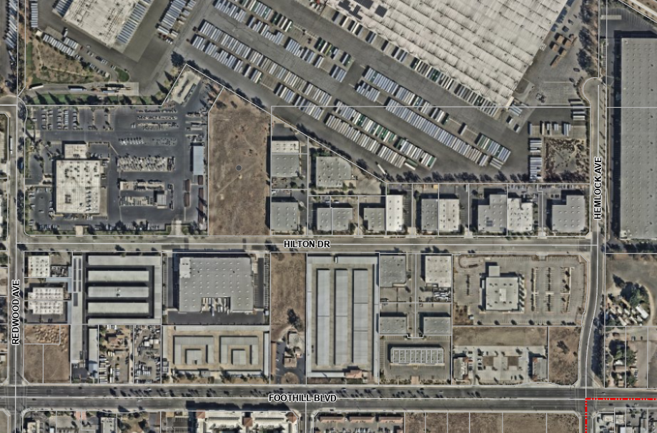  On March 17, 2026, the Planning Commission adopted a Categorical Exemption for the development of the property for Master Case No. 18-000053: Tentative Parcel Map No. 18-000005 (TPM No. 19950), and Design Review No. 18-000010, in accordance with Section 15332 (Class No. 32 – Infill Development) of the California Environmental Quality Act (CEQA) and Section 3.22 of the 2019 City of Fontana Local Guidelines for Implementing the CEQA.  Hilton Dr.  Hemlock Ave.  Redwood Ave.  Project Site  Foothill Blvd.
Location of Property: | The project site is located north of Hilton Dr. and west of Hemlock Ave. (APN Nos.: 1110-151-03)
Date of Hearing: | May 12, 2026  ATTACHMENT NO. 8
Place of Hearing: | Steelworkers’ Auditorium  8437 Sierra Avenue  Fontana, CA 92335
Time of Hearing: | 2:00 P.M.

Should you have any questions concerning this project, please contact Salvador Quintanilla, Senior Planner, at 909-350-6656 or by e-mail at squintanilla@fontanaca.gov.

ANY INTERESTED PARTY MAY APPEAR AND PRESENT ANY INFORMATION BY LETTER OR EMAIL WHICH MAY BE OF ASSISTANCE TO THE CITY COUNCIL. A COPY OF THE APPLICATION AND ENVIRONMENTAL DOCUMENTATION IS AVAILABLE FOR INSPECTION. PLEASE CONTACT THE PLANNER LISTED ABOVE.
IF YOU CHALLENGE ANY ACTION TAKEN CONCERNING THIS ITEM IN COURT, YOU MAY BE LIMITED TO RAISING ONLY THOSE ISSUES YOU OR SOMEONE ELSE RAISED AT THE PUBLIC HEARING DESCRIBED IN THIS NOTICE, OR IN WRITTEN CORRESPONDENCE PROVIDED TO THE CITY AT, OR PRIOR TO, THE PUBLIC HEARING.

Publish date: May 1, 2026

