NOTICE OF PUBLIC HEARING

SI DESEA INFORMACION EN ESPAÑOL REFERENTE A ESTA NOTIFICACION O PROYECTO, FAVOR DE COMUNICARSE AL (909) 350-6728.

In compliance with Section 202 of the Americans with Disabilities Act of 1990 (42 U.S.C. Sec. 12132) and the federal rules and regulations adopted in implementation thereof, the Agenda will be made available in appropriate alternative formats to persons with a disability. Should you need special assistance to participate in this meeting, please contact the City Clerk’s Department by calling (909) 350-7602. Notification 48 hours prior to the meeting will enable the City to make reasonable arrangements to ensure accessibility to this meeting.

A PUBLIC HEARING HAS BEEN SCHEDULED BEFORE THE CITY COUNCIL OF THE CITY OF FONTANA FOR THE FOLLOWING:

Master Case No. 22-008: General Plan Amendment (GPA) 22-012, Development Code Amendment (ZCA) No. 24-003, and Specific Plan (SP) No. 24-001 for the New Walnut Village Specific Plan Project

General Plan Amendment to revise Figure 15.9 (Land Use Category) in Chapter 15 (Land Use, Zoning and Urban Design) of the General Plan to change: approximately 7 acres from Community Commercial (C-C) to Multi-Family Medium to High Density Residential (R-MFMH), approximately 38 acres from Residential Planned Community (R-PC) to Multi-Family High Density Residential (R-MFH), approximately 10 acres from Residential Planned Community (R-PC) to Multi Family Residential (R-MF), removal of the Auto Center Overlay designation on approximately 7 acres within the Walnut Village Specific Plan boundary; Zoning Code Amendment to revise Section Nos. 30-635, 30-639 and 30-642 of the Zoning and Development Code to remove the Fontana Auto Center Overlay District on approximately 7 acres within the Walnut Village Specific Plan boundary; along with rescinding the existing Walnut Village Specific Plan and adoption of a new Specific Plan to establish a new Walnut Village Specific Plan of approximately 342 acres including new planning areas and development standards.

Environmental Determination: | 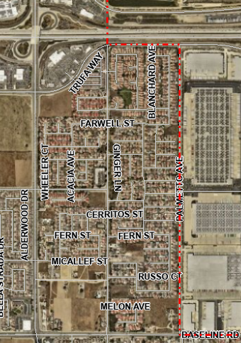  This project has been determined to have a potentially significant effect on the environment and a Final Environmental Impact Report (EIR) (SCH No. 2023050271) has been prepared pursuant to Sections 15080 and 15097 of the California Environmental Quality Act (CEQA).  SOUTH HIGHLAND AVE  Project Area
Location of Property: | The Project Site is located north of  Baseline Avenue, south of the 210  Freeway, east of Sierra Avenue  and west of Palmetto Avenue
Date of Hearing: | July 23, 2024 | SIERRA AVE
Place of Hearing: | City Hall Council Chambers  8353 Sierra Avenue  Fontana, CA 92335 | SIERRA AVE
Time of Hearing: | 2:00 P.M. | SIERRA AVE

The City of Fontana (City) has prepared an Environmental Impact Report (EIR) for the proposed project. The Draft and Final EIR are available for review at City Hall (8353 Sierra Avenue Fontana, CA 92335) and online at https://www.fontanaca.gov/2137/Environmental-Documents. Should you have any questions concerning this project, please contact Cecily Session-Goins, Associate Planner at (909) 350-6723 or csgoins@fontanaca.gov.

ANY INTERESTED PARTY MAY PROVIDE INFORMATION BY LETTER OR EMAIL WHICH MAY BE OF ASSISTANCE TO THE CITY COUNCIL. A COPY OF THE APPLICATION AND ENVIRONMENTAL DOCUMENTATION IS AVAILABLE FOR INSPECTION. PLEASE CONTACT THE PLANNER LISTED ABOVE.

IF YOU CHALLENGE IN COURT ANY ACTION TAKEN CONCERNING A PUBLIC HEARING ITEM, YOU MAY BE LIMITED TO RAISING ONLY THOSE ISSUES YOU OR SOMEONE ELSE RAISED AT THE PUBLIC HEARING DESCRIBED IN THIS NOTICE, OR IN WRITTEN CORRESPONDENCE TO THE CITY AT, OR PRIOR TO, THE PUBLIC HEARING.

Publish Date: June 21, 2024

