FIRST AMENDMENT TO NAMING RIGHTS AGREEMENT
This First Amendment to Naming Rights Agreement (the “Amendment”) is entered into as of this ____ day of August, 2026 (the “Effective Date”) by and between the City of Fontana (“City”) and Red Head Inc., a California corporation (“Company”). All defined terms herein shall have the same meaning as in the Agreement.
RECITALS
WHEREAS, City and Company entered into that certain Naming Rights Agreement dated September 30, 2022 (the “Agreement”); and
WHEREAS, on December 5, 2023, Company submitted to the United States Patent and Trademark Office an application to register the mark “STAGE RED” (the “Trademark”), and the Trademark has since been approved and duly registered; and
WHEREAS, Company is the owner of all right, title, and interest in and to the Trademark and desires to assign, transfer, and convey to City all of Company’s right, title and interest therein; and
WHEREAS, City desires to acquire from Company all of Company’s right, title, and interest in and to the Trademark for use in connection with its business and operations; and
WHEREAS, City has agreed to grant Company a license to use the Trademark, subject to the terms and conditions set forth herein; and
WHEREAS, the parties wish to amend the Agreement to reflect the foregoing assignment and license arrangements, and further to expand the scope of the Agreement to include the development, production, marketing, distribution and sale of merchandise bearing either or both (i) the intellectual property “SAMMY HAGAR,” which is the subject of the Agreement, (ii) the Trademark, and (iii) such other City intellectual property as described herein.
NOW, THEREFORE, in consideration of the mutual covenants and agreements herein, and other good and valuable consideration, the receipt and sufficiency of which are hereby acknowledged, the parties agree as follows:
AGREEMENT
1. The title of Section 1 of the Agreement, currently “Grant of License,” is hereby deleted in its entirety and substituted with the text “Marks; Transfer and Grant of Licenses.”
2. The existing text of Section 1 shall be designated as Section 1(a) and, except as expressly amended herein, shall remain in full force and effect, provided that the first paragraph shall be amended by deleting the text “but does not include the sale of merchandise” and substituting the text with “including merchandise (subject to the terms of the Merchandise Addendum dated June __, 2026).” Section 1(a) shall be further amended to include the following language to the end of the section, “[F]or avoidance of doubt, in the event this Agreement is renewed in accordance with Section 5, the licenses granted by the City to Company and by Company to City shall automatically extend for each renewal term on the same terms and conditions unless otherwise modified by mutual written agreement of the parties.”
3. Section 1 of the Agreement shall be amended by adding the following text as Section 1(b):
“Company hereby irrevocably sells, assigns, transfers and conveys to City all of Company’s right, title and interest as it holds in the trademark "STAGE RED" registered in the United States patent and Trademark Office under the number 7951201 for the goods and services in International Classes 35 and 41, together with all goodwill associated with the use of the Trademark, as further described in Exhibit A attached hereto and incorporated herein by this reference.
This assignment includes, without limitation, all rights and benefits relating to the Trademark, including all causes of action and rights to recover for past, present and future infringements thereof.
Company represents and warrants that: (i) it is the sole and exclusive owner of the Trademark; (ii) the Trademark is free and clear of all liens, claims, encumbrances, or adverse rights of any third party; (iii) it has full right, power, and authority to execute this assignment and transfer the Trademark to City.
Upon execution of this Amendment, Company shall retain no rights, title, or interest in or to the Trademark, whether legal, equitable, or beneficial, and shall ease all use of the Trademark, except as expressly provided in Section 1(c) herein.”
4. Section 1 of the Agreement shall be amended by adding the following text as Section 1(c):
“City grants to Company an exclusive, irrevocable, gratis license to use the Trademark “STAGE RED” in connection with concert venues located fifty (50) miles or more from the Venue; provided that City retains the right to operate and use the Trademark for its own business purposes, as provided for in the Agreement. The license is non-assignable (a) without City’s prior written consent, which shall not be unreasonably withheld; or (b) in accordance with Section 7 of the Agreement. Unless earlier terminated in accordance with this Agreement, the license shall continue for the duration of this Agreement.
Company shall use the Trademark in a professional manner, consistent with the reputation of City and the Trademark, and shall comply with all reasonable quality control standards, brand guidelines, and operational requirements that City may establish from time to time, provided that City gives Company written notice of any new standards at least thirty (30) days prior to their effective date.
Company shall not use City’s name in conjunction with the Trademark, nor use the Trademark in any manner that disparages, dilutes, or harms City or the value of the Trademark. Company shall promptly notify City of any known unauthorized use, infringement, or misuse of the Trademark by any third party, and shall cooperate with City in any legal or administrative action City chooses to take to protect the Trademark. City shall have the right, but not the obligation, to pursue such enforcement action, at its discretion.
City may terminate the License for breach of this provision, at any time, by giving fourteen (14) days written notice of termination to Company, during which time Company shall have the opportunity to cure the cause and/or reason(s) for termination provided in the written notice, and if so corrected, such termination shall not occur.
Upon termination, Company shall immediately cease all use of the Trademark and remove it from all materials and concert venues within ten (10) business days of receipt of notice from City. This license is granted solely for the purpose of operating concert venues and selling merchandise associated therewith, as specified herein, and does not grant any rights to utilize the Trademark except as expressly set forth in this Agreement.”
5. Section 3 of the Agreement shall be amended by adding the following text as Section 3(b):
“As consideration for the sale, assignment, transfer, and conveyance of the Trademark from Company to City, City shall reimburse Company for all reasonable costs and expense incurred in connection with the acquisition of the Trademark, including legal fees incurred in preparing this Agreement, as well as staff time and administrative expenses reasonably associated with the processing, registration and transfer of the Trademark, as set forth in Exhibit B attached hereto and incorporated herein by this reference.”
The existing text of Section 3 shall be designated as Section 3(a) and shall remain in full force and effect.

6. Section 5 of the Agreement is hereby amended to read as follows:
“The Term of this Agreement shall be for twenty (20) years following the date upon which the Venue opens to the public, which occurred on June 15, 2024.”
7. Section 5 of the Agreement shall be amended by adding the following text:
“Upon expiration of the initial Term, this Agreement shall automatically renew for up to five (5) successive one (1) year renewal terms unless either Party is in default under this Agreement at the time of renewal and such breach remains uncured following any applicable notice and cure periods set forth in this Agreement. Neither Party shall unreasonably withhold, condition, or delay renewal, and any refusal to renew must be based on substantial and documented noncompliance with this Agreement.
For purposes of this Section, “notice and cure periods” shall mean that the non-breaching Party must provide breaching Party written notice describing the alleged material breach in reasonable detail, and breaching Party shall have sixty (60) days from receipt of such notice to cure such breach to non-breaching Party’s reasonable satisfaction. A breach shall be deemed “uncured” only if non-breaching Party fails to (i) commence cure within the applicable cure period, (ii) diligently pursue cure to completion, or (iii) fully remedy the breach within the applicable cure period. If breaching Party cures the breach within such period, the breach shall be deemed resolved and shall not constitute a basis for non-renewal under this Agreement.”
For purposes of this Agreement, “default” or “for cause” shall mean any failure by the breaching Party, or any of the breaching Party’s respective agencies, contractors, licensees, or representatives to perform or comply with any material obligation, representation, warranty, covenant, or standard under this Agreement, including, without limitation, the following:

- Reputational Harm / Morals Clause
Any act, omission, event, or condition that is reasonably likely to:
(i) harm, disparage, or adversely affect the reputation, goodwill, or public image of the non-defaulting Party or the respective Intellectual Property of the non-defaulting Party; or
(ii) associate the Intellectual Property with conduct, events, uses, sponsors, partnerships, messaging, or activities that are unlawful, discriminatory, hateful, defamatory, politically extreme, conflict with or dilute the Intellectual Property or brand or otherwise are inconsistent with generally accepted community standards of the brand.
- Payment or Consideration Failures
Failure to make any required payments or deliver agreed consideration (if any) when due, subject to a limited cure period.
- Other Material Defaults
Any other material breach of this Agreement that remains uncured beyond the applicable notice and cure period; provided, however, that breaches involving reputational harm or unlawful conduct shall be deemed incurable if immediate termination is reasonably necessary to protect the non-breaching Party.
8. Except as modified herein, the Agreement shall remain unaffected and continue in full force and effect and is hereby deemed ratified and confirmed. This Amendment shall be deemed incorporated into and make a part of the Agreement.
9. This Amendment maybe executed in counterparts and delivered electronically, each of which shall be deemed an original and all of which together shall constitute one instrument.
SIGNATURE PAGE FOLLOWS

CITY OF FONTANA RED HEAD INC.

By: _________________________ By: _________________________
Matthew Ballantyne Name:
City Manager

ATTEST:

By: _________________________
Germaine Key
City Clerk

APPROVED AS TO FORM:

By: _________________________
Ruben Duran
Assistant City Attorney

EXHIBIT "A"
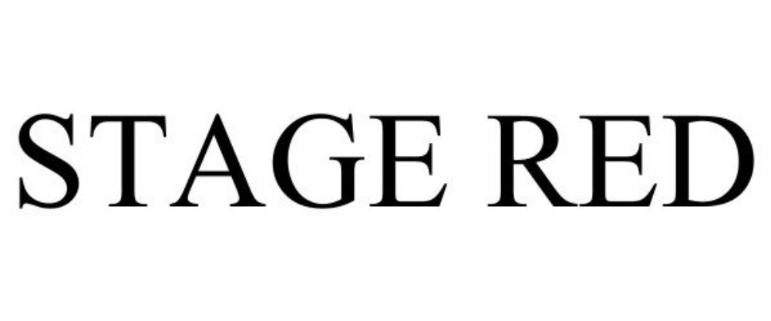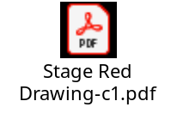
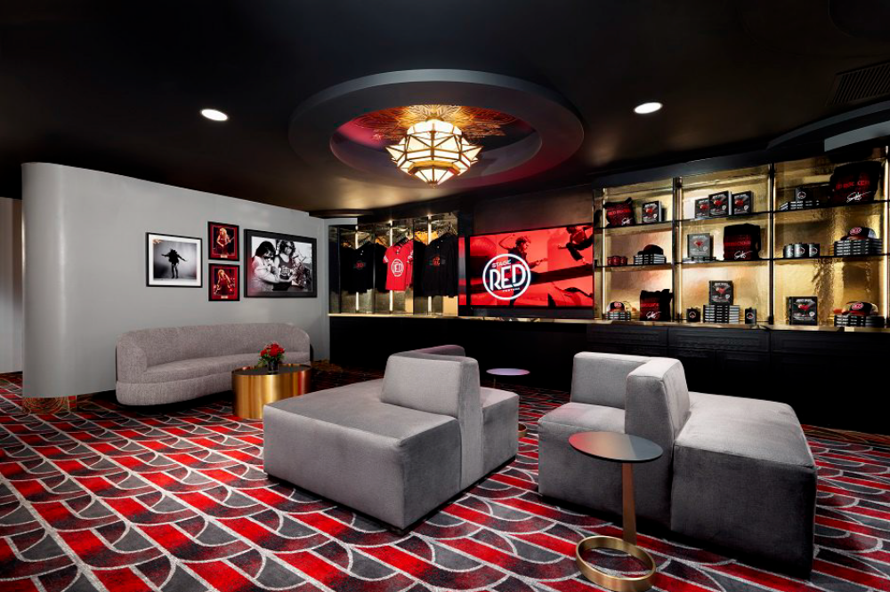

EXHIBIT "B"


